**VISVESVARAYA TECHNOLOGICAL UNIVERSITY**

**“JnanaSangama”, Belgaum -590014, Karnataka.**



**LAB REPORT**

**on**

**Data Structures using C Lab**

**(23CS3PCDST)**

***Submitted by***

**SHASHANK SHANTHARAM NAYAK**

**(1BM23CS313)**

***in partial fulfillment for the award of the degree of***

**BACHELOR OF ENGINEERING**

***in***

**COMPUTER SCIENCE AND ENGINEERING**



**B.M.S. COLLEGE OF ENGINEERING**

**(Autonomous Institution under VTU)**

**BENGALURU-560019**

**Sep-2024 to Jan-2025**

**B.M.S. College of Engineering,**

**Bull Temple Road, Bangalore 560019**

(Affiliated To Visvesvaraya Technological University, Belgaum)

**Department of Computer Science and Engineering**



**CERTIFICATE**

This is to certify that the Lab work entitled “Data Structures using C Lab(23CS3PCDST)” carried out by **SHASHANK SHANTHARAM NAYAK(1BM23CS313),** who is bonafide student of **B.M.S.College of Engineering.** It is in partial fulfillment for the award of **Bachelor of Engineering in Computer Science and Engineering** of the Visvesvaraya Technological University, Belgaum. The Lab report has been approved as it satisfies the academicrequirements in respect of Data Structures using C Lab(23CS3PCDST) work prescribed for the said degree.

|  |  |
| --- | --- |
| Dr. Namratha M.  Assistant Professor  Department of CSE, BMSCE | Dr. Kavitha Sooda  Professor & HOD  Department of CSE, BMSCE |

**Index**

|  |  |  |  |
| --- | --- | --- | --- |
| **Sl. No.** | **Date** | **Experiment Title** | **Page No.** |
| 1 | 30-09-2024 | Implementation of Stack | 4 |
| 2 | 07-10-2024 | Infix to Postfix Implementation | 11 |
| 3 | 14-10-2024 21-10-2024 | 1. Implementation of Queue 2. Implementation of Circular Queue | 15 19 |
| 4 | 28-10-2024 | Implement a Linked List - Insertion LeetCode Problem – Valid Parantheses | 24 29 |
| 5 | 11-11-2024 | Implement a Linked List - Deletion LeetCode Problem – Daily Temperatures | 31 37 |
| 6 | 02-12-2024 | 1. Sorting, concatenating and reversing a Linked List 2. Implement stacks and queues using linked list | 39 46 |
| 7 | 16-12-2024 | Insertion in a Doubly Linked List | 55 |
| 9 | 23-12-2024 | Construct a Binary Search Tree Traverse using inorder, preorder and postorder methods | 60 |
| 10 | 23-12-2024 | Implement a graph and traverse using BFS and DFS | 64 |

Github Link:

[**https://github.com/DevelSSN/1BM23CS313-SHASHANK-SHANTHARAM-NAYAK**](https://github.com/DevelSSN/1BM23CS313-SHASHANK-SHANTHARAM-NAYAK)

**Program 1**

Write a program to simulate the working of stack using an array with the following:

a) Push

b) Pop

c) Display

The program should print appropriate messages for stack overflow, stack underflow

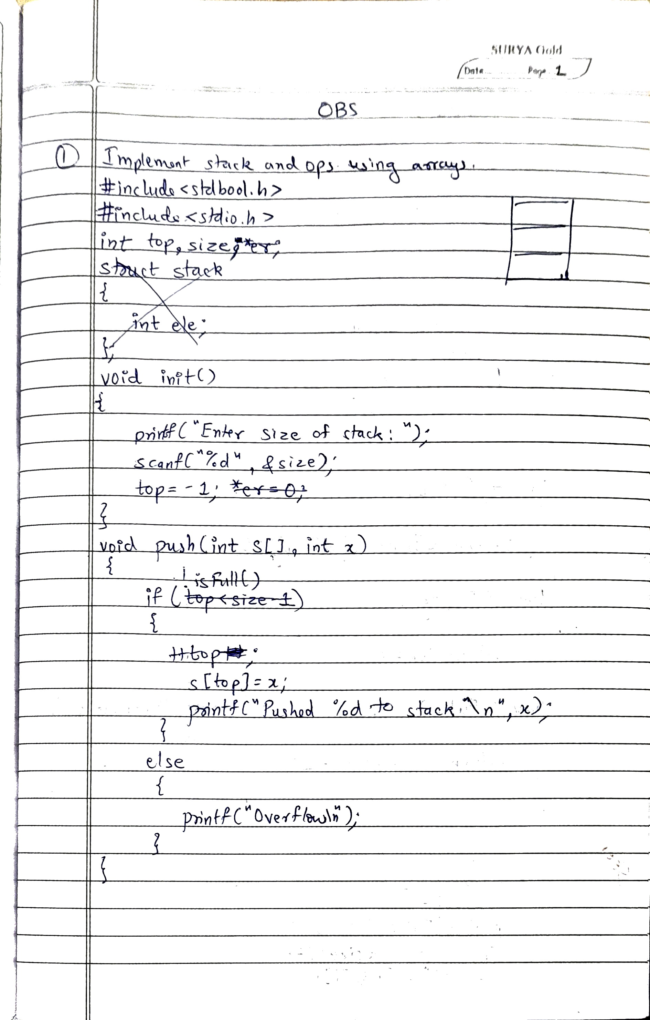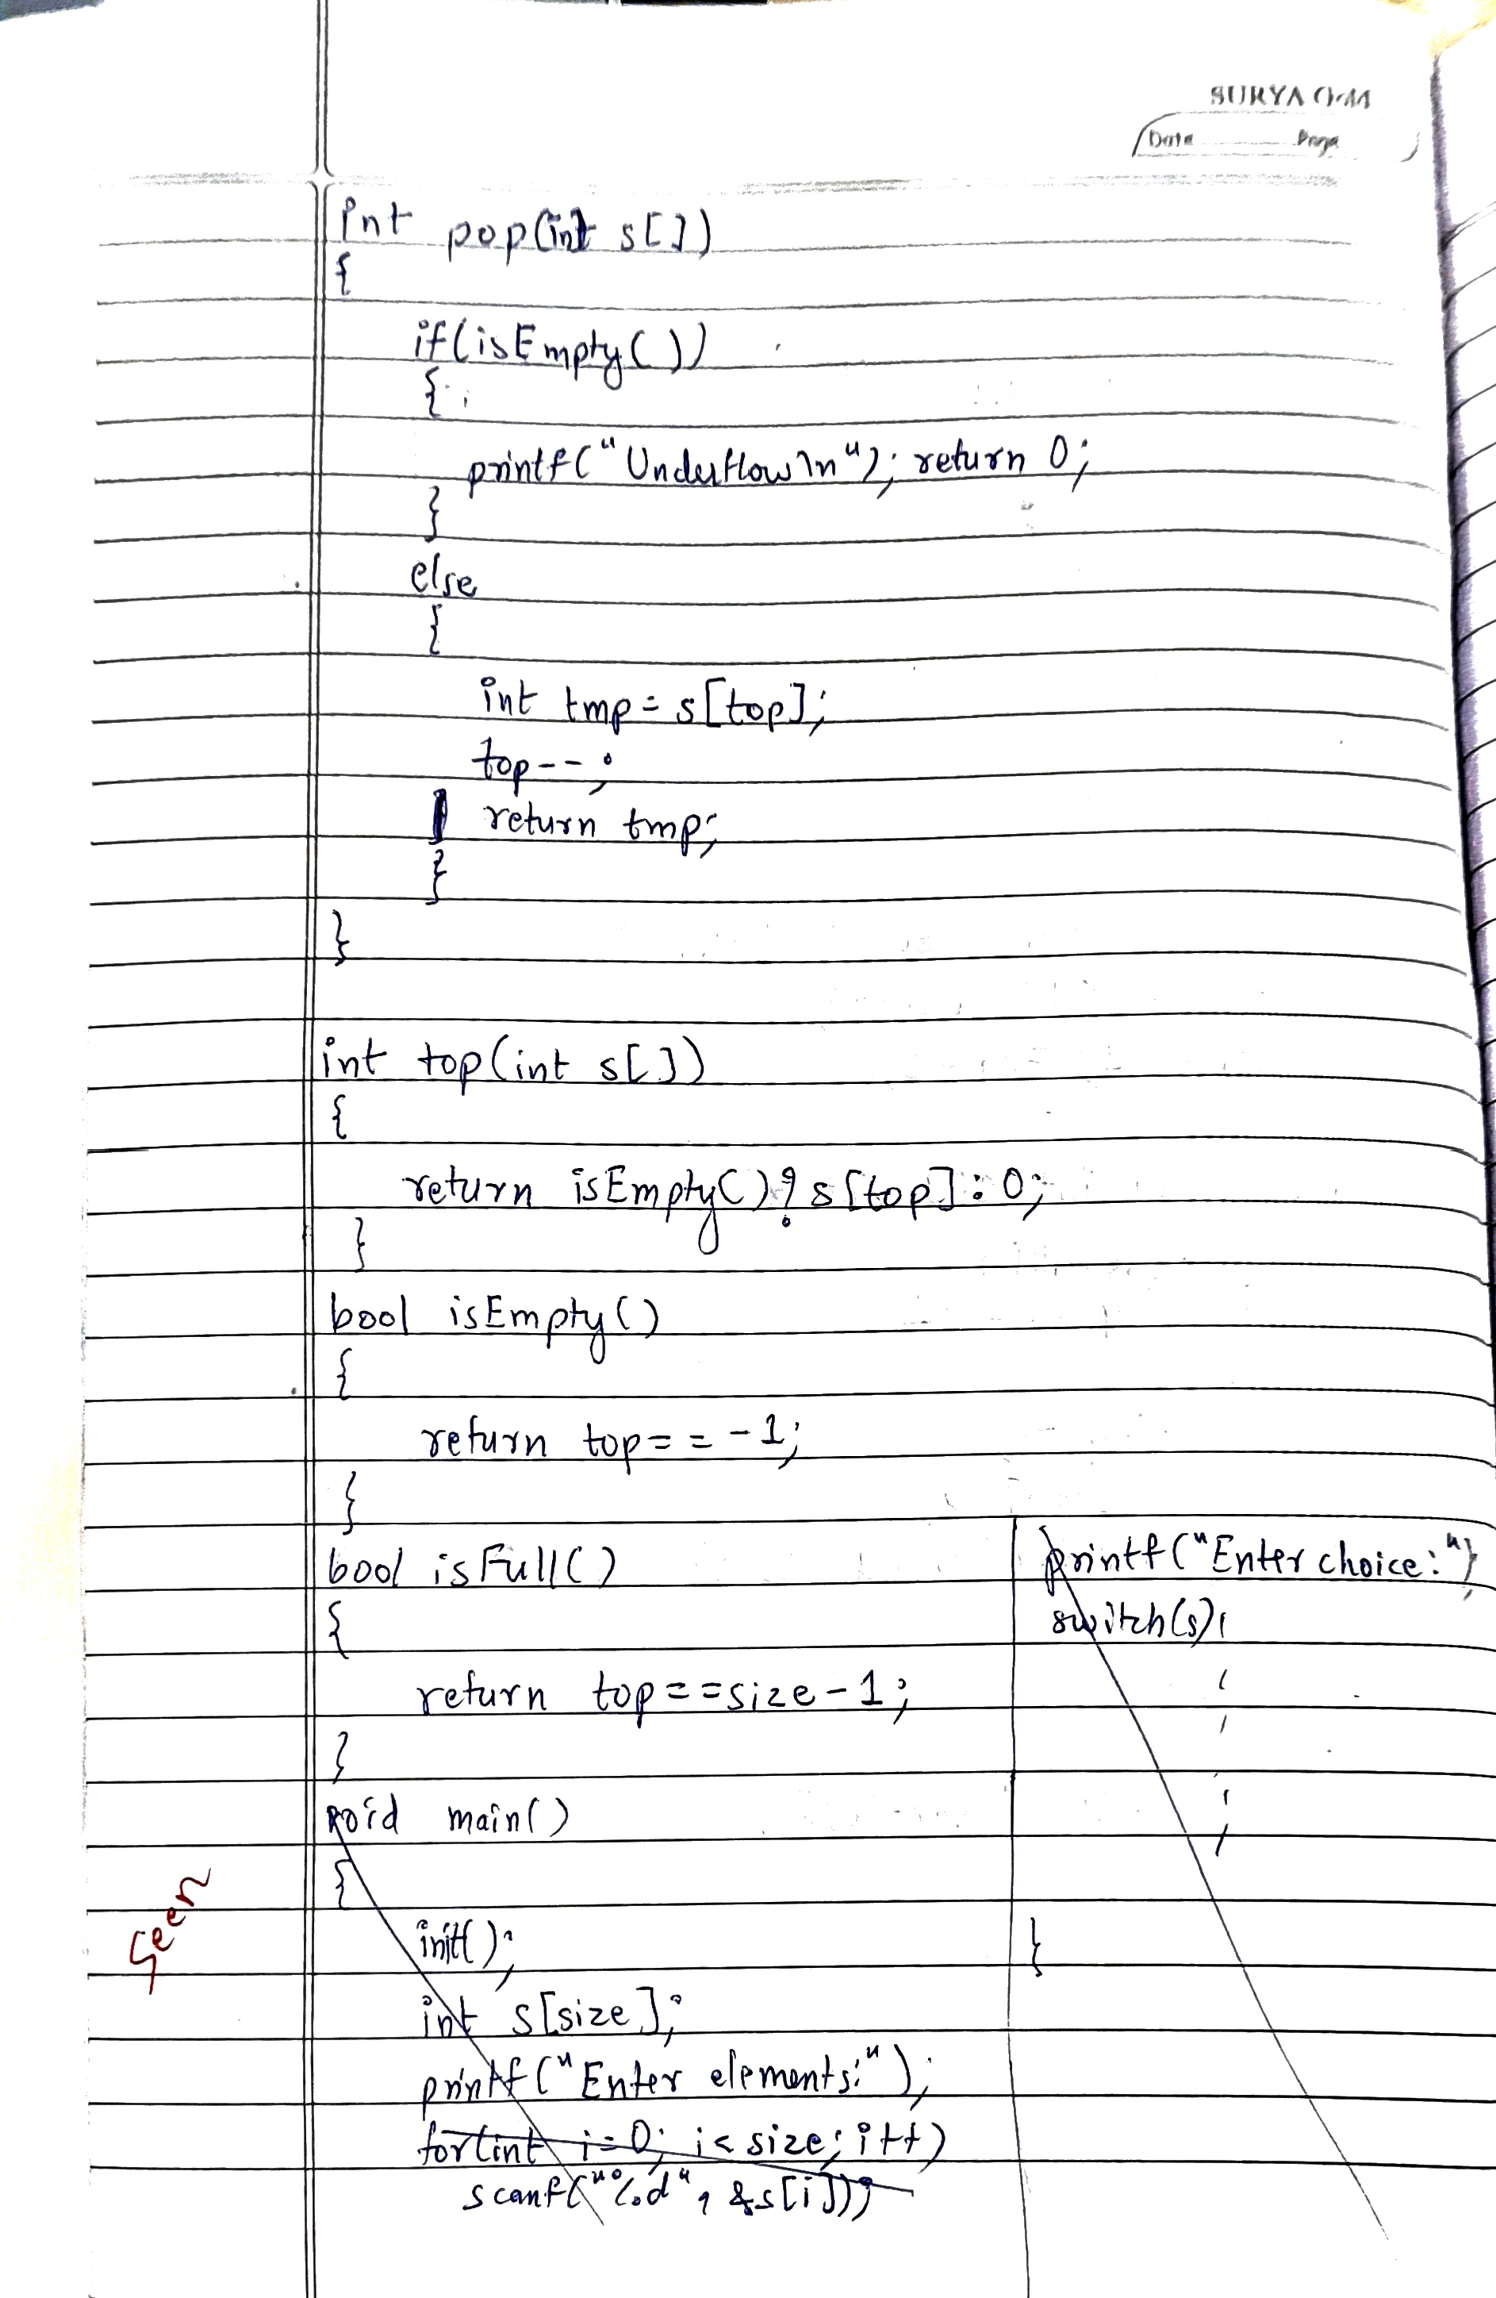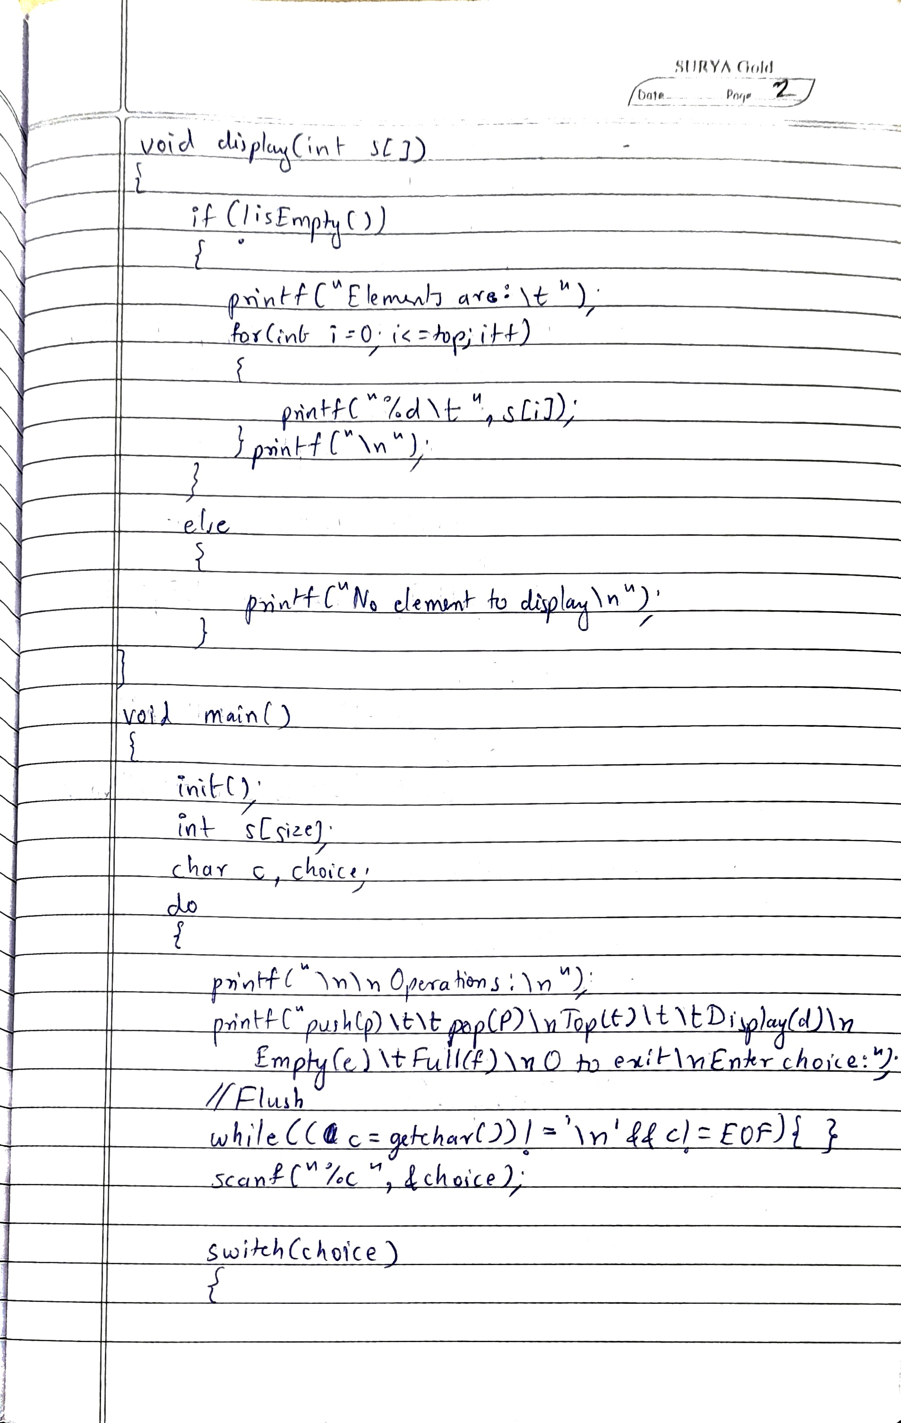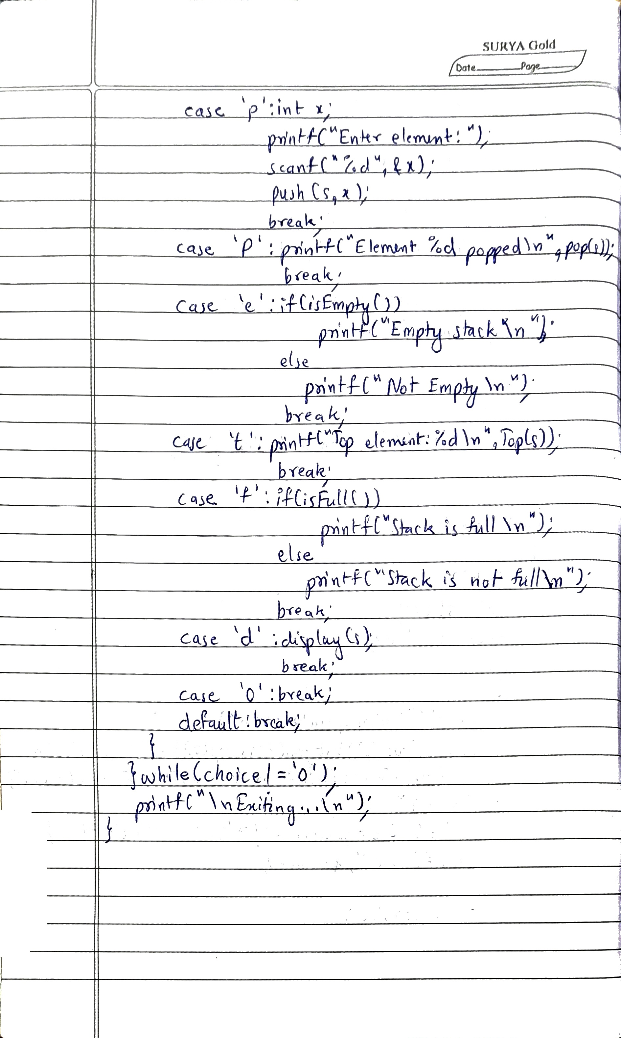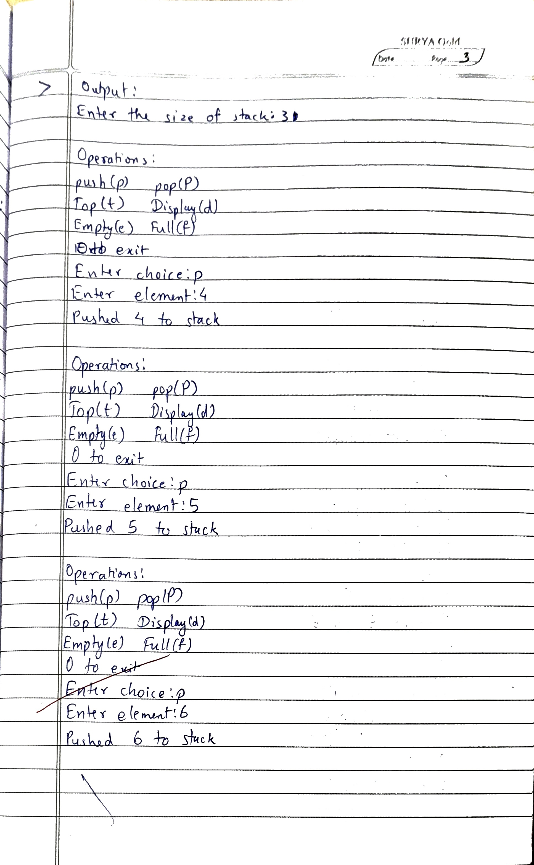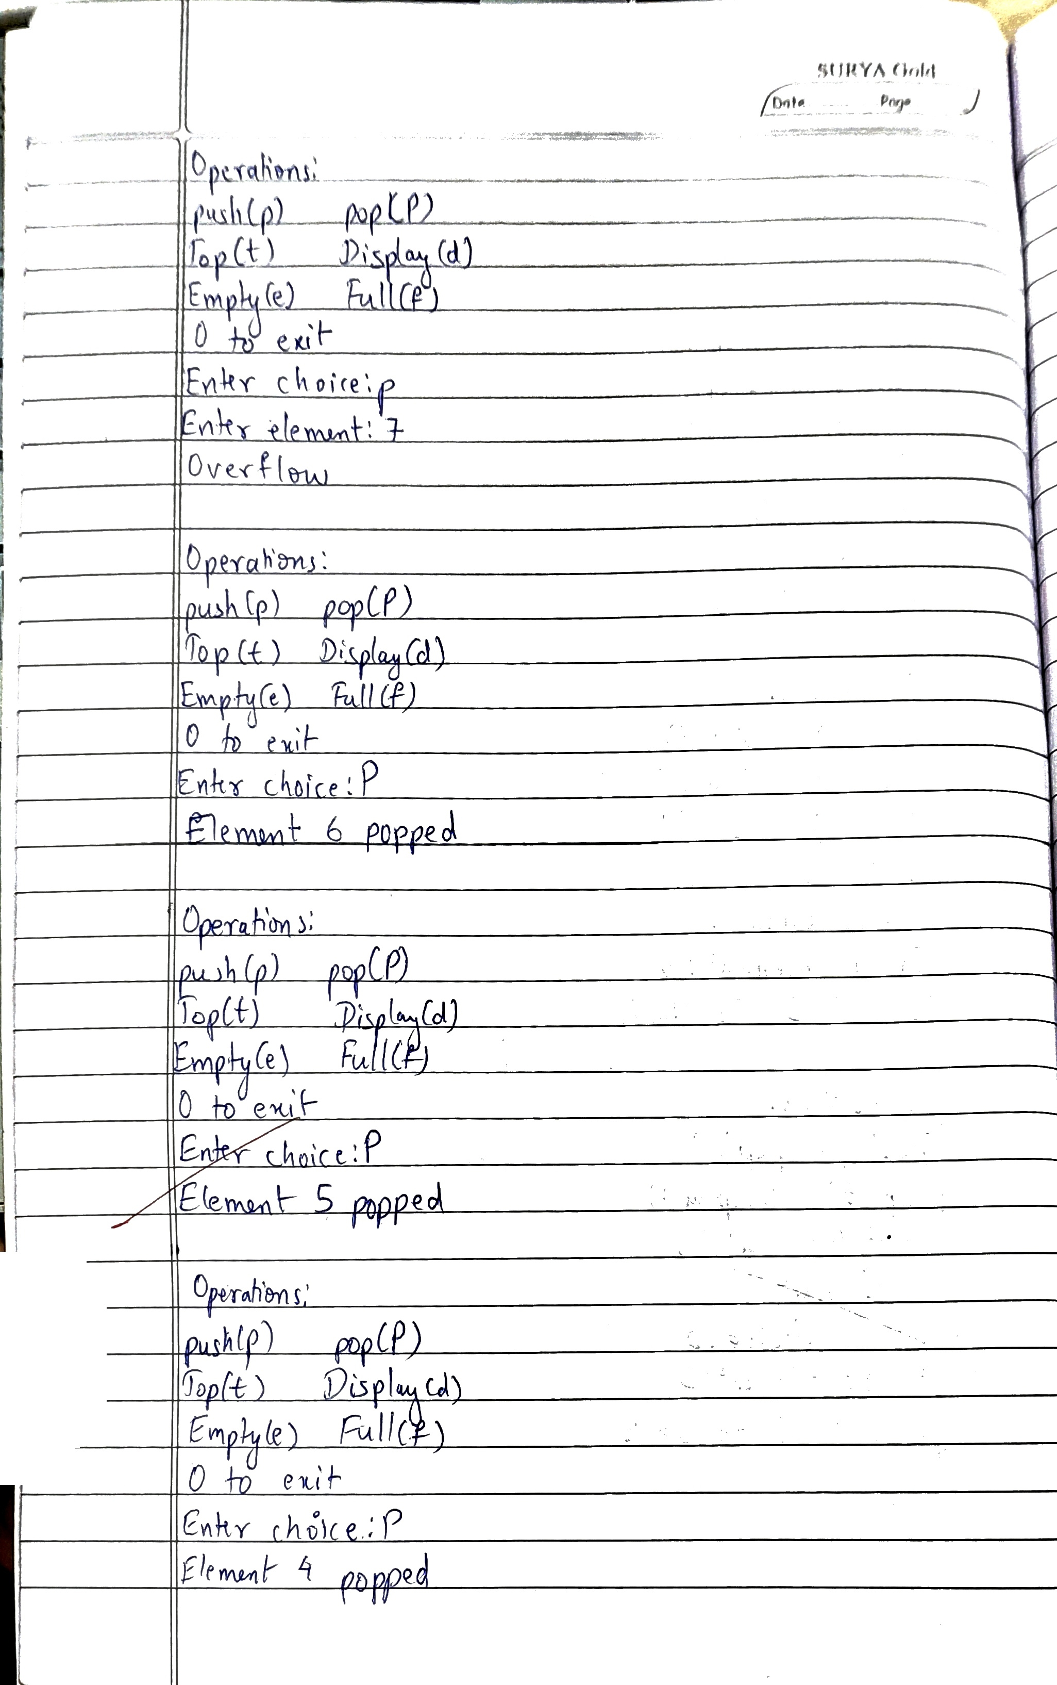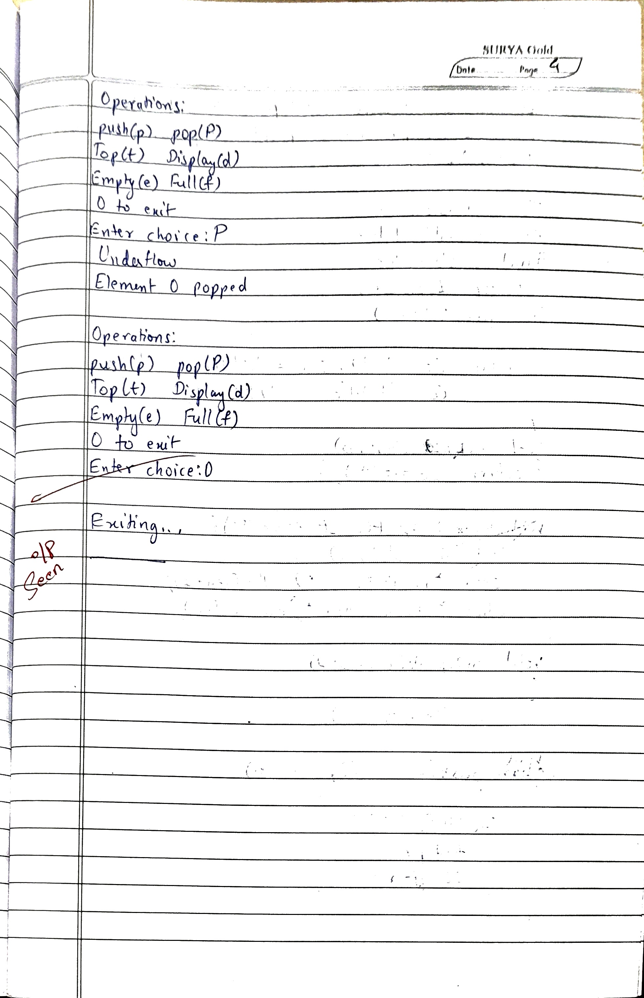

**Code:**

#include <stdbool.h>

#include <stdio.h>

int top, size;

void init()

{

printf("Enter the size of stack:");

scanf("%d",&size);

top=-1;

}

bool isEmpty()

{return top==-1;}

bool isFull()

{return top==size-1;}

void push(int s[], int x)

{

if(!isFull())

{

++top;

s[top]=x;

printf("Pushed %d to stack\n",x);

printf("%d",top);

}

else

{

printf("Overflow\n");

}

}

int pop(int s[])

{

if(isEmpty())

{

printf("Underflow\n");

return 0;

}

else

{

int tmp=s[top];

top--;

return tmp;

}

}

int Top(int s[])

{return s[top];}

void display(int s[])

{

if(!isEmpty())

{

printf("Elements are:\t");

for(int i=0;i<=top;i++)

printf("%d\t", s[i]);

printf("\n");

}

else

printf("No element to display\n");

}

void main()

{

init();

int s[size];

char choice, c;

do{

printf("\n\nOperations:\n");

printf("push(p)\t\tPop(P)\nTop(t)\t\tDisplay(d)\nEmpty(e)\tFull(f)\n0 to exit\nEnter choice:");

// Flush stdin

while ((c = getchar()) != '\n' && c != EOF) { }

// TODO input here

scanf("%c",&choice);

switch(choice)

{

case 'p':int x;

printf("Enter element:");

scanf("%d",&x);

push(s,x);

break;

case 'P':printf("Element %d popped\n",pop(s));

break;

case 'e':if(isEmpty())

printf("Empty Stack\n");

else

printf("Not Empty\n");

break;

case 't':printf("Top element:%d\n",Top(s));

break;

case 'f':if(isFull())

printf("Stack is full\n");

else

printf("Stack is not full\n");

break;

case 'd':display(s);

break;

case '0': break;

default: break;

}

}while(choice!='0');

printf("\nExiting...\n");

}

**OUTPUT**

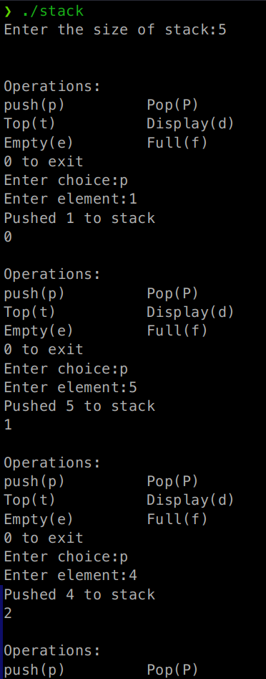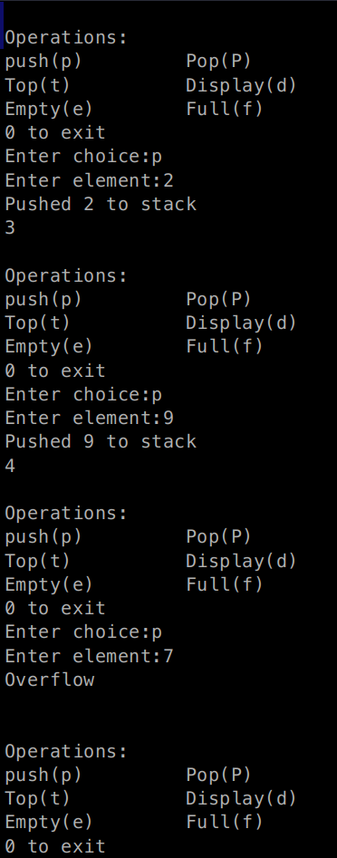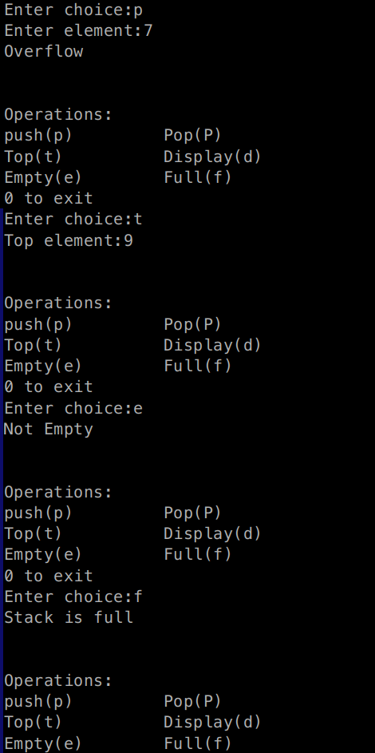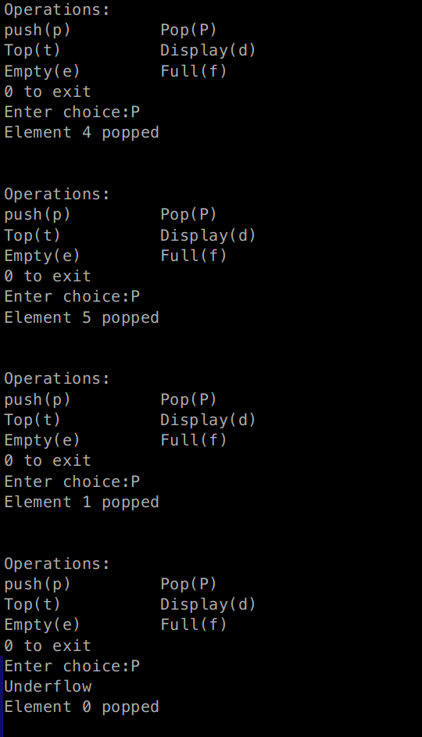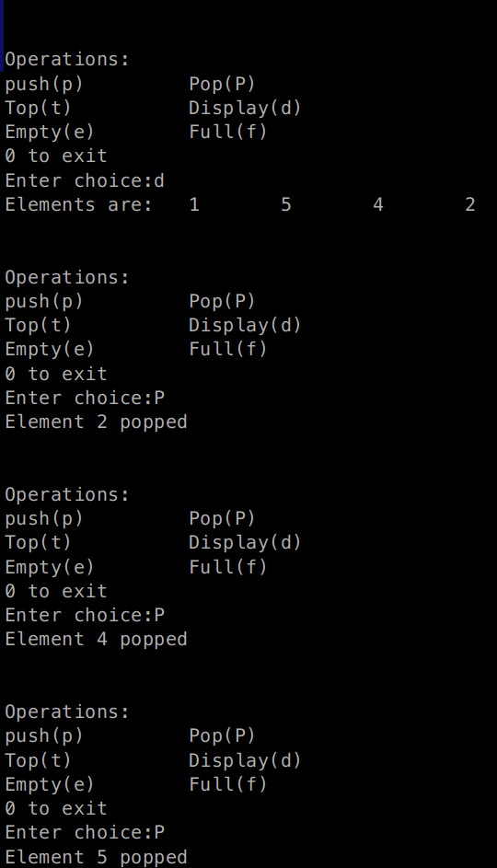

**Program 2**

WAP to convert a given valid parenthesized infix arithmetic expression to postfix expression. The expression consists of single character operands and the binary operators + (plus), - (minus), * (multiply) and / (divide).

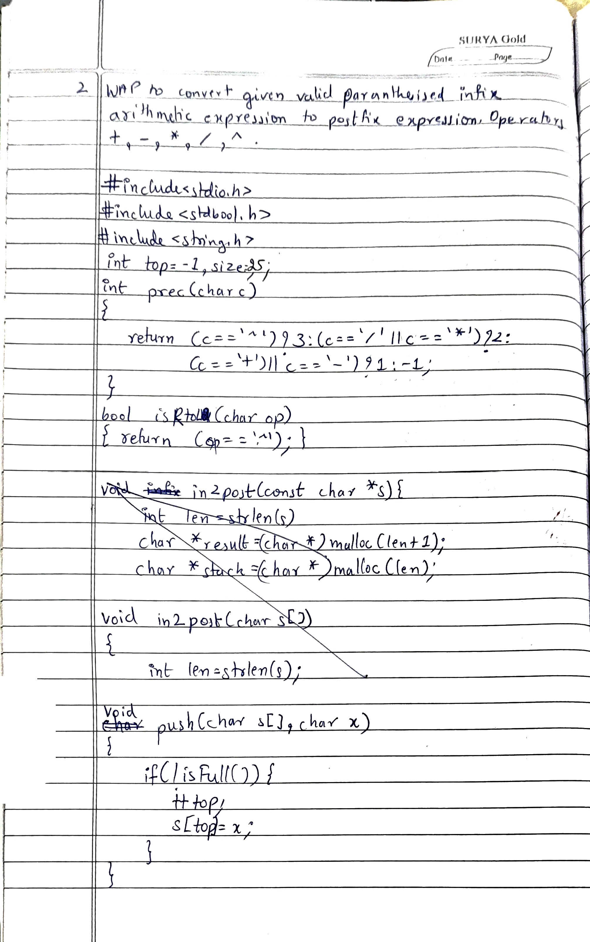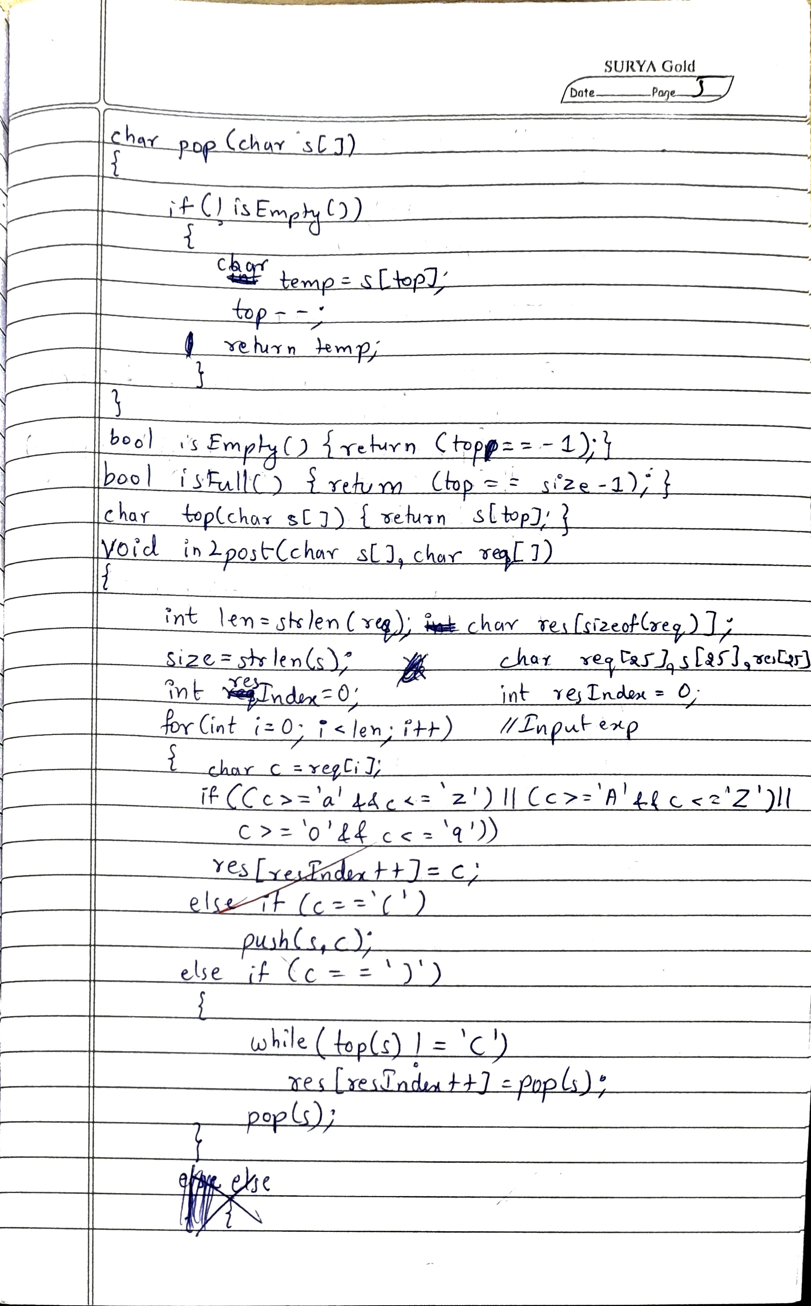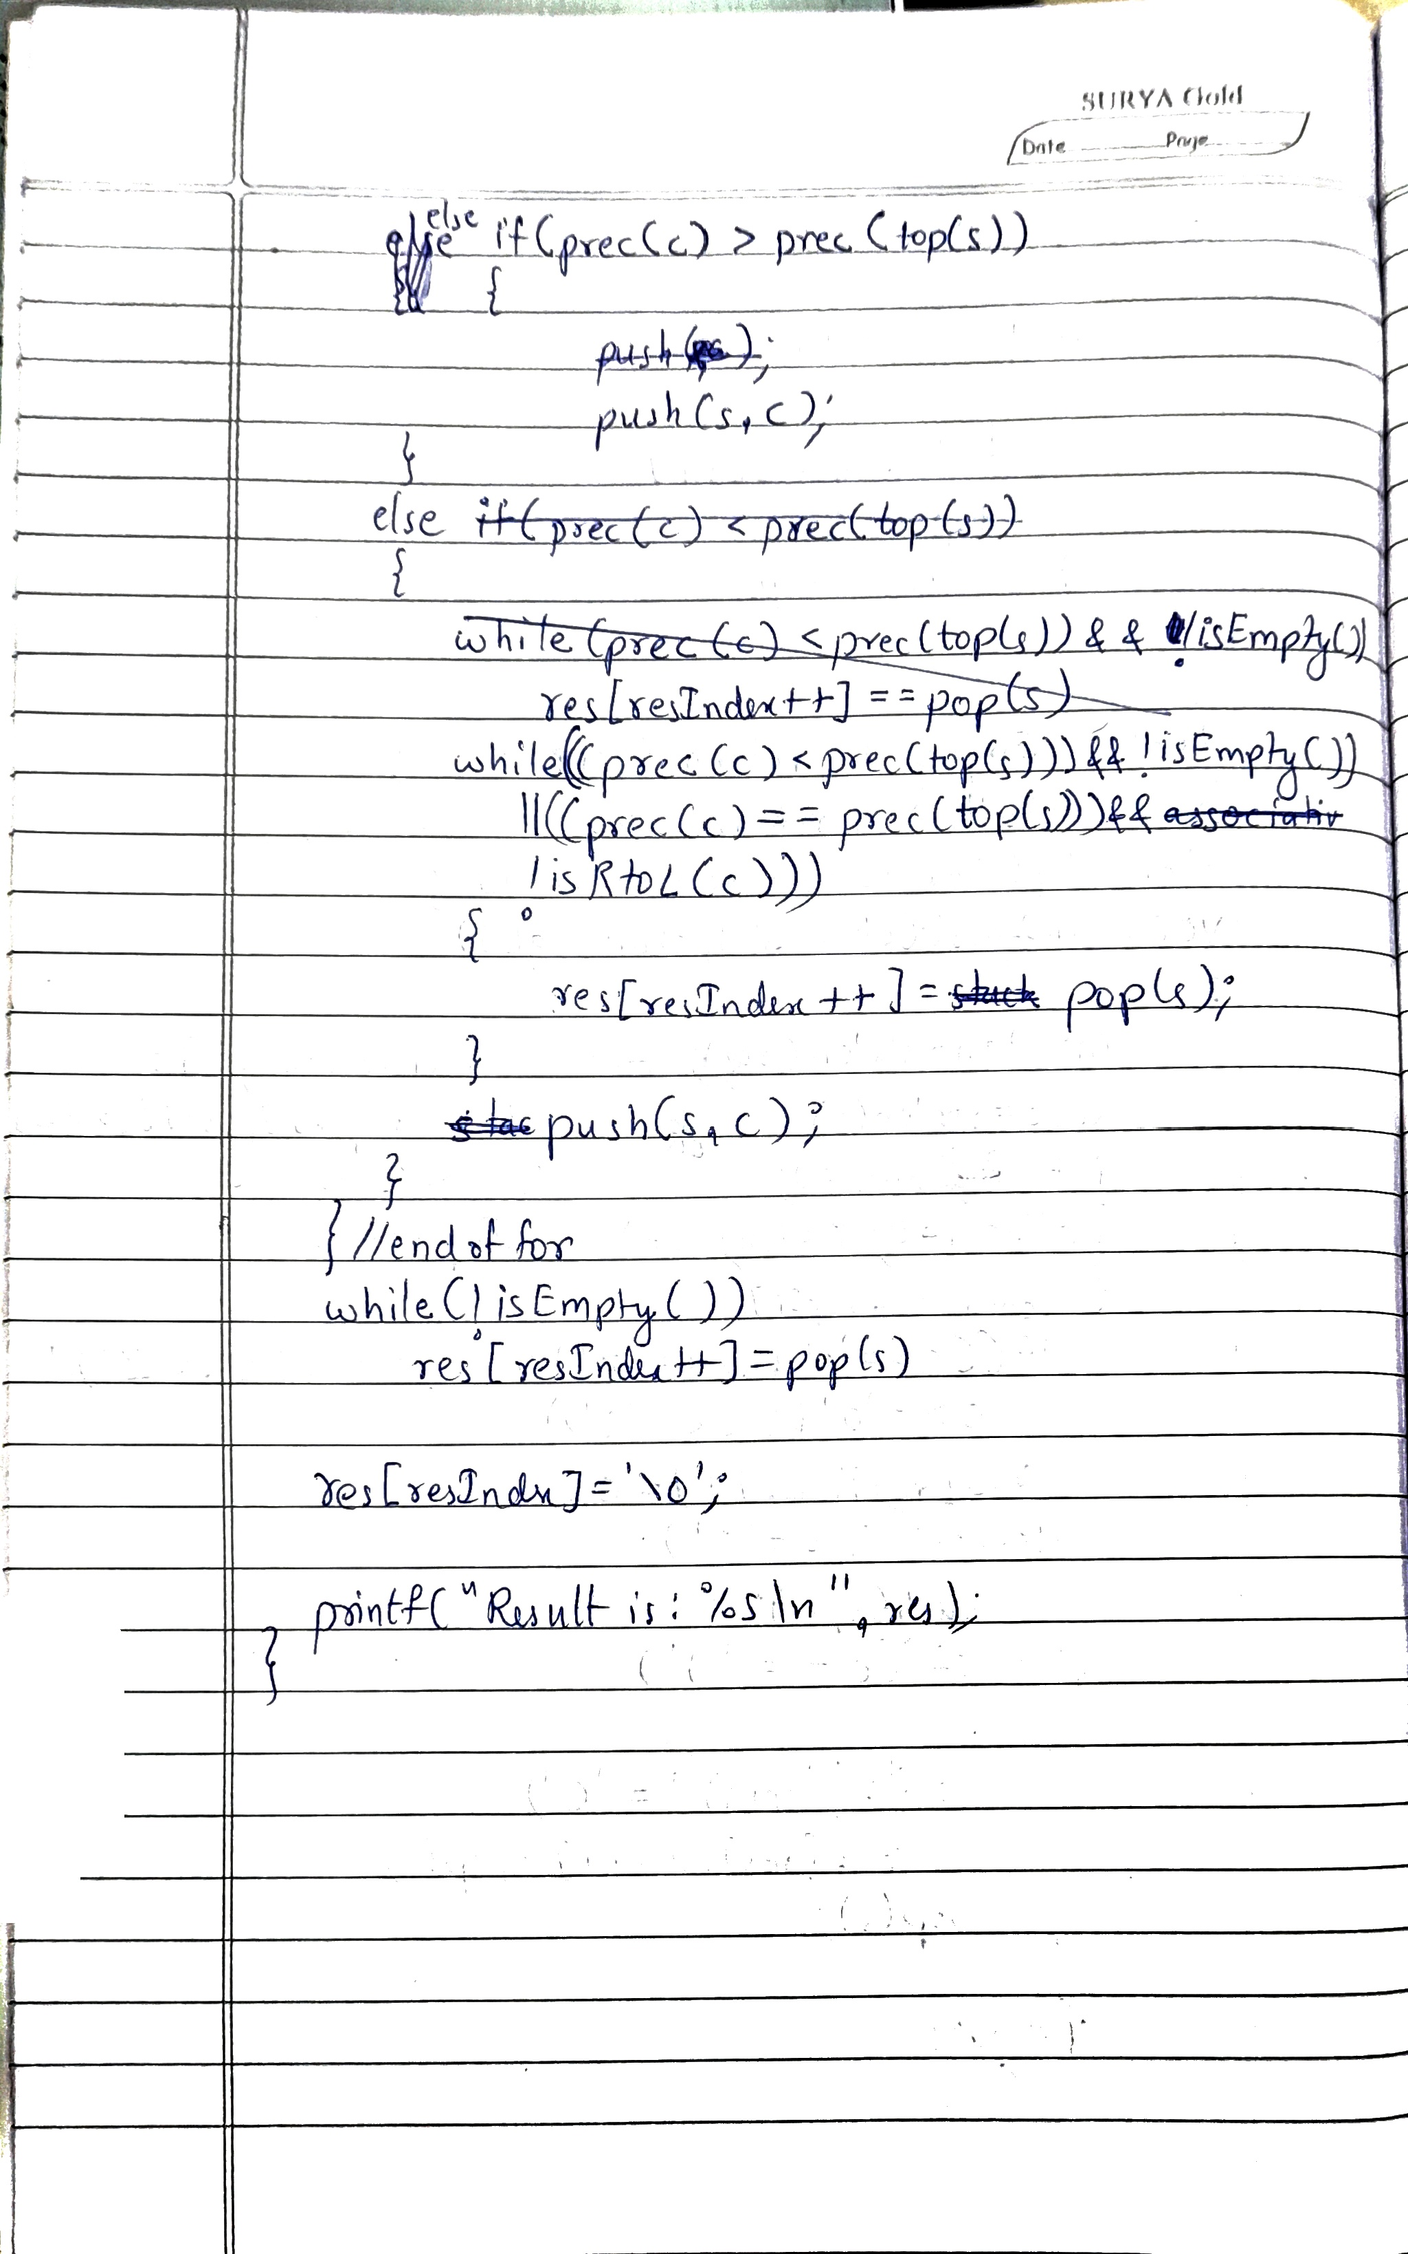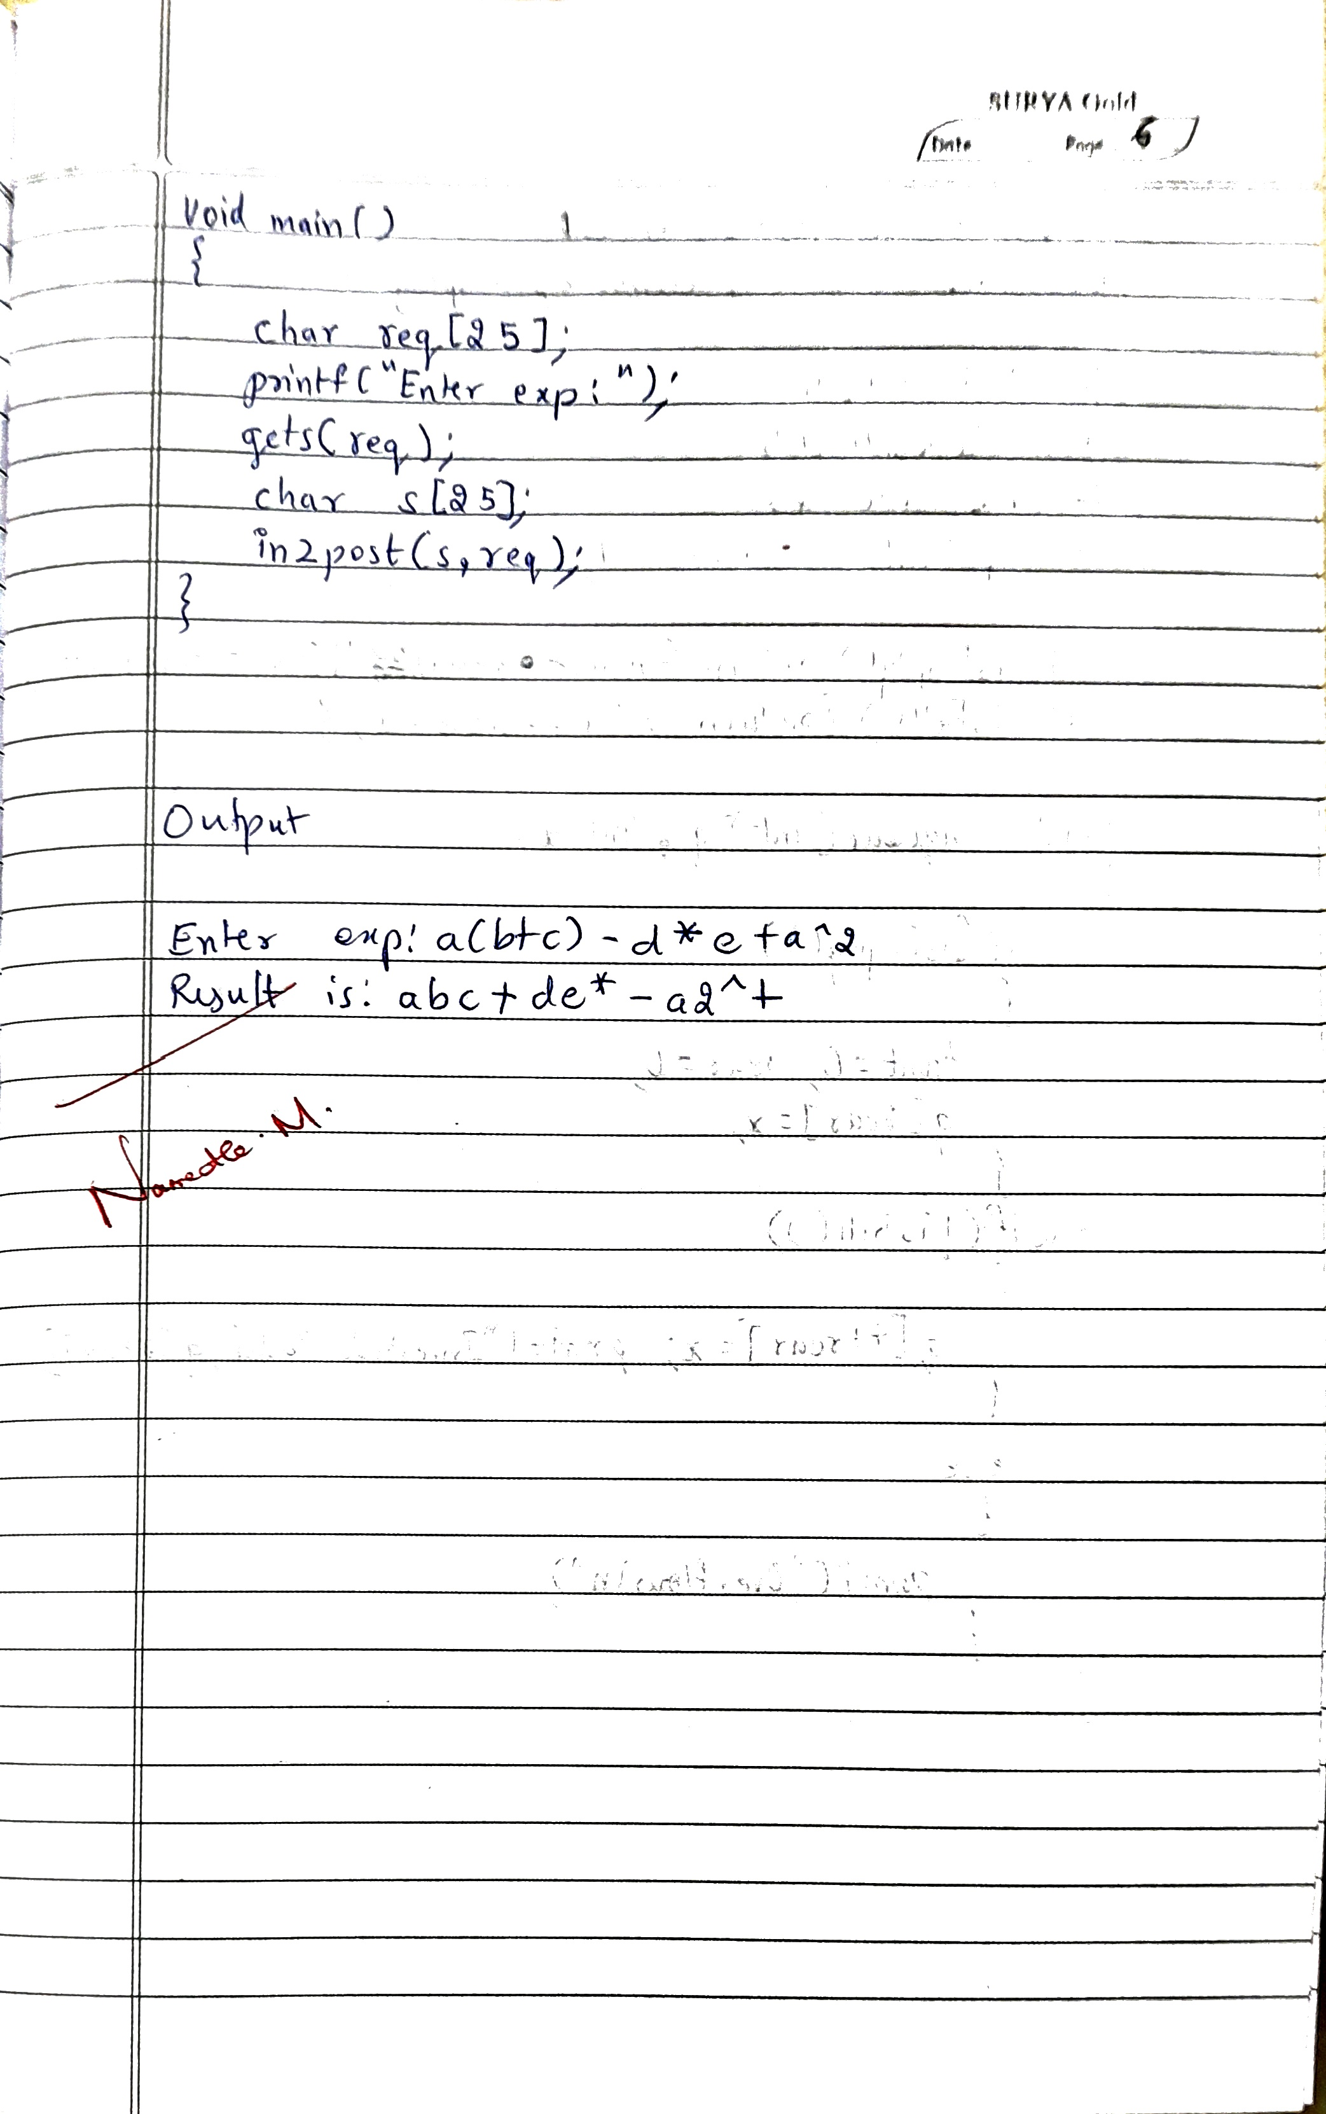

**Code:**

#include <stdio.h>

#include <stdbool.h>

#include <string.h>

int top=-1, size=25;

int prec(char c){

return (c=='^')?3:(c=='/'||c=='*')?2:(c=='+'||c=='-')?1:-1;

}

bool isEmpty(){return (top==-1);}

bool isFull(){return (top==size-1);}

bool isRtoL(char op){return (op=='^');}

char Top(char s[]){if (!isEmpty()) {

return s[top];

}

return '\0'; }

void push(char s[], char x)

{

if (!isFull()) {

++top;

s[top] = x;

}

}

char pop(char s[]){

if (!isEmpty()) {

return s[top--];

}

return '\0';

}

void in2post(){

char req[25];

char s[25]; // Stack for operators

char res[25]; // Result array

int resIndex = 0;

printf("Enter expression: ");

fgets(req, sizeof(req), stdin);

int len = strlen(req);

memset(res, 0, sizeof(res)); // Clear result array

for (int i = 0; i < len; i++) {

char c = req[i];

if ((c >= 'a' && c <= 'z') || (c >= 'A' && c <= 'Z') || (c >= '0' && c <= '9')) {

res[resIndex++] = c; // Append operand to result

} else if (c == '(') {

push(s, c); // Push '(' to stack

} else if (c == ')') {

while (!isEmpty() && Top(s) != '(') {

res[resIndex++] = pop(s);

}

pop(s); // Pop '(' from stack

} else if (prec(c) > prec(Top(s))) {

push(s, c); // Push operator to stack

} else {

while (!isEmpty() && ((prec(c) < prec(Top(s))) || (prec(c) == prec(Top(s)) && !isRtoL(c)))) {

res[resIndex++] = pop(s);

}

push(s, c);

}

}

// Clear stack

while (!isEmpty()) {

res[resIndex++] = pop(s);

}

res[resIndex] = '\0'; // Null-terminate the result string

printf("Result: %s\n", res);

}

void main()

{

in2post();

}

**OUTPUT**

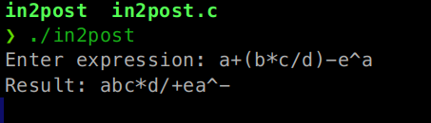

**Program 3:**

3a) WAP to simulate the working of a queue of integers using an array. Provide the following operations: Insert, Delete, Display The program should print appropriate messages for queue

empty and queue overflow conditions.

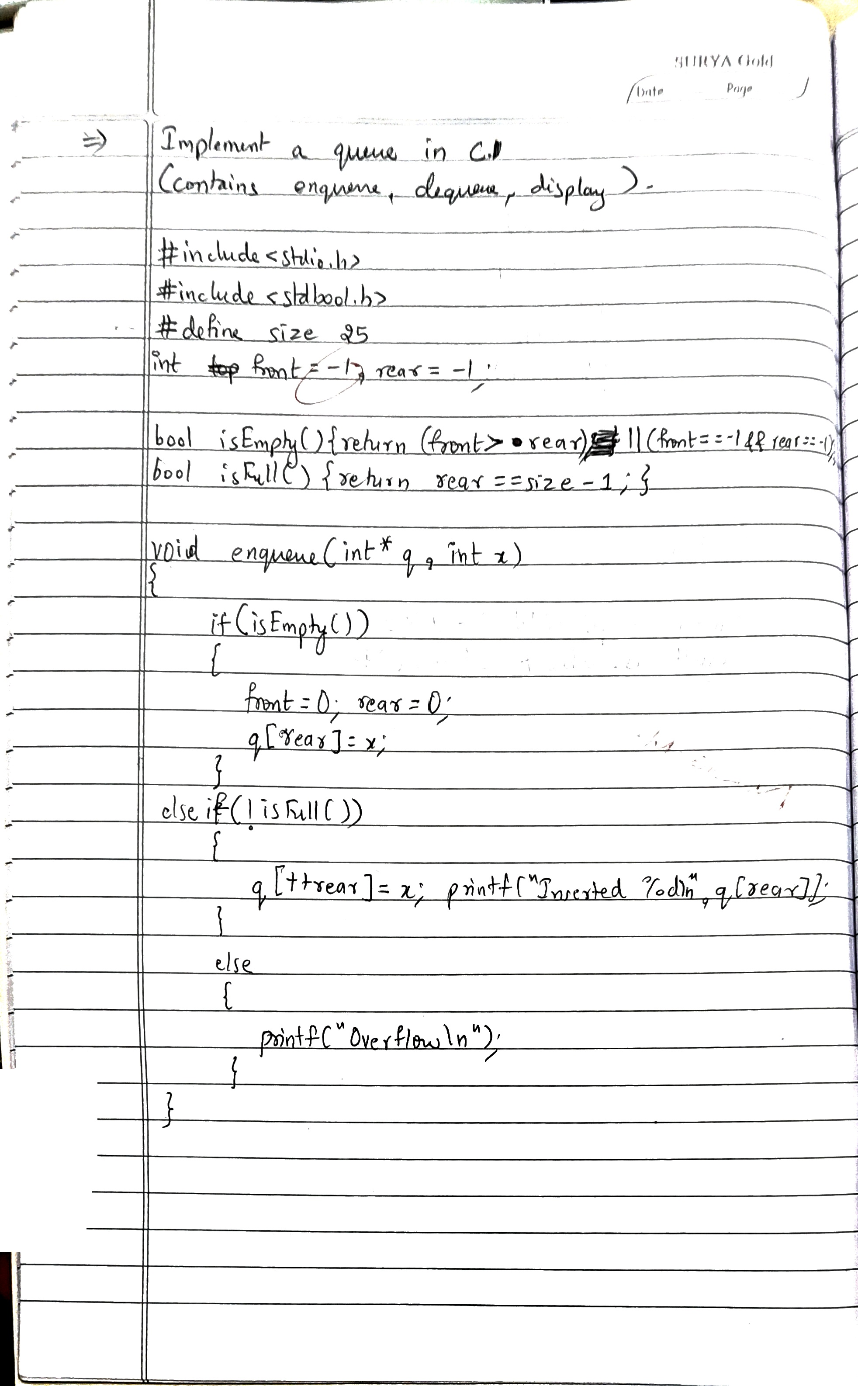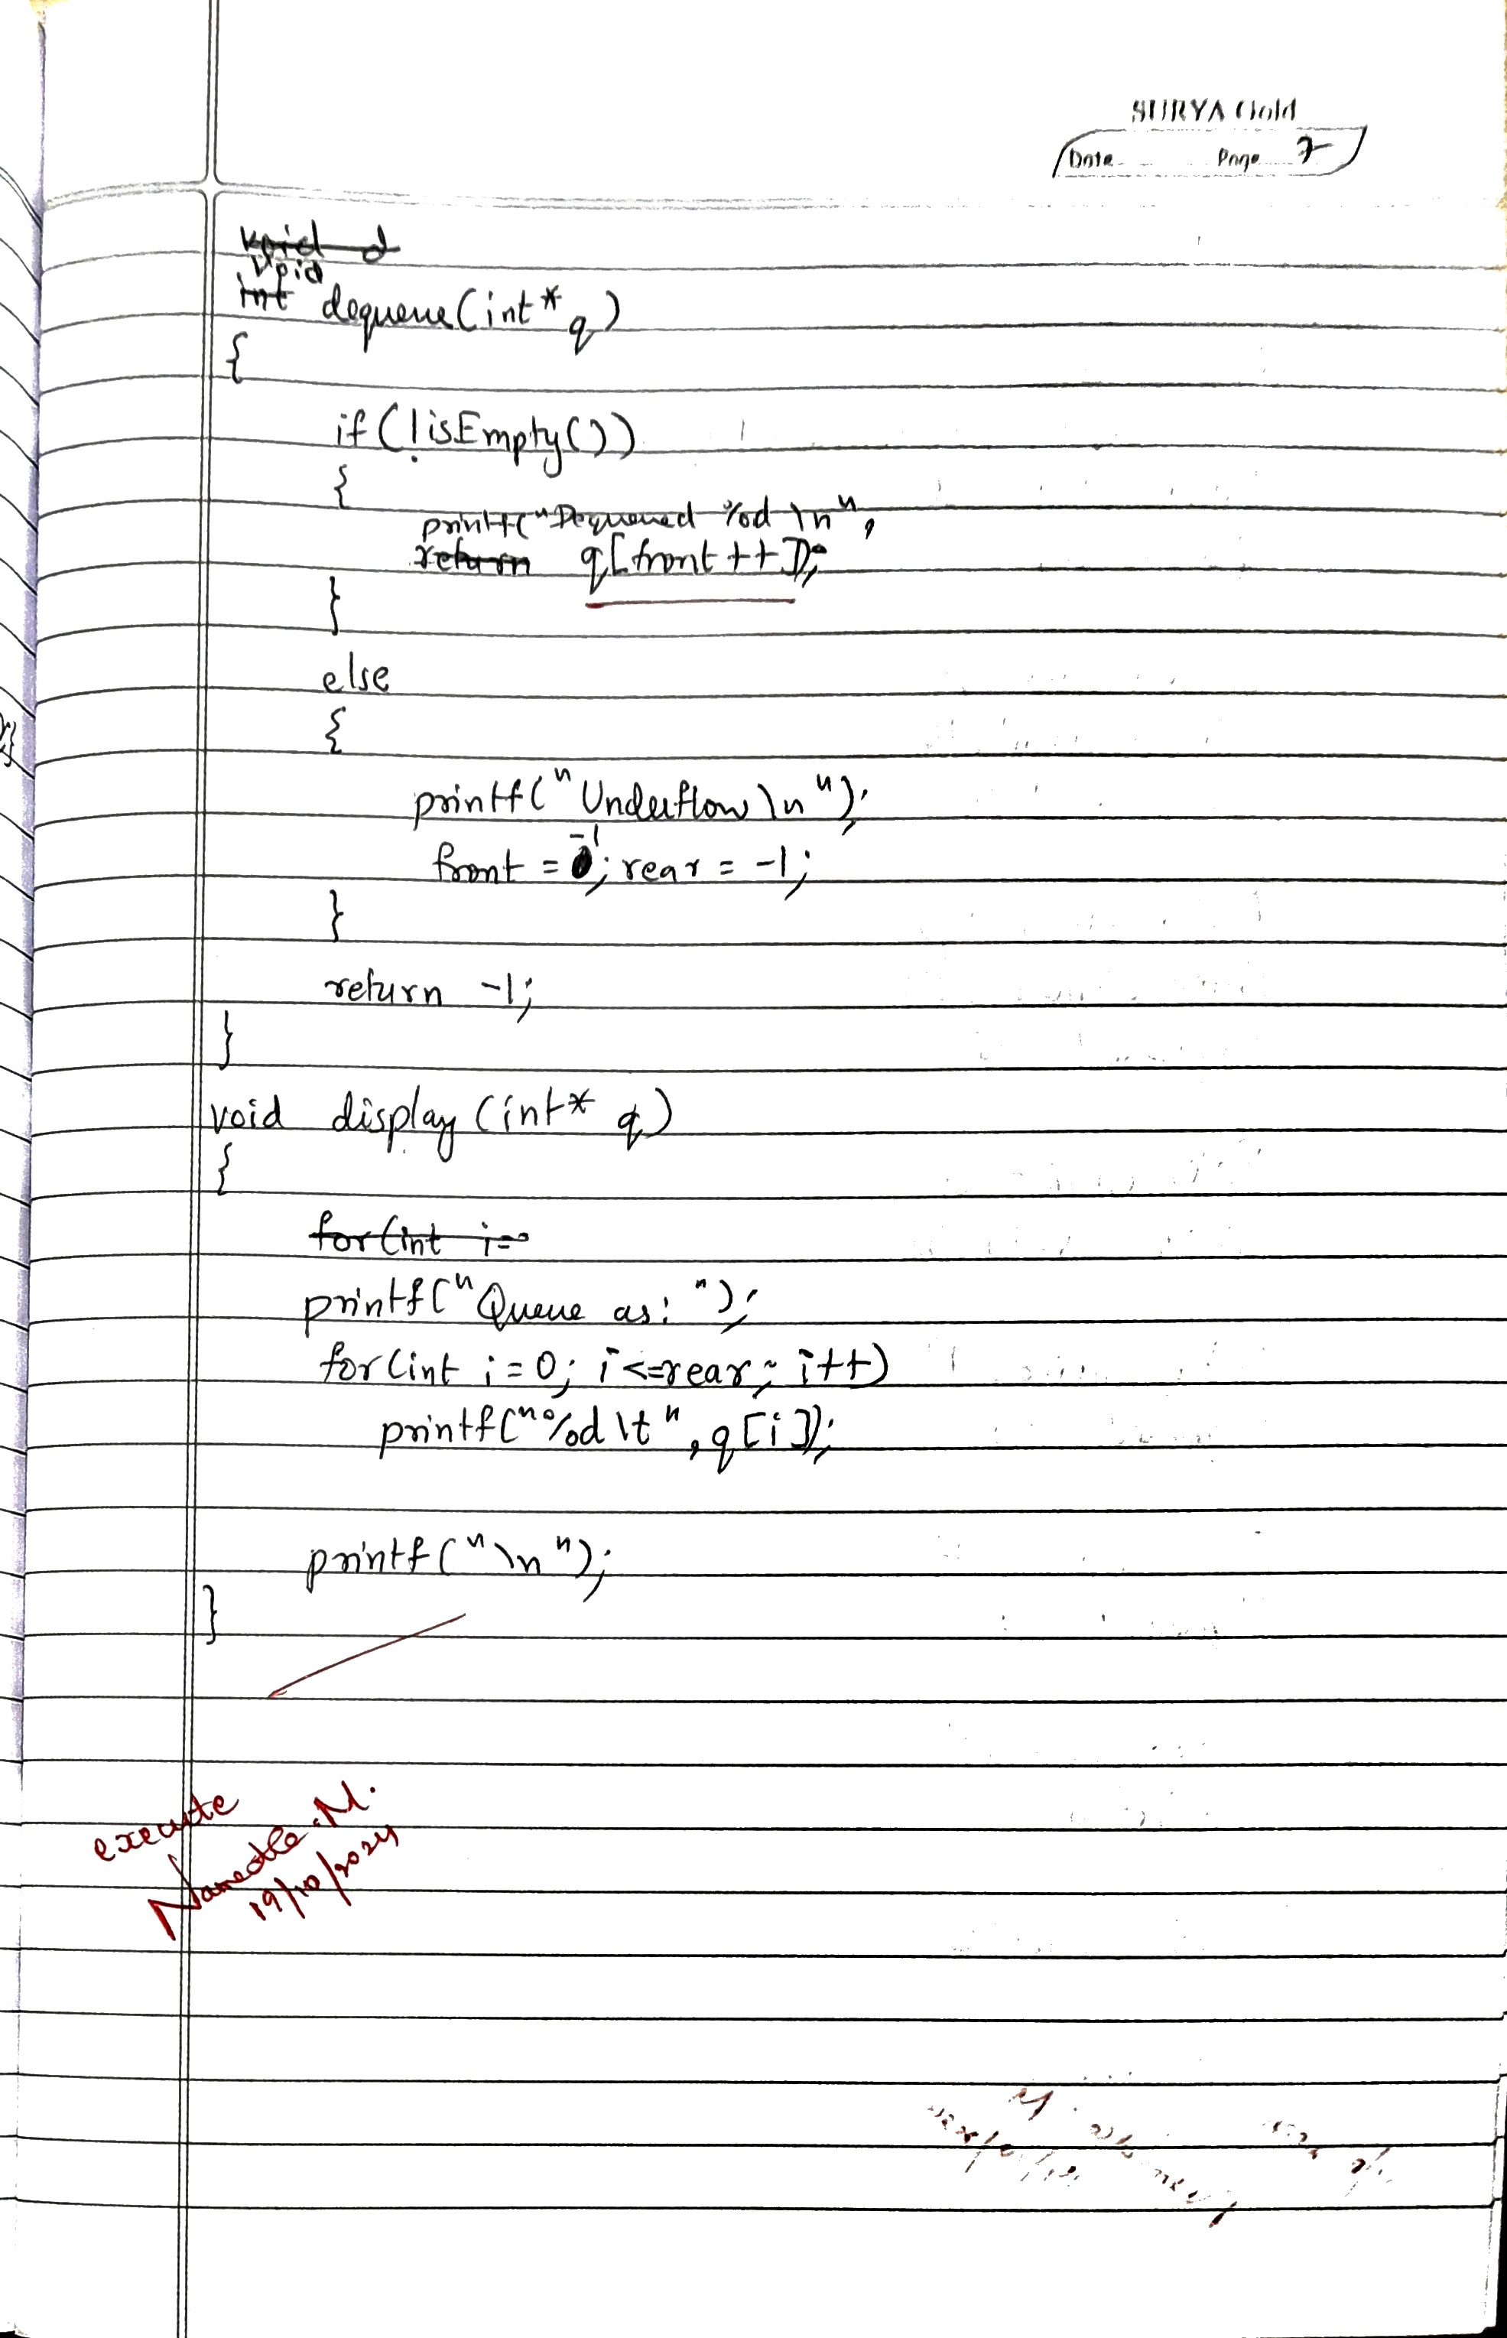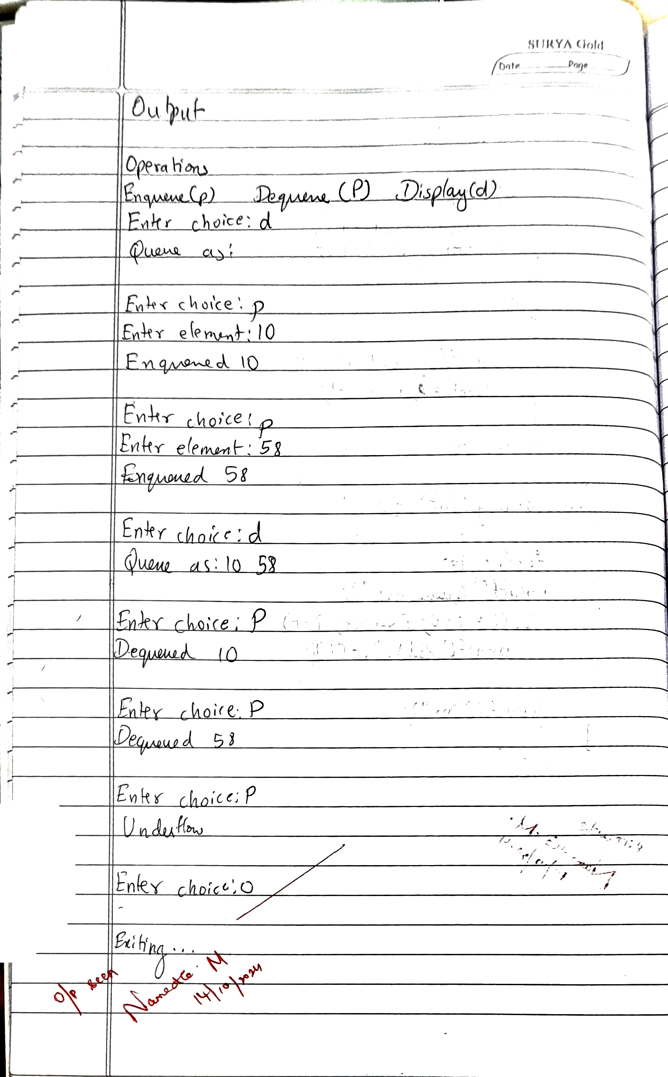

**Code:**

#include <stdio.h>

#include <stdbool.h>

#define size 5

int front=-1, rear=-1;

bool isEmpty(){return (front>rear)||(front==-1&&rear==-1);}

bool isFull(){return rear==size-1;}

void enqueue(int* q, int x)

{

if(isEmpty())

{

front=0; rear=0;

q[rear]=x;

}

else if(!isFull())

{

q[++rear]=x;

printf("Enqueued %d\n",q[rear]);

}

else

{

printf("Overflow\n");

}

}

void dequeue(int* q)

{

if(!isEmpty())

{

printf("Dequeued %d\n", q[front++]);

}

else

{

printf("Underflow\n");

front=-1;rear=-1;

}

}

void display(int* q)

{

printf("Queue as:");

for(int i=0;i<=rear;i++)

printf("%d\t",q[i]);

printf("\n");

}

void main()

{

int q[size];

char choice, c;

printf("\n\nOperations:\n");

printf("Enqueue(p)\t\tDequeue(P)\t\tDisplay(d)\n0 to exit\n");

do{

// TODO input here

printf("\nEnter choice:");

scanf("%c",&choice);

switch(choice)

{

case 'p':int x;

printf("Enter element:");

scanf("%d",&x);

enqueue(q,x);

break;

case 'P':dequeue(q);

break;

case 'e':if(isEmpty())

printf("Empty Stack\n");

else

printf("Not Empty\n");

break;

case 'f':if(isFull())

printf("Stack is full\n");

else

printf("Stack is not full\n");

break;

case 'd':display(q);

break;

case '0': break;

default: break;

}

// Flush stdin

if((c=getchar())=='\n'||c==EOF){}

}while(choice!='0');

printf("\nExiting...\n");

}

**OUTPUT**

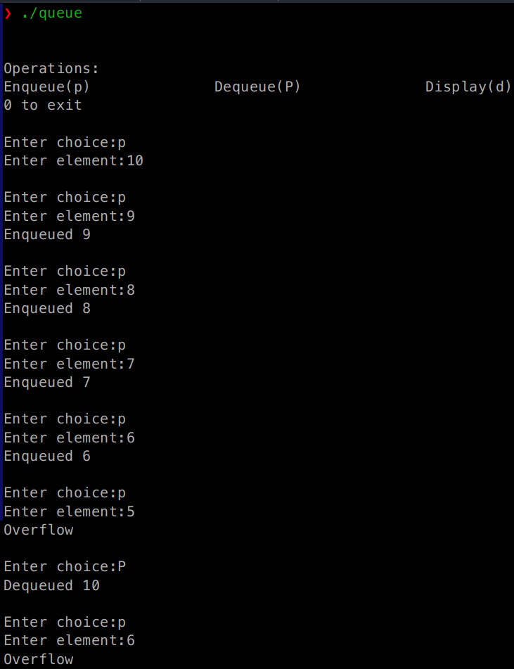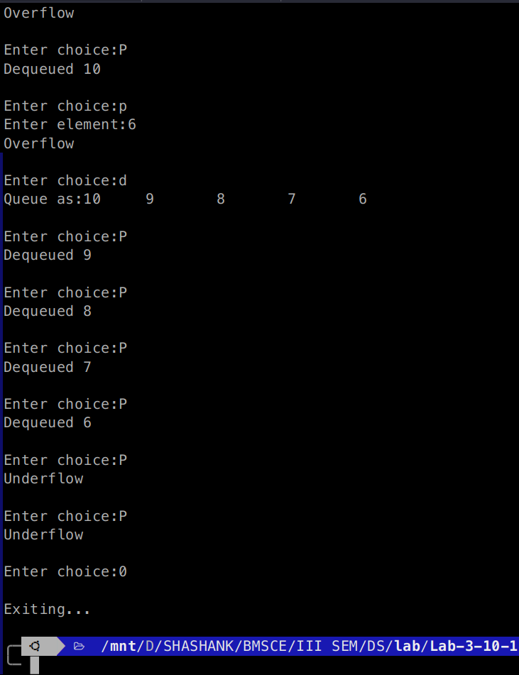

3b ) WAP to simulate the working of a circular queue of integers using an array. Provide the following operations: Insert, Delete & Display. The program should print appropriate messages for queue empty and queue overflow conditions.

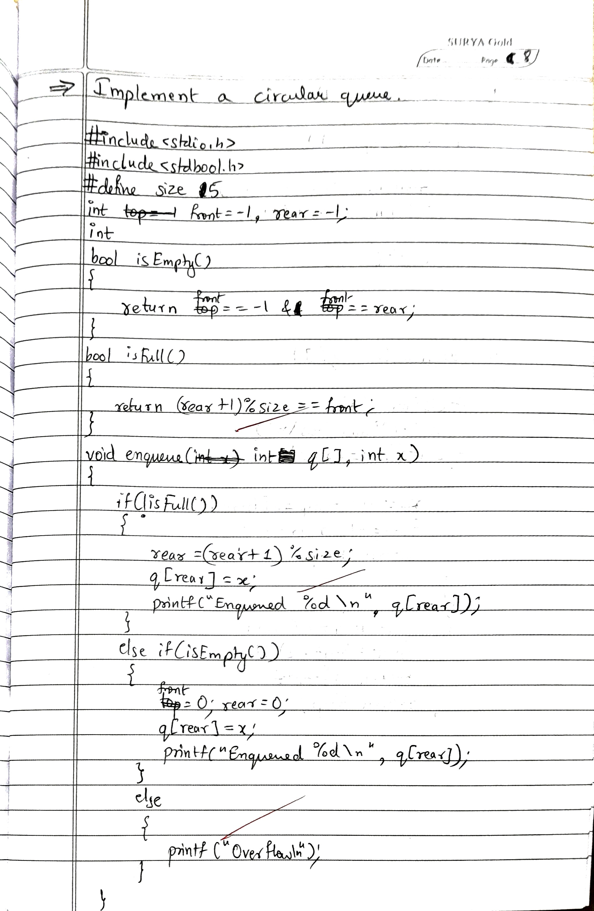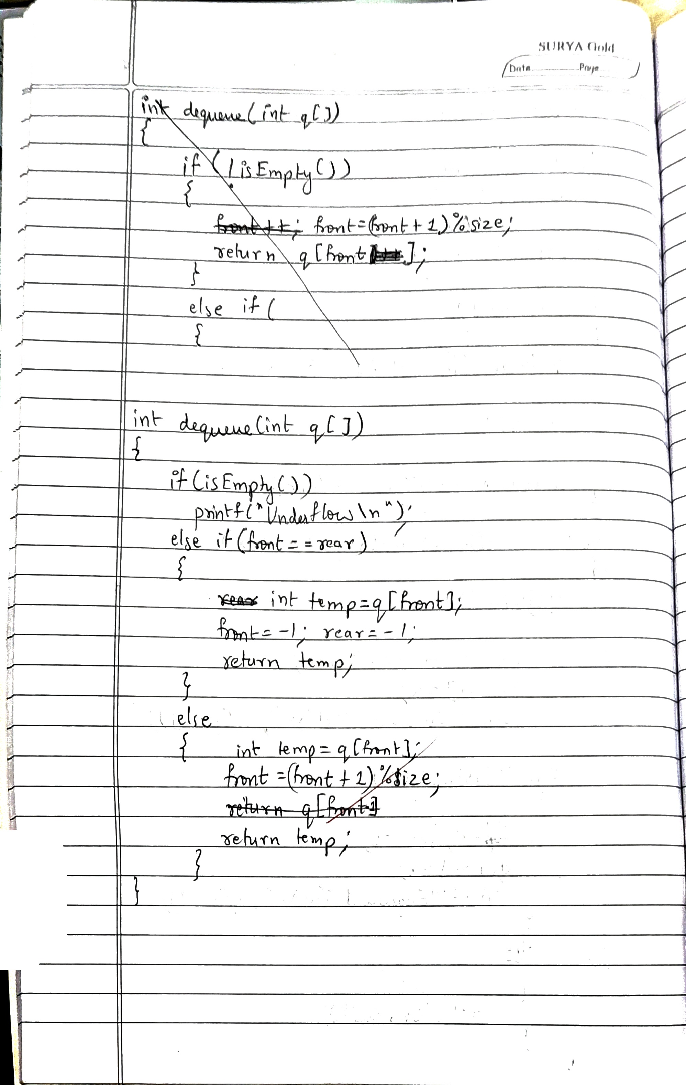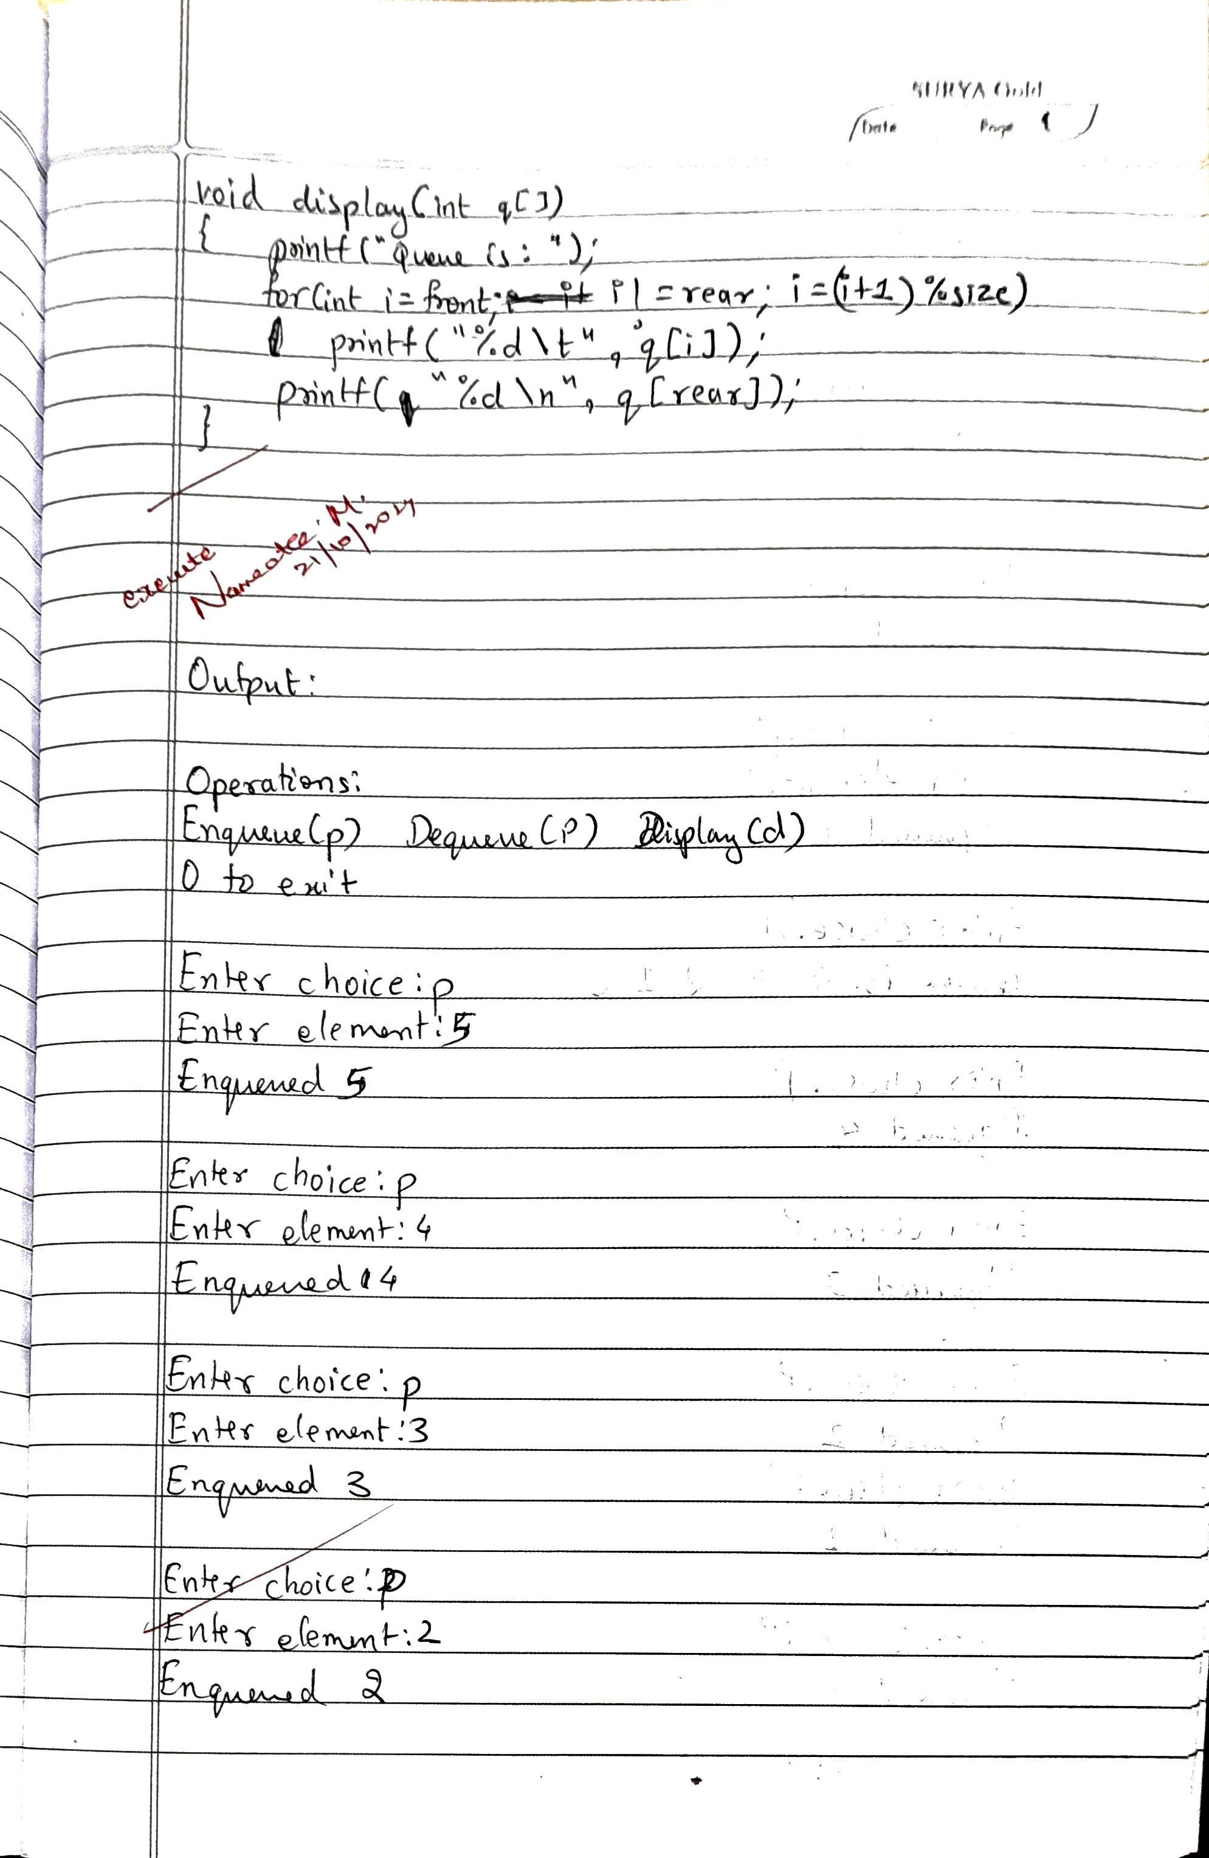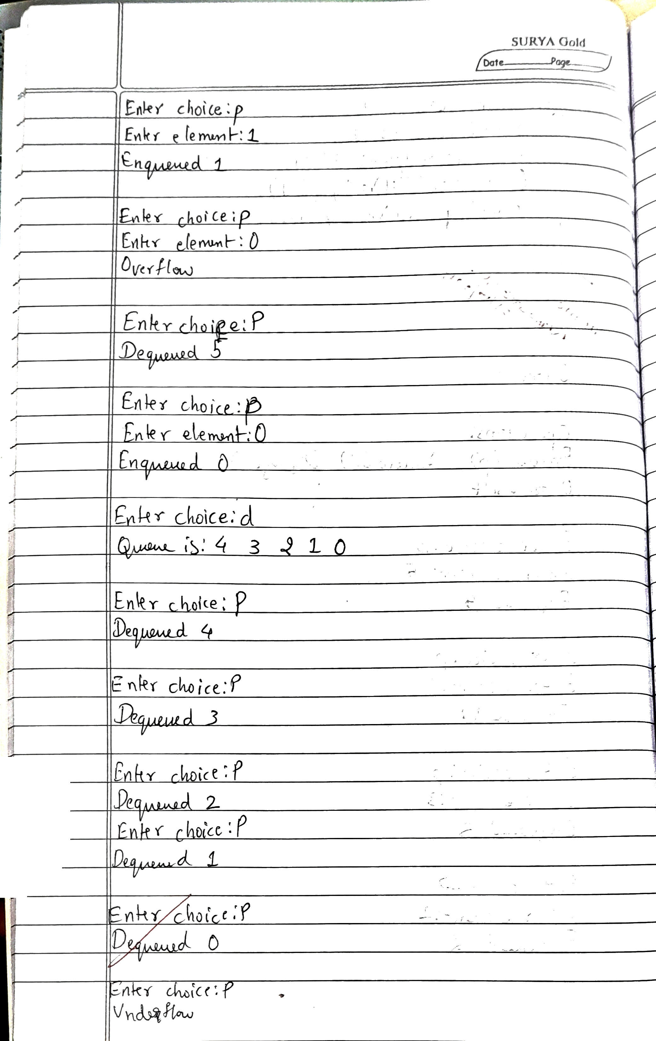

**Code:**

#include <stdio.h>

#include <stdbool.h>

#define size 5

int front=-1, rear=-1;

bool isEmpty(){return front==-1&rear==front;}

bool isFull(){return (rear+1)%size==front;}

void enqueue(int q[], int x)

{

if(isEmpty())

{

front=0; rear=0;

q[rear]=x;

printf("Enqueued %d\n",q[rear]);

}

else if(!isFull())

{

rear=(rear+1)%size;

q[rear]=x;

printf("Enqueued %d\n",q[rear]);

}

else

{

printf("Overflow\n");

}

}

int dequeue(int q[])

{

if(isEmpty())

{

printf("Underflow\n");

}

else if(front==rear)

{

int temp=q[front];

front=-1;rear=-1;

return temp;

}

else

{

int temp=q[front];

front=(front+1)%size;

return temp;

}

}

void display(int* q)

{

printf("Queue is:");

for(int i=front;i!=rear;i=(i+1)%size)

printf("%d\t",q[i]);

printf("%d\n",q[rear]);

}

void main()

{

int q[size];

char choice, c;

printf("\n\nOperations:\n");

printf("Enqueue(p)\t\tDequeue(P)\t\tDisplay(d)\n0 to exit\n");

do{

// TODO input here

printf("\nEnter choice:");

scanf("%c",&choice);

switch(choice)

{

case 'p':int x;

printf("Enter element:");

scanf("%d",&x);

enqueue(q,x);

break;

case 'P':if(isEmpty())

printf("Underflow\n");

else

printf("Dequeued %d\n",dequeue(q));

break;

case 'd':display(q);

break;

case '0': break;

default: break;

}

// Flush stdin

if((c=getchar())=='\n'||c==EOF){}

}while(choice!='0');

printf("\nExiting...\n");

}

**OUTPUT**

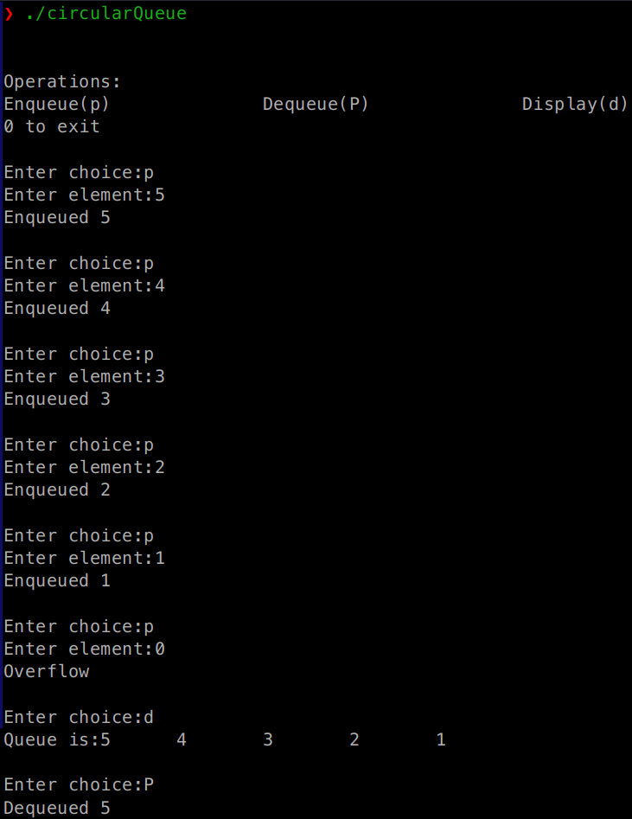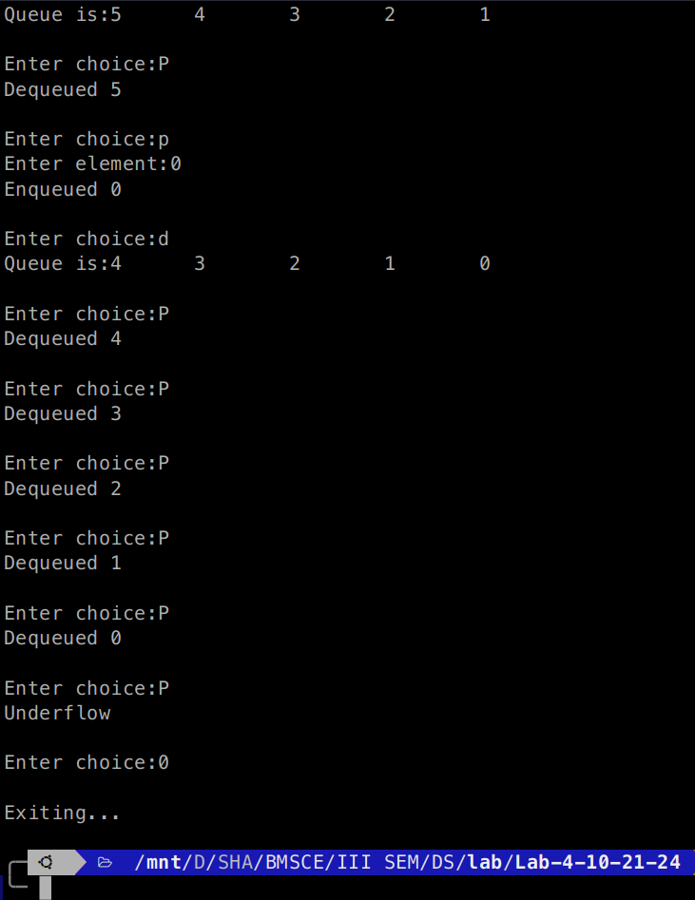

**Problem 4:**

WAP to Implement Singly Linked List with following operations:

a) Create a linked list.

b) Insertion of a node at first position, at any position and at end of list.

Display the contents of the linked list.

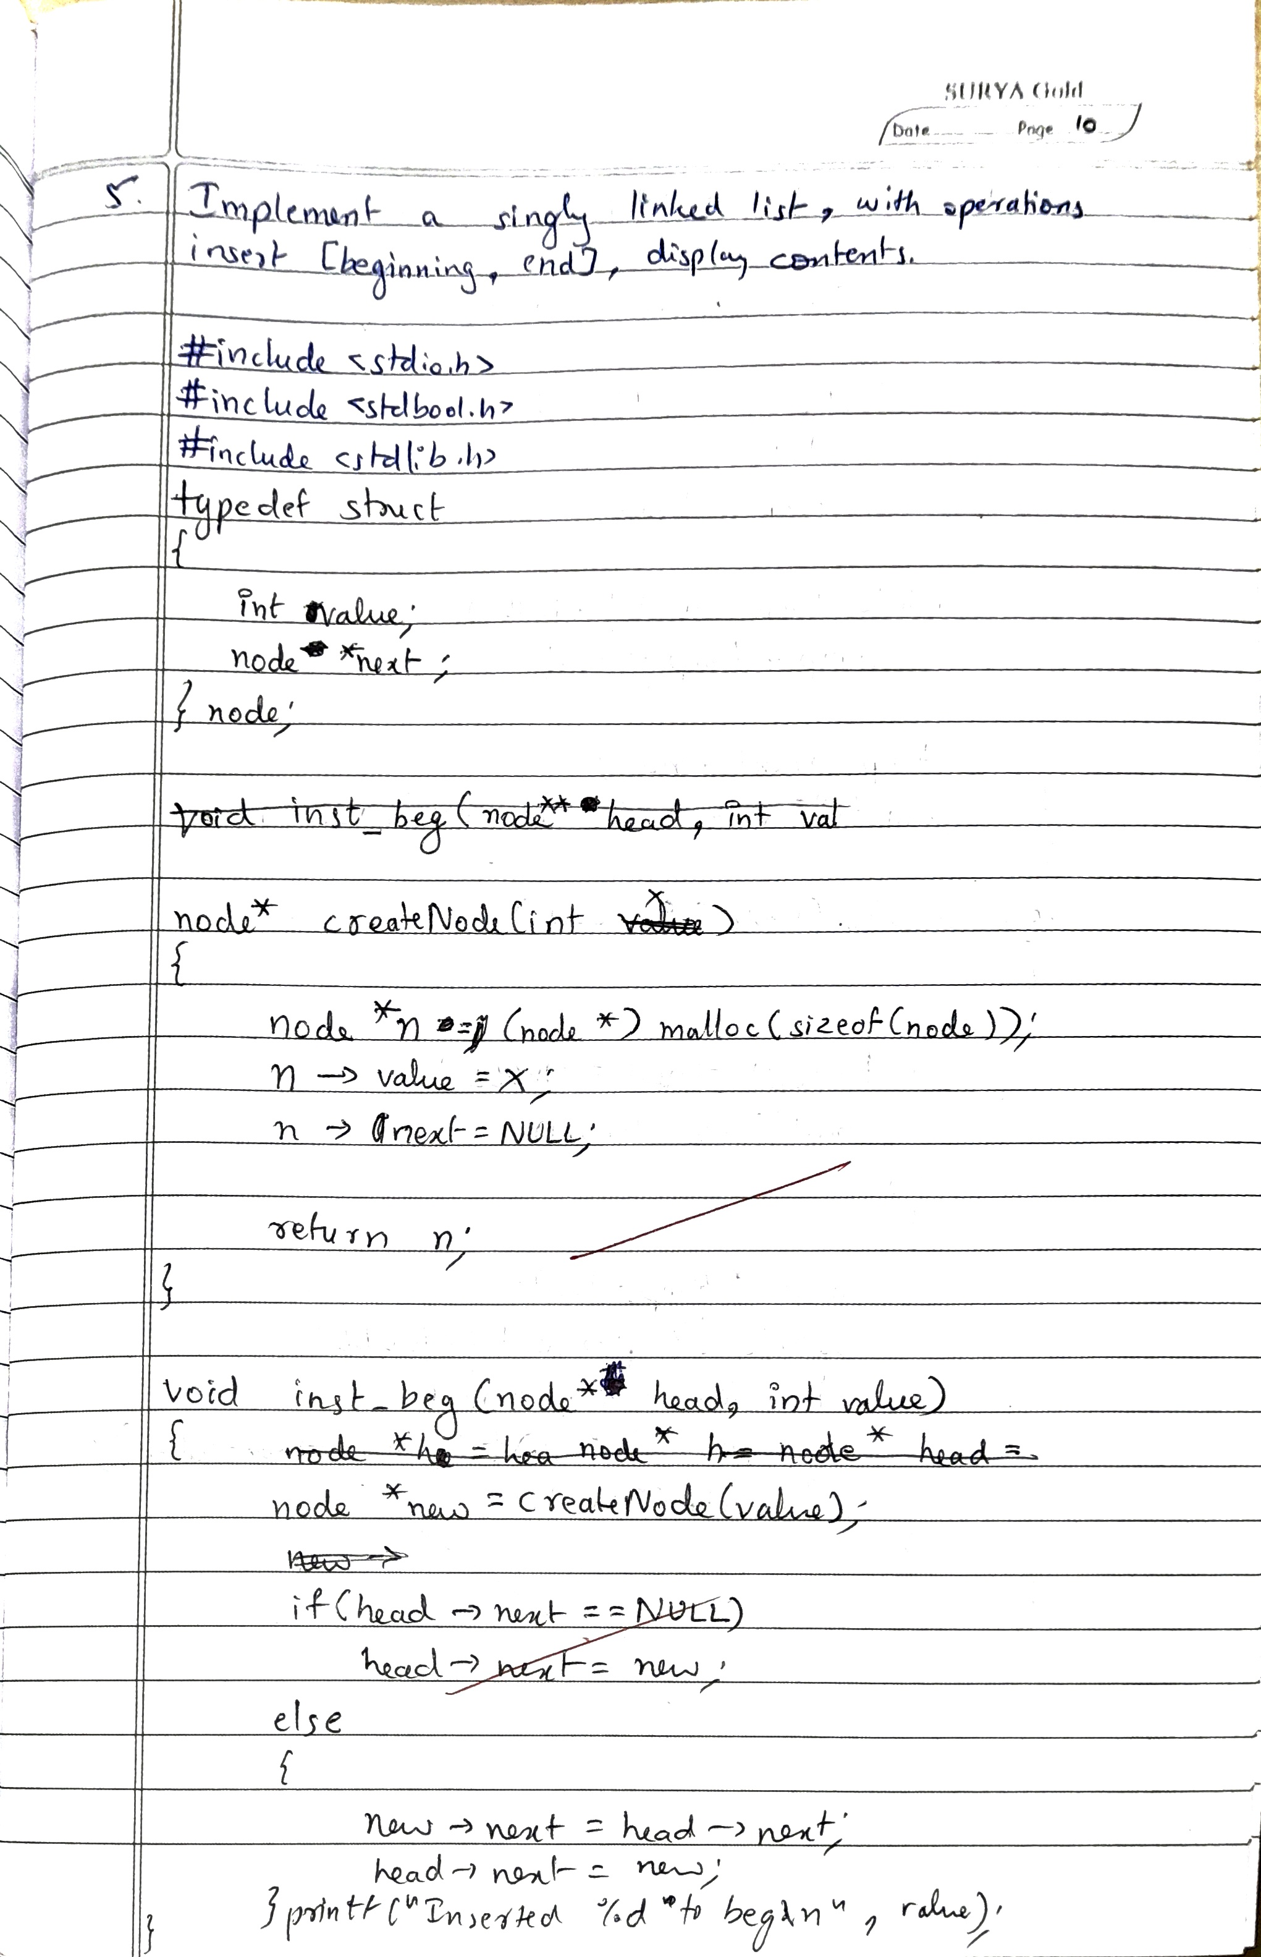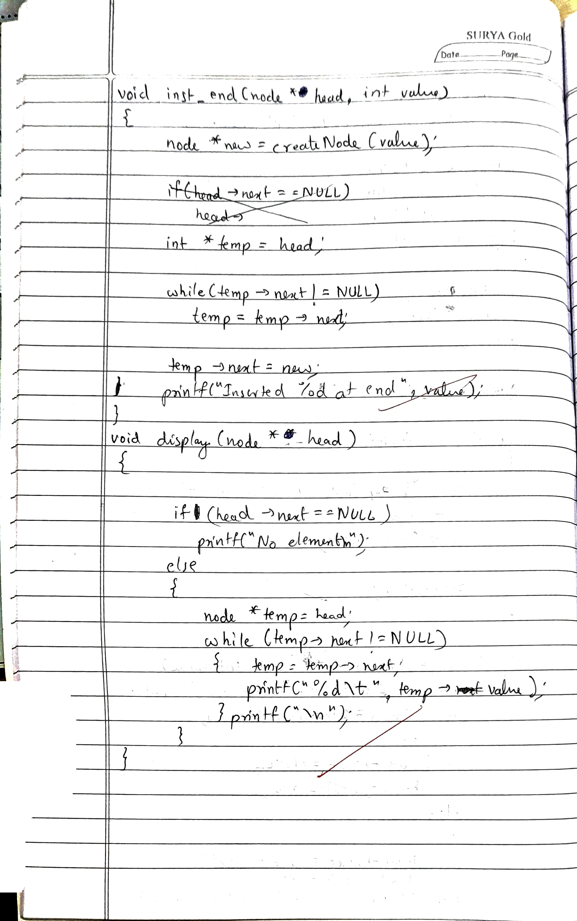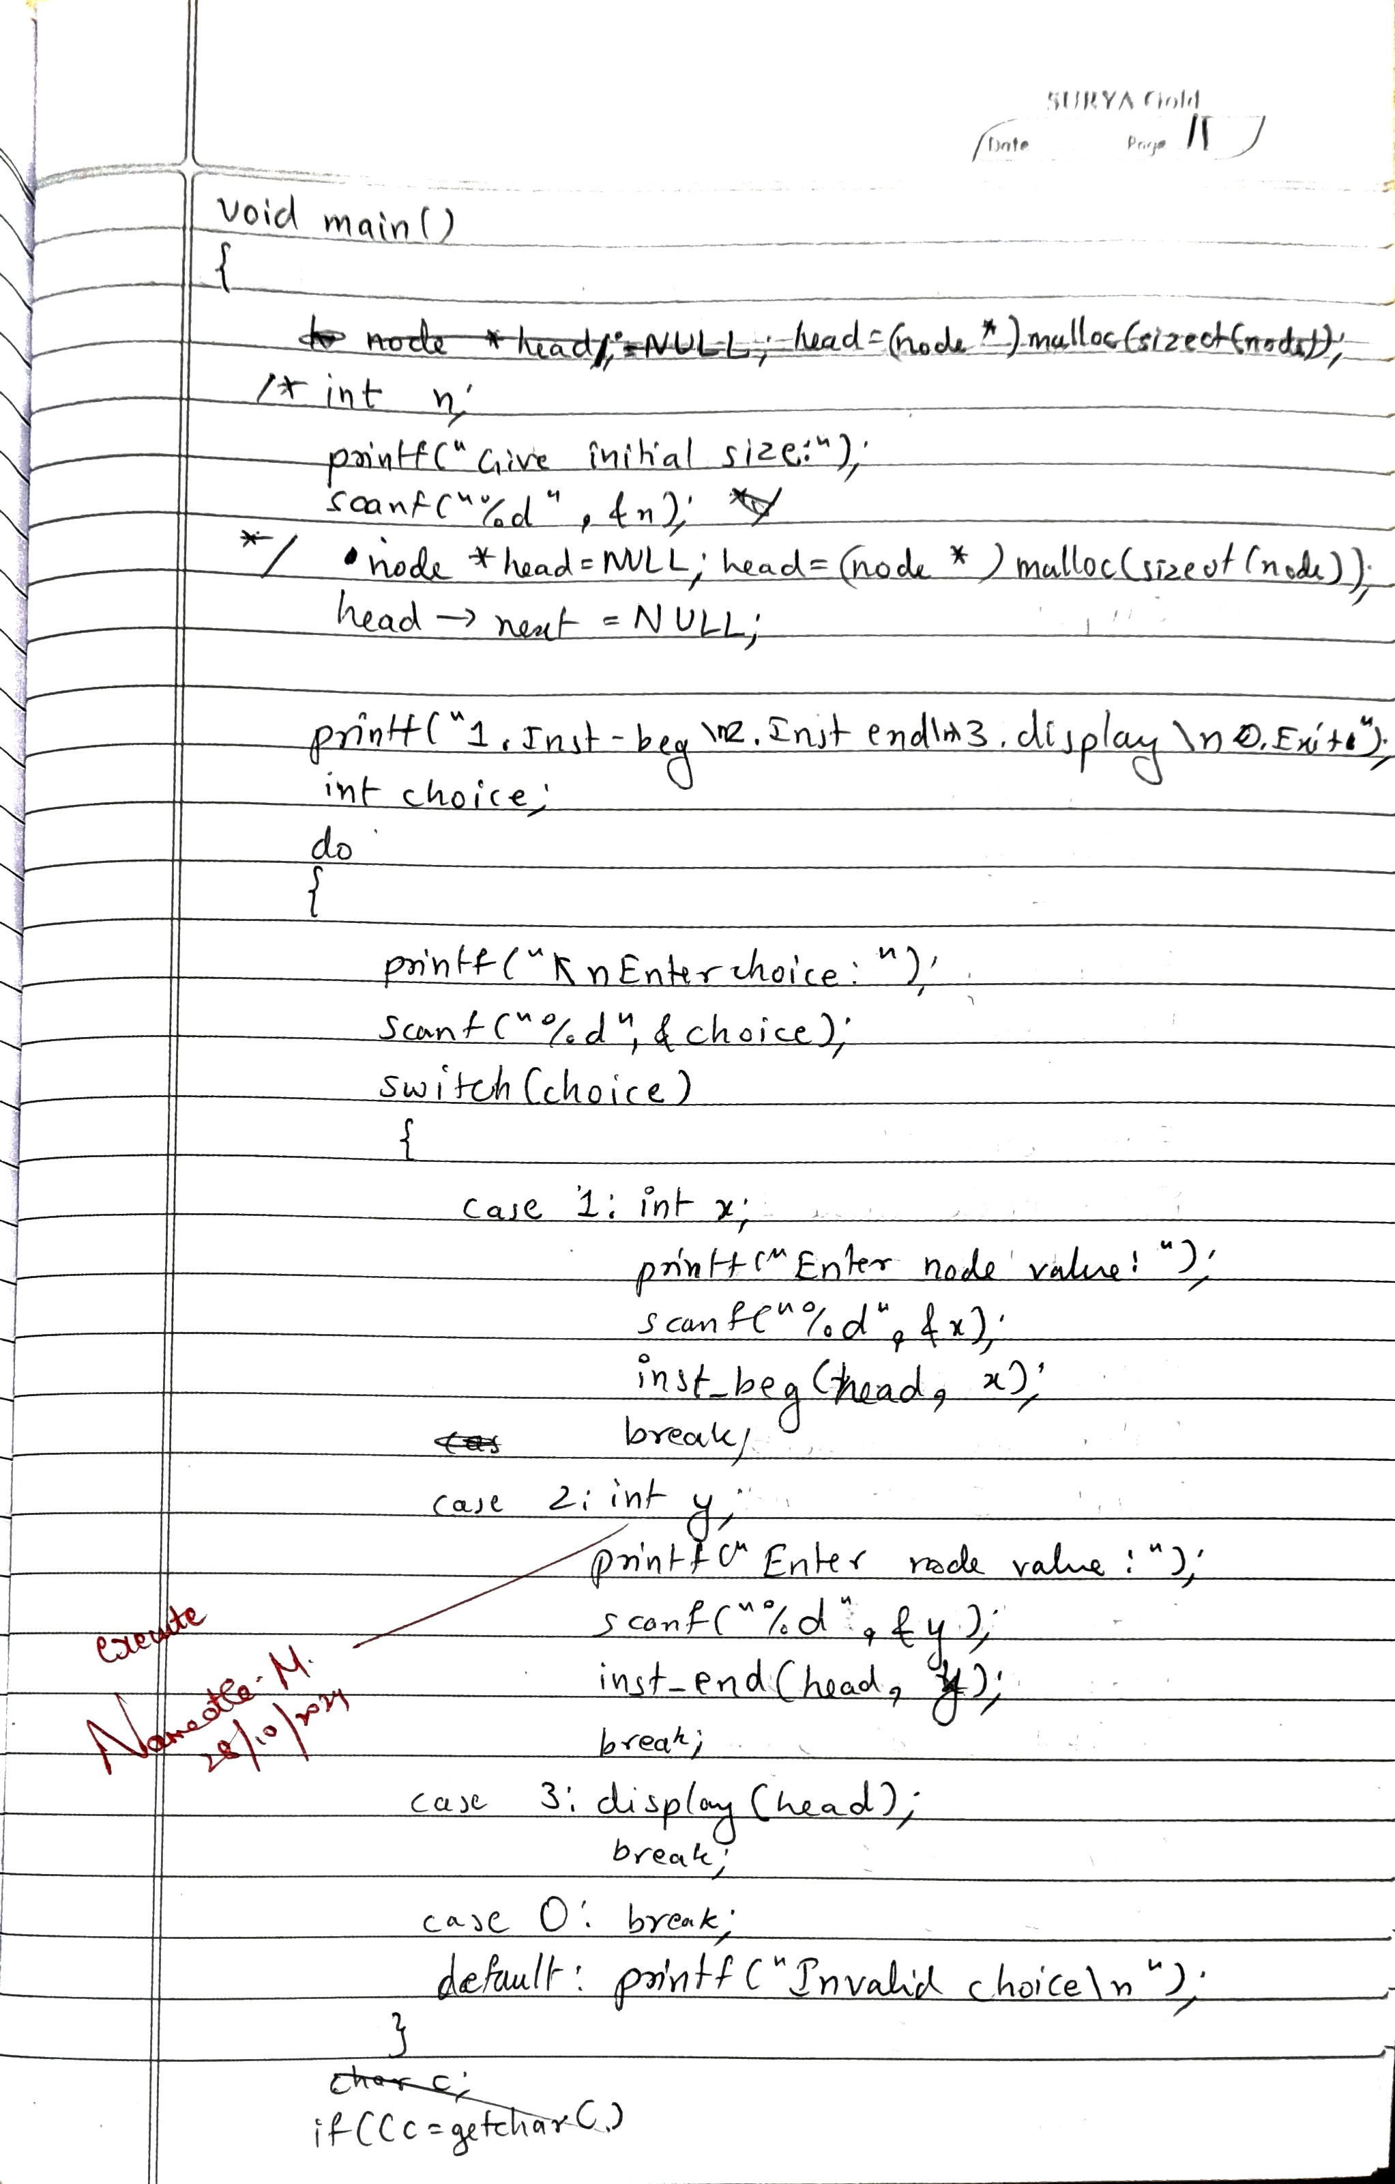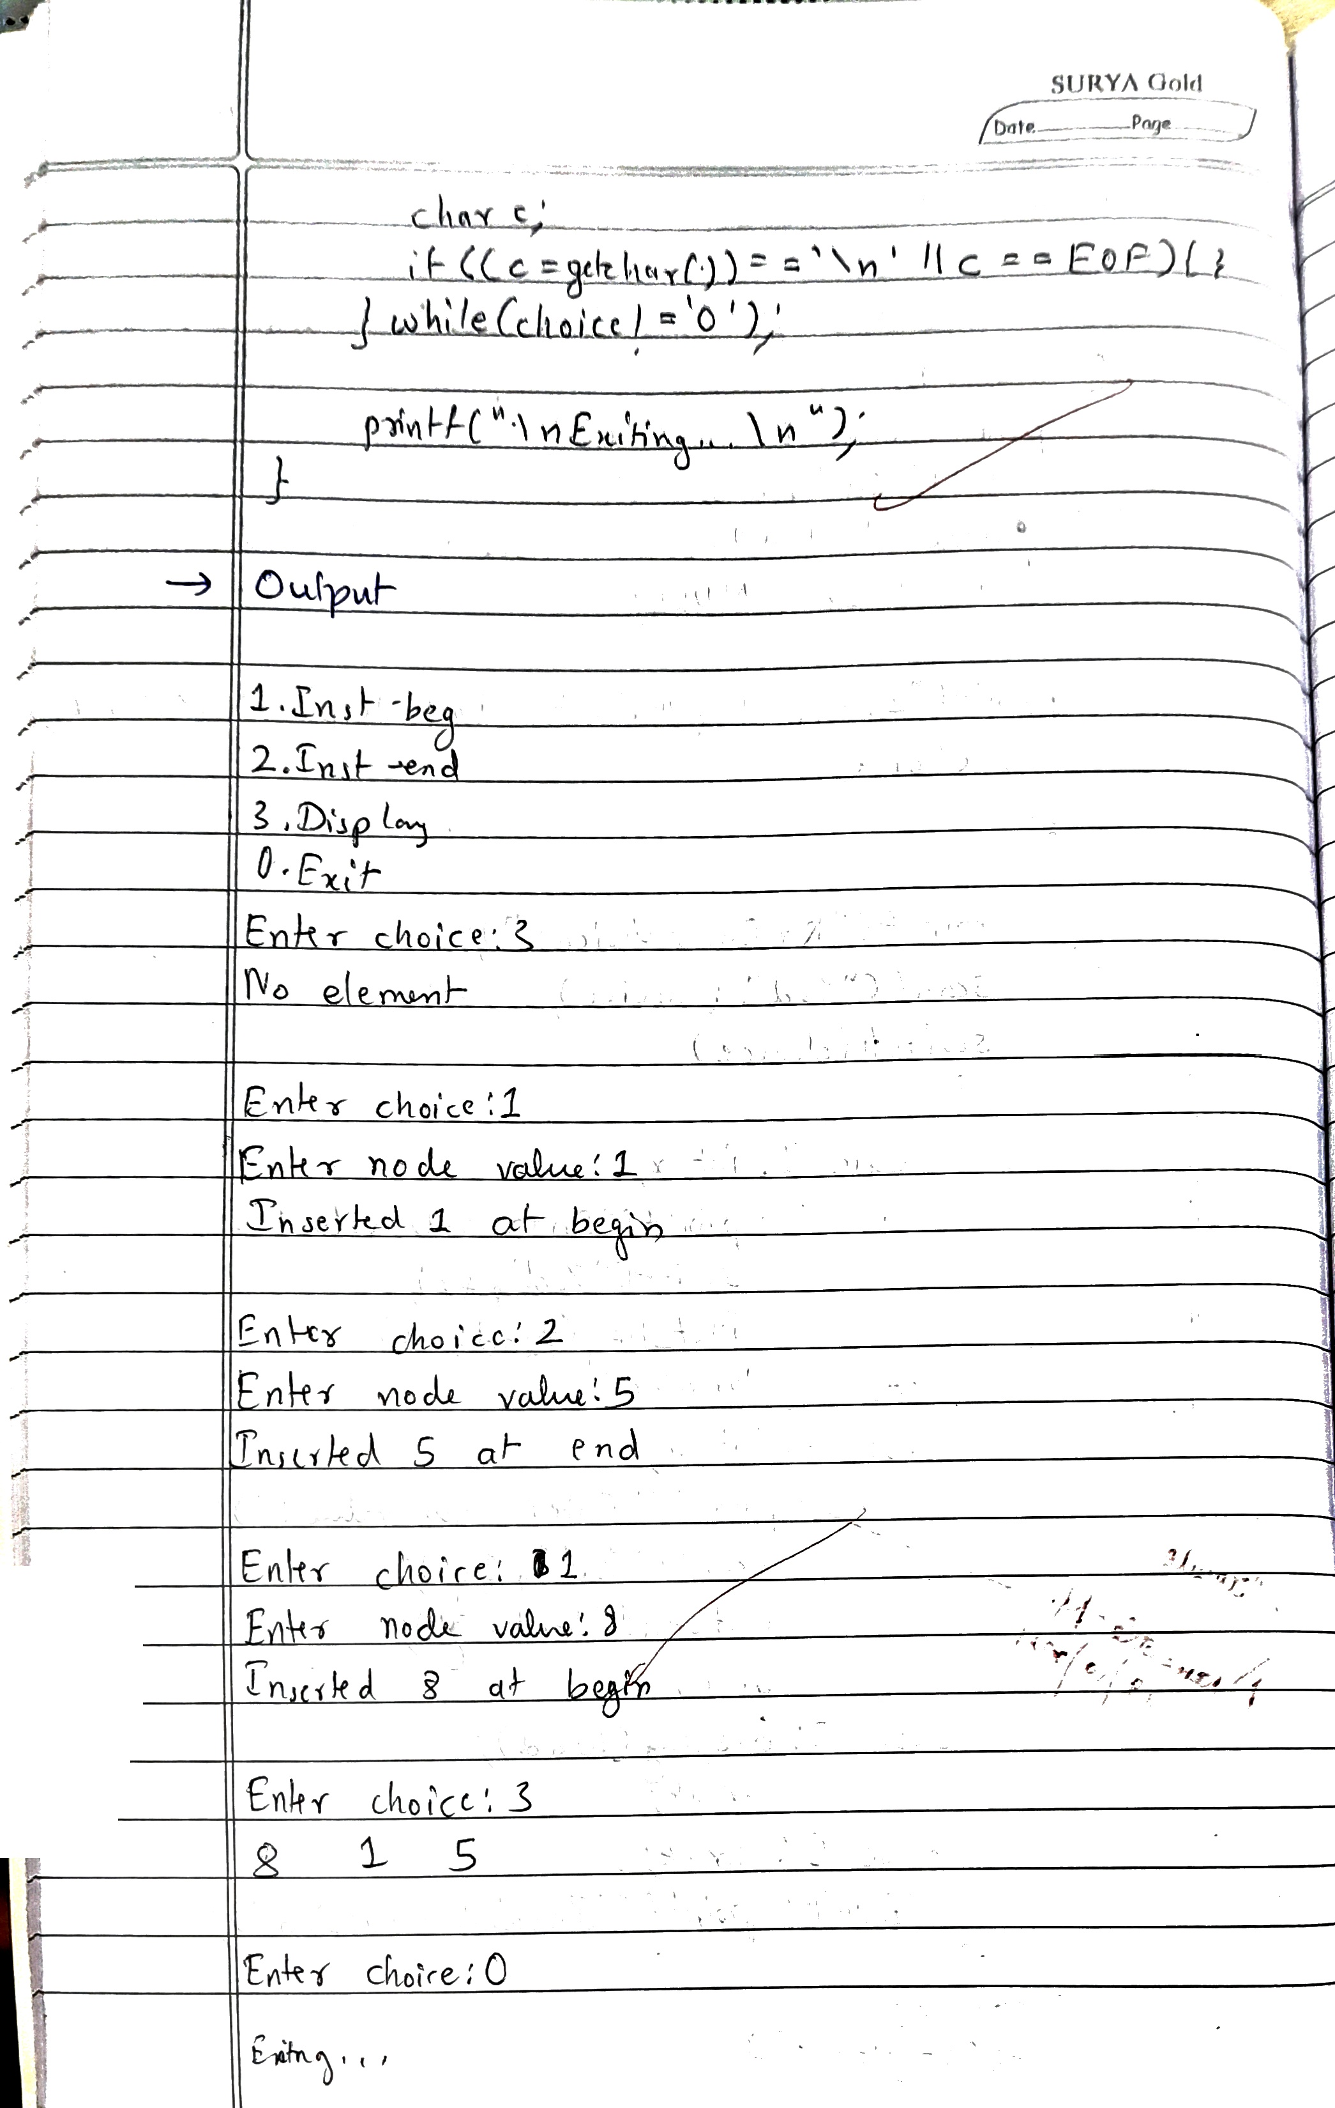

**Code:**

#include <stdio.h>

#include <stdbool.h>

#include <stdlib.h>

typedef struct node node;

struct node

{

int value;

struct node *next;

};

node* createNode(int x)

{

node *n = (node*)malloc(sizeof(node));

n->value=x;

n->next=NULL;

return n;

}

void inst_beg(node* head, int value)

{

node *new = createNode(value);

if(head->next == NULL)

head->next = new;

else

{

new->next = head->next;

head->next = new;

}

printf("Inserted %d at begin\n",value);

}

void inst_end(node* head, int value)

{

node *new = createNode(value);

node *temp = head;

while(temp->next!=NULL)

temp = temp->next;

temp->next = new;

printf("Inserted %d at end\n",value);

}

void display(node* head)

{

node *temp= head;

if(head->next==NULL){

printf("No element\n");

return;

}

while(temp->next!=NULL)

{

temp = temp->next;

printf("%d\t",temp->value);

}

printf("\n");

}

void main()

{

node *head=NULL;

head = (node *) malloc(sizeof(node));

head->next = NULL;

printf("1.Inst-beg\n2.Inst-end\n3.Display\n0.Exit");

int choice;

char c;

do

{

printf("\nEnter choice:");

scanf("%d",&choice);

switch(choice)

{

case 1: int x;

printf("Enter node value:");

scanf("%d",&x);

inst_beg(head,x);

break;

case 2: int y;

printf("Enter node value:");

scanf("%d",&y);

inst_end(head,y);

break;

case 3: display(head);

break;

case 0: break;

default:printf("Invalid choice\n");

}

if((c=getchar())=='\n'||c==EOF){}

}while(choice!=0);

printf("\nExiting...\n");

}

**OUTPUT**

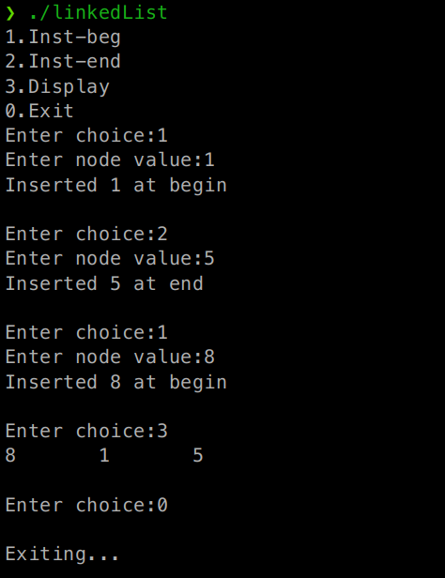

Program - Leetcode platform – Valid Parantheses

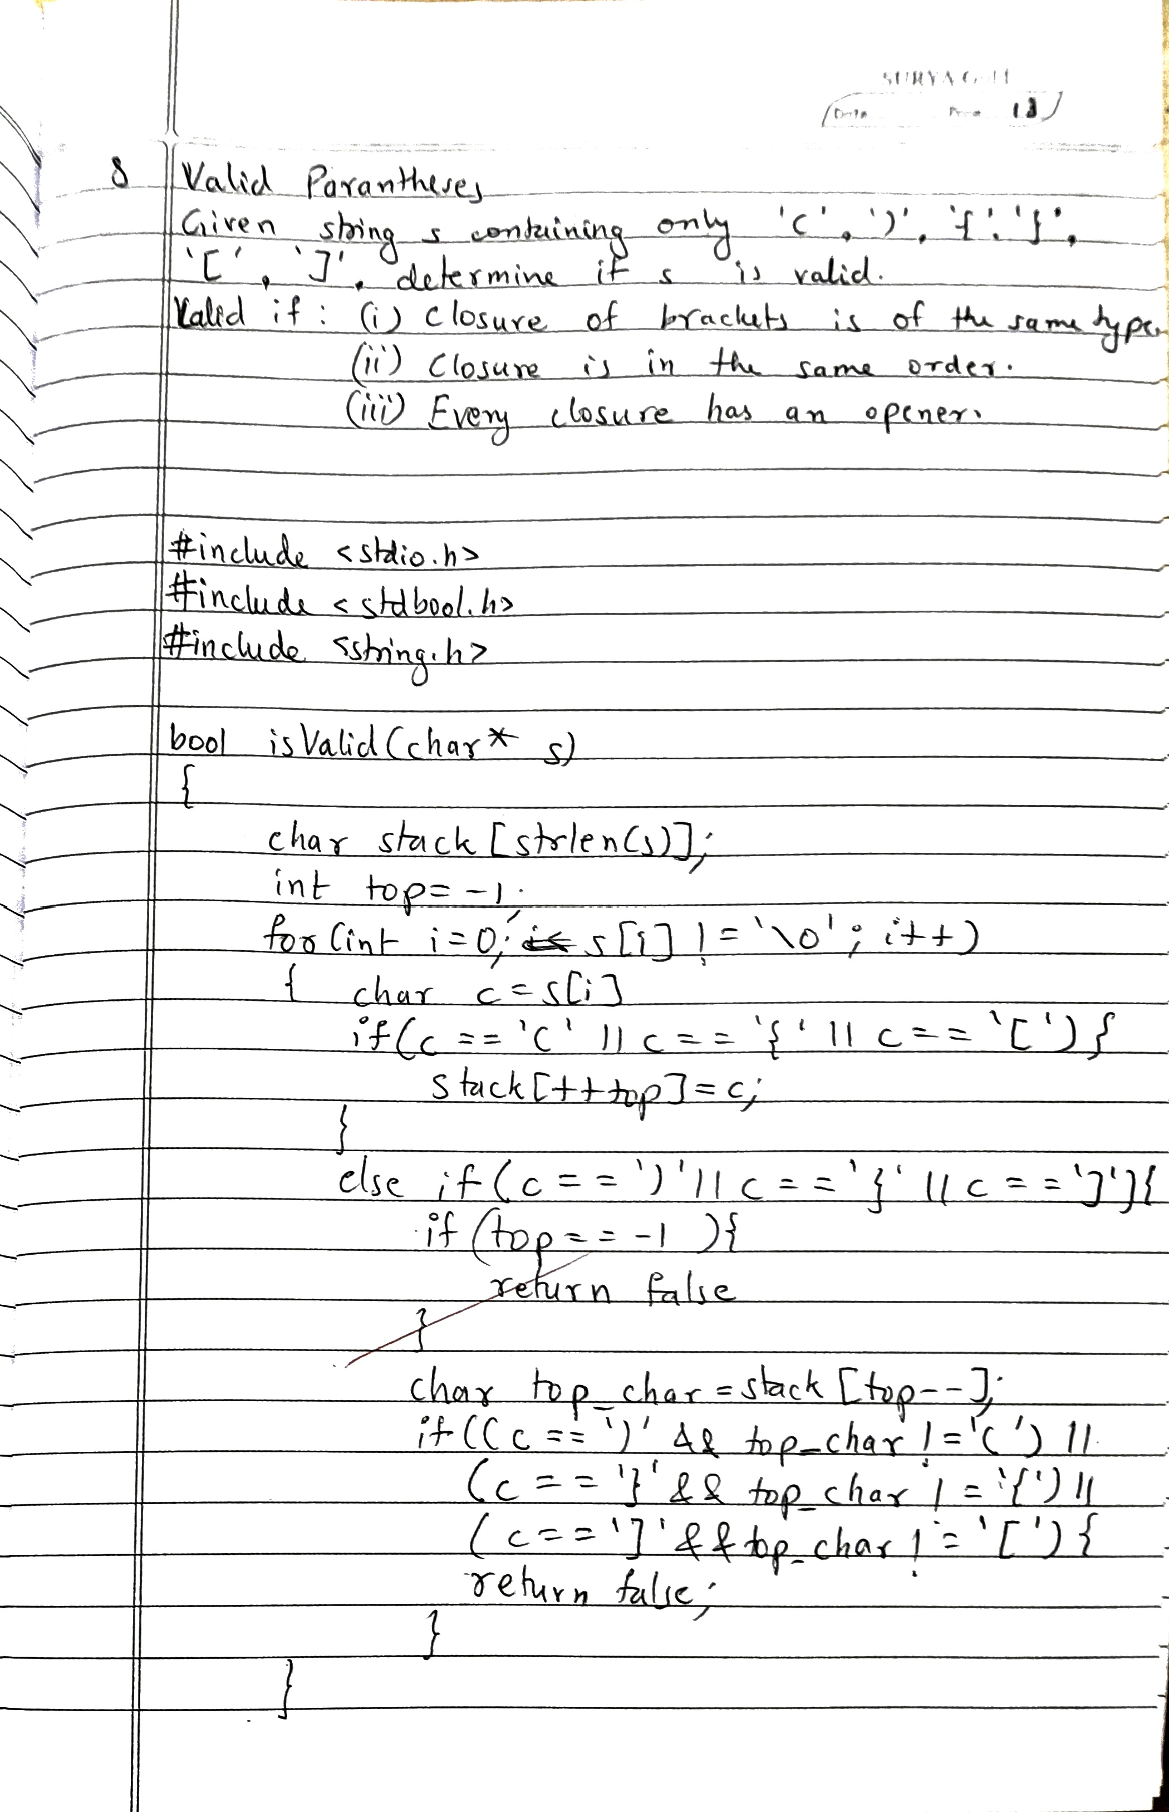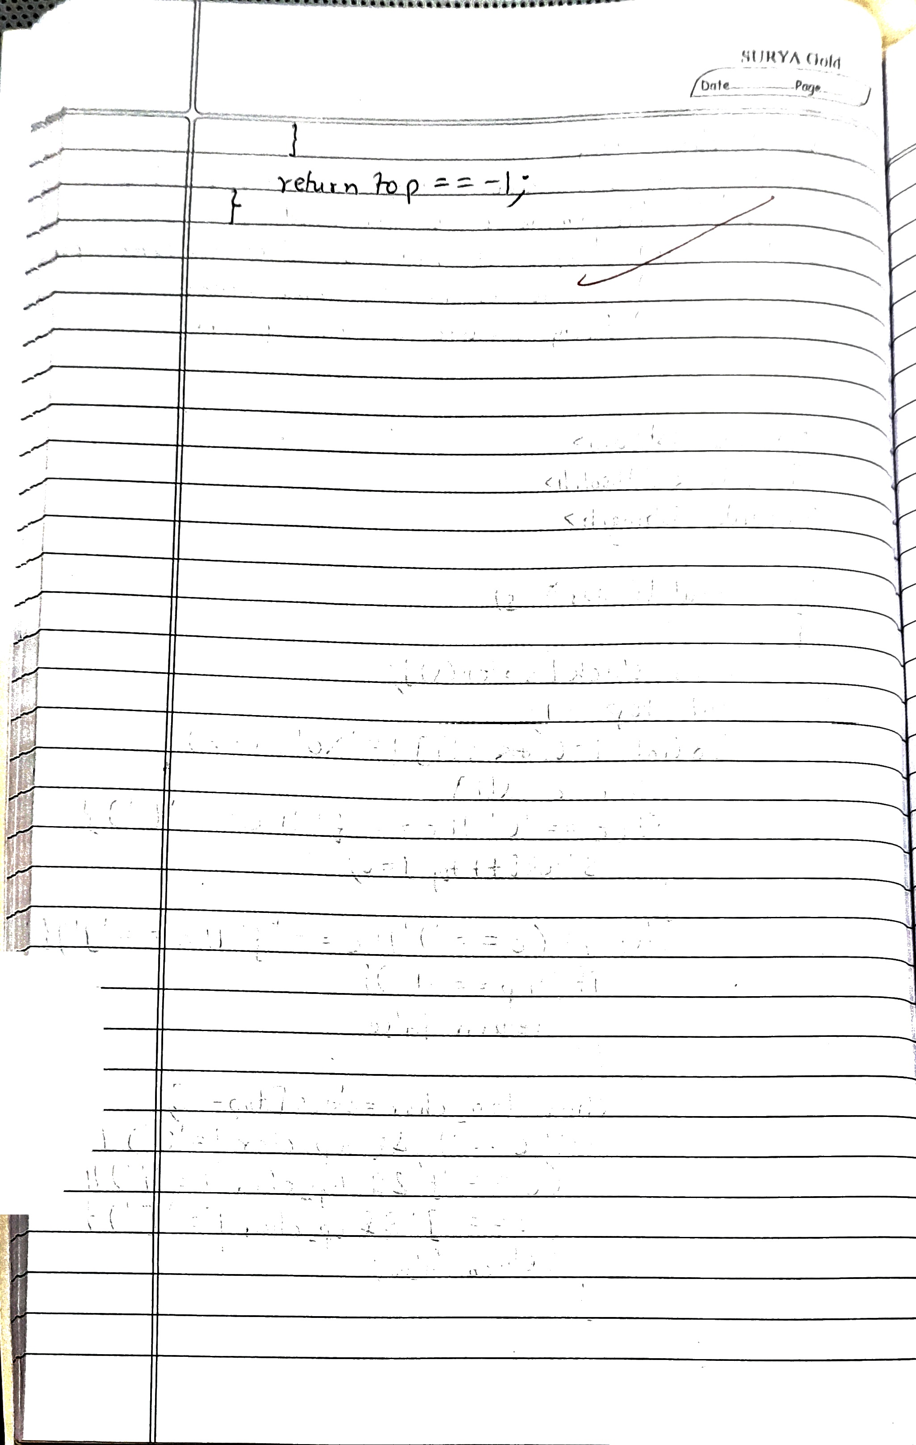

**OUTPUT**

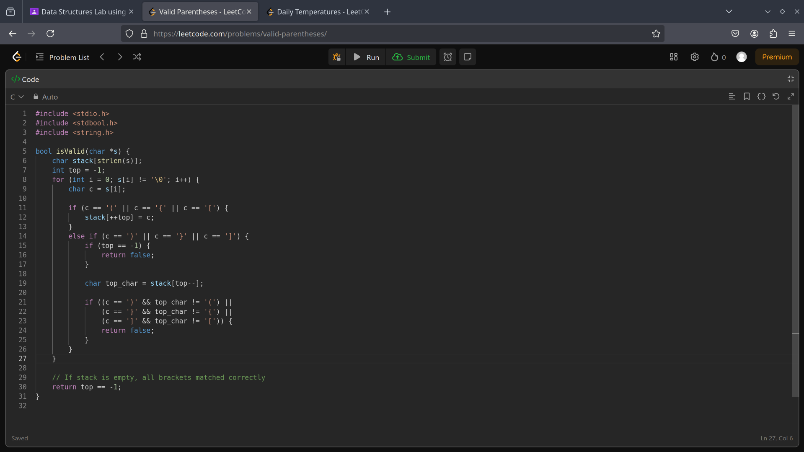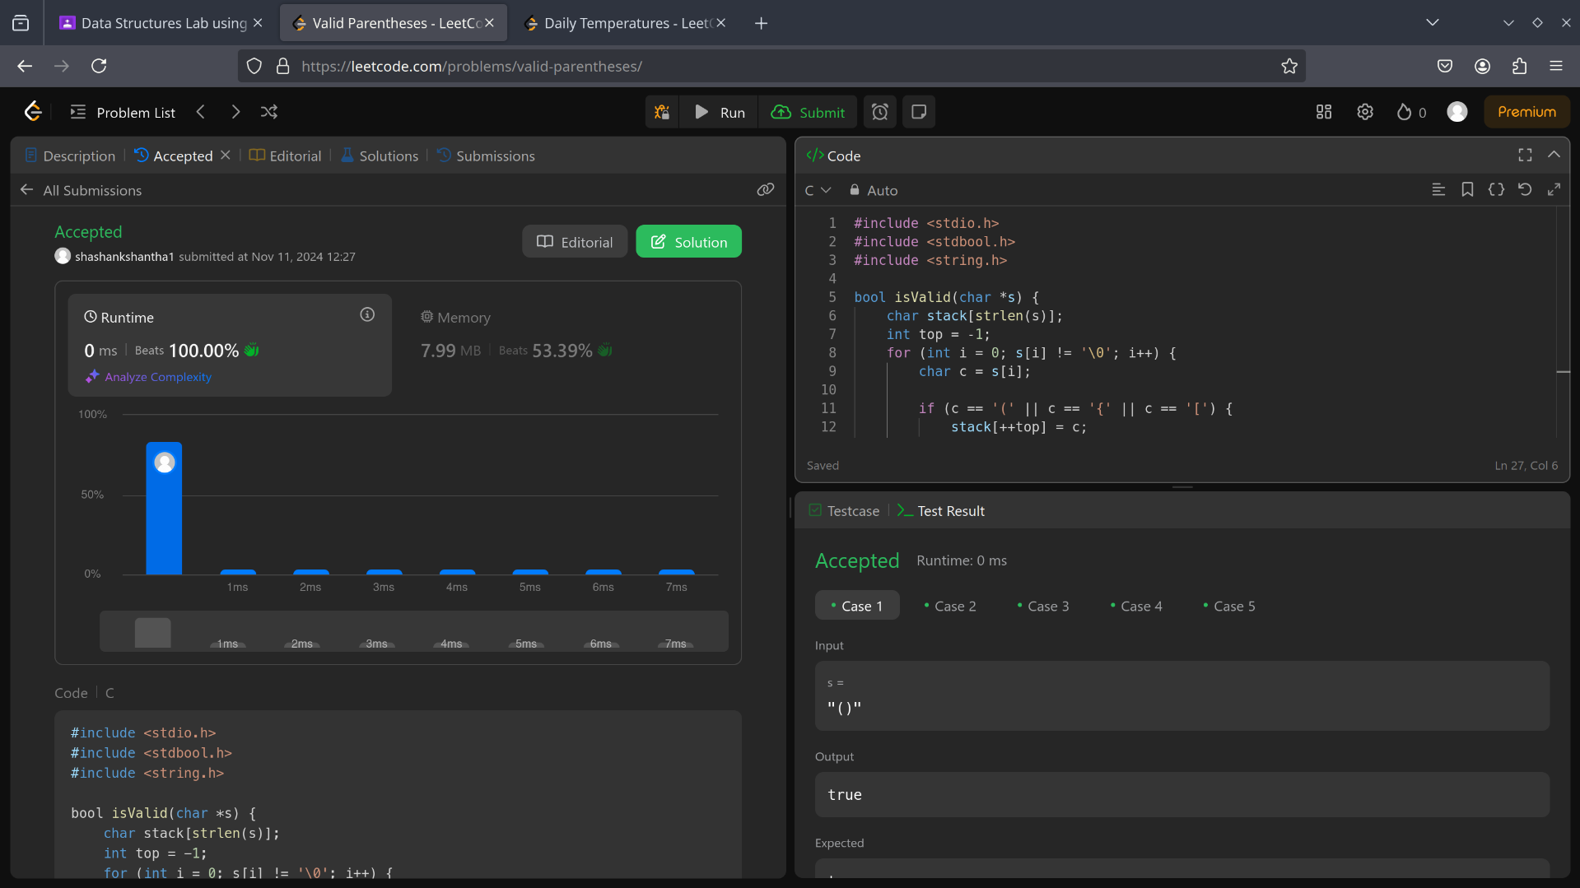

**Program 5:**

WAP to Implement Singly Linked List with following operations:

a) Create a linked list.

b) Deletion of first element, specified element and last element in the list.

c) Display the contents of the linked list.

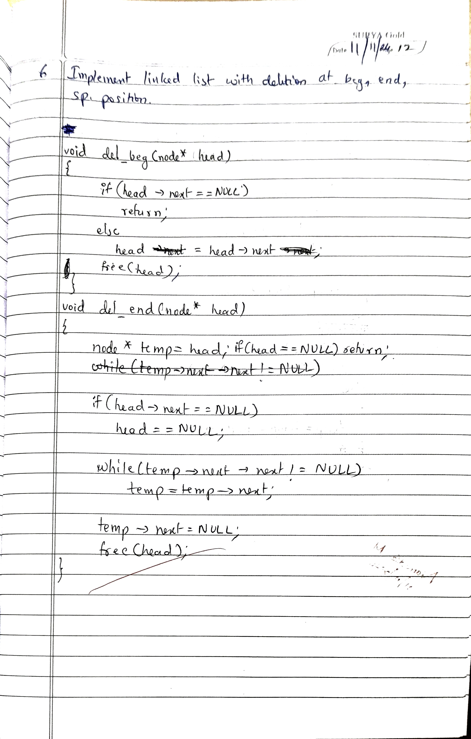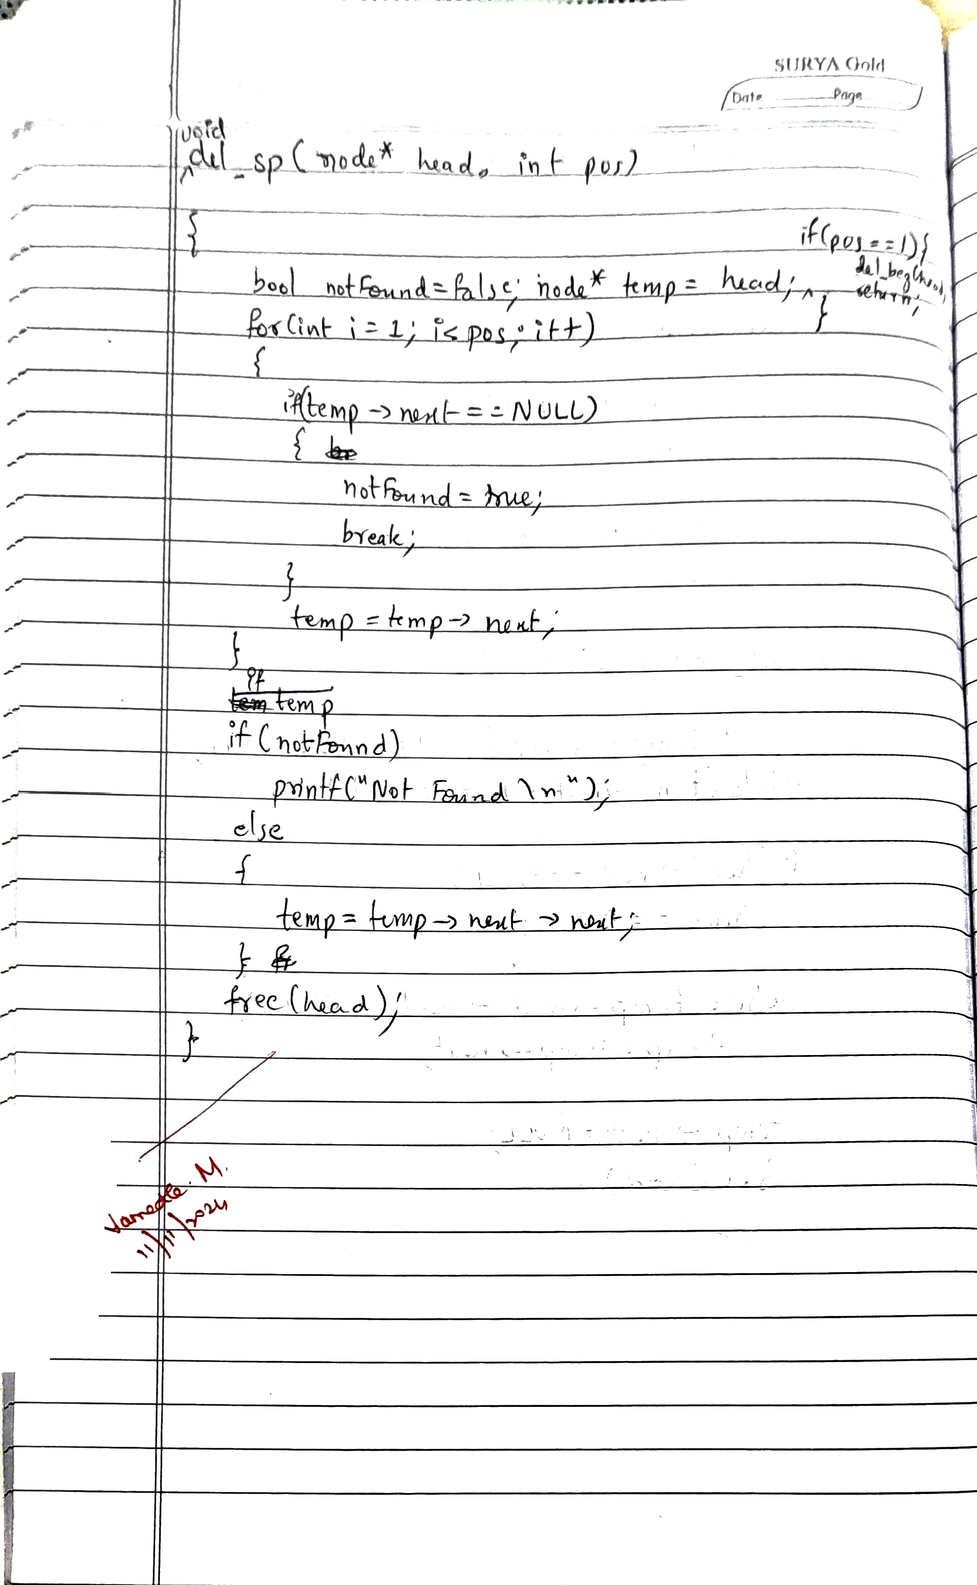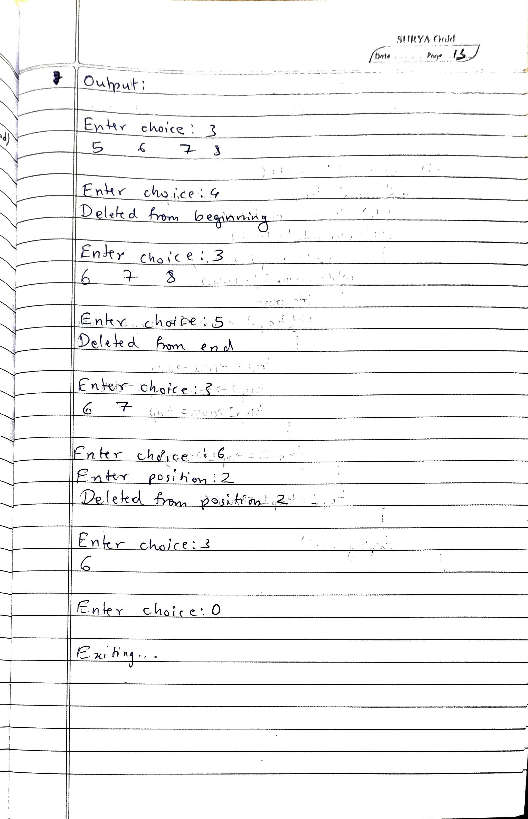

**Code:**

#include <stdio.h>

#include <stdbool.h>

#include <stdlib.h>

typedef struct node node;

struct node {

int value;

struct node *next;

};

node* createNode(int x) {

node *n = (node*)malloc(sizeof(node));

n->value = x;

n->next = NULL;

return n;

}

void inst_beg(node* head, int value) {

node *new = createNode(value);

new->next = head->next;

head->next = new;

printf("Inserted %d at begin\n", value);

}

void inst_end(node* head, int value) {

node *new = createNode(value);

node *temp = head;

while (temp->next != NULL) {

temp = temp->next;

}

temp->next = new;

printf("Inserted %d at end\n", value);

}

void display(node* head) {

node *temp = head->next;

if (temp == NULL) {

printf("No element\n");

return;

}

while (temp != NULL) {

printf("%d\t", temp->value);

temp = temp->next;

}

printf("\n");

}

void del_beg(node* head) {

if (head == NULL || head->next == NULL) {

return;

}

node* temp = head->next;

head->next = temp->next;

free(temp);

printf("Deleted from the beginning\n");

}

void del_end(node* head) {

if (head == NULL || head->next == NULL) {

return;

}

node* temp = head;

while (temp->next != NULL && temp->next->next != NULL) {

temp = temp->next;

}

node* toDelete = temp->next;

temp->next = NULL;

free(toDelete);

printf("Deleted from the end\n");

}

void del_sp(node* head, int pos) {

if (head == NULL || head->next == NULL) {

printf("List is empty\n");

return;

}

node* temp = head;

for (int i = 1; i < pos; i++) {

if (temp->next == NULL) {

printf("Position not found\n");

return;

}

temp = temp->next;

}

node* toDelete = temp->next;

if (toDelete != NULL) {

temp->next = toDelete->next;

free(toDelete);

printf("Deleted from position %d\n", pos);

}

}

int main() {

node *head = (node *)malloc(sizeof(node));

head->next = NULL;

printf("1. Inst-beg\n2. Inst-end\n3. Display\n4. Del-beg\n5. Del-end\n6. Del-sp\n0. Exit\n");

int choice;

char c;

do {

printf("\nEnter choice: ");

scanf("%d", &choice);

switch (choice) {

case 1: {

int x;

printf("Enter node value: ");

scanf("%d", &x);

inst_beg(head, x);

break;

}

case 2: {

int y;

printf("Enter node value: ");

scanf("%d", &y);

inst_end(head, y);

break;

}

case 3:

display(head);

break;

case 4:

del_beg(head);

break;

case 5:

del_end(head);

break;

case 6: {

int pos;

printf("Enter position: ");

scanf("%d", &pos);

del_sp(head, pos);

break;

}

case 0:

break;

default:

printf("Invalid choice\n");

}

if ((c = getchar()) == '\n' || c == EOF) {}

} while (choice != 0);

printf("\nExiting...\n");

return 0;

}

**OUTPUT**

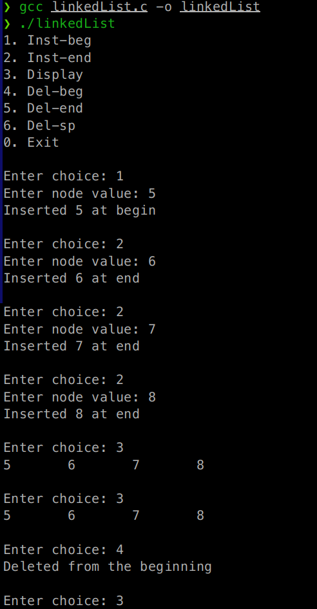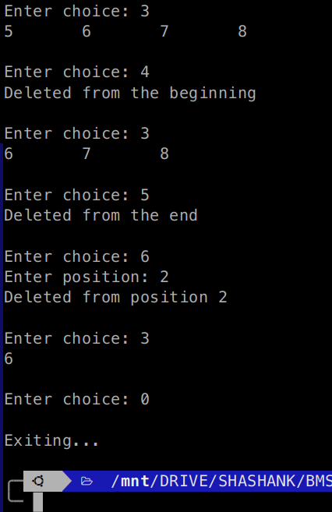

Program – LeetCode Question – Daily Temperatures

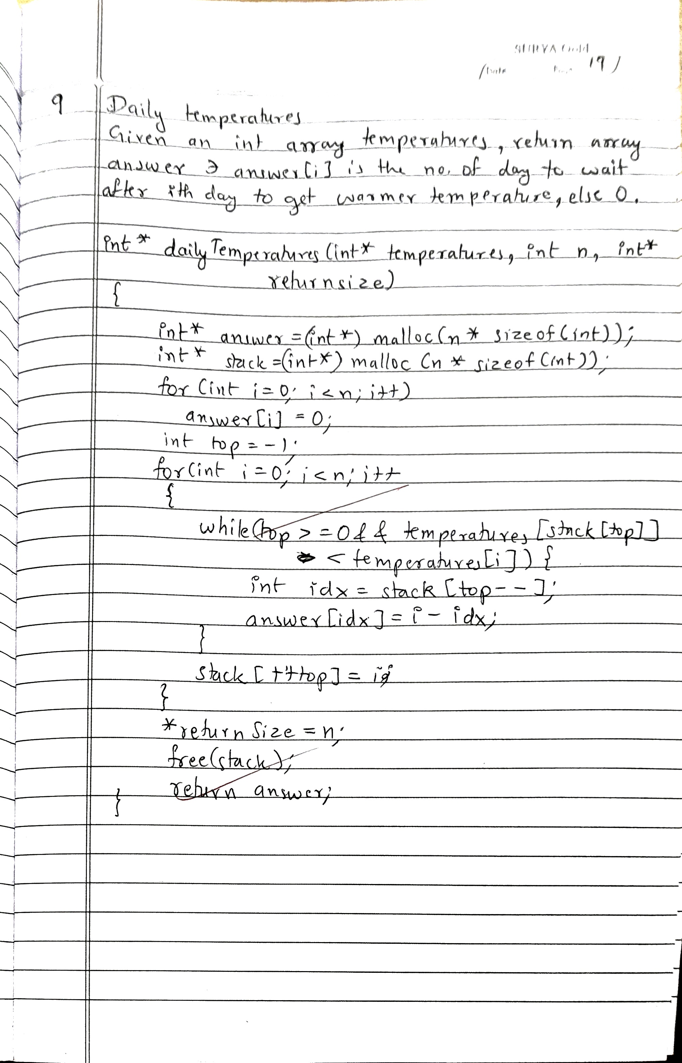

**OUTPUT**

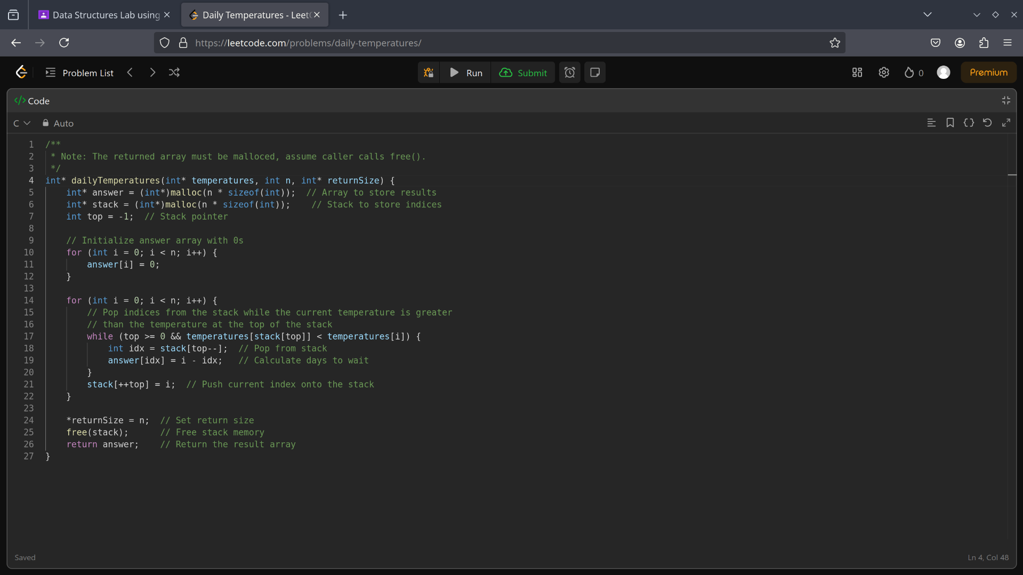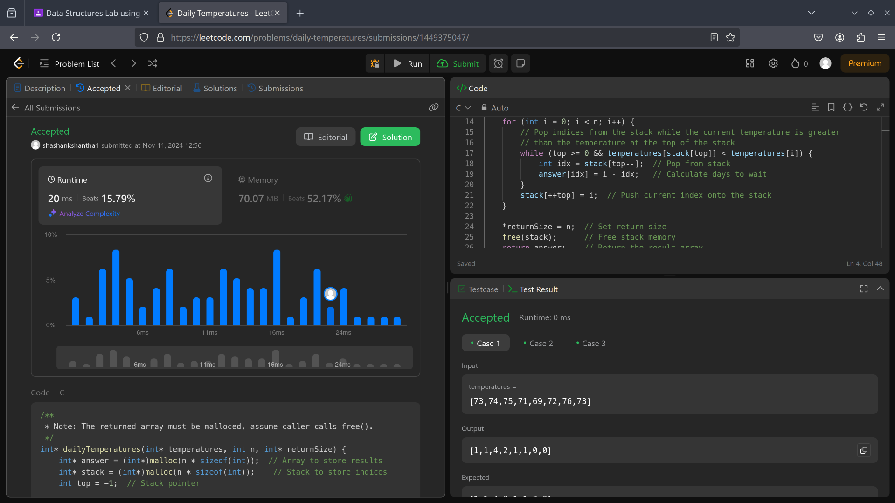

**Program 6:**

6a) WAP to Implement Single Link List with following operations:   
Sort the linked list,   
Reverse the linked list,

Concatenation of two linked lists.

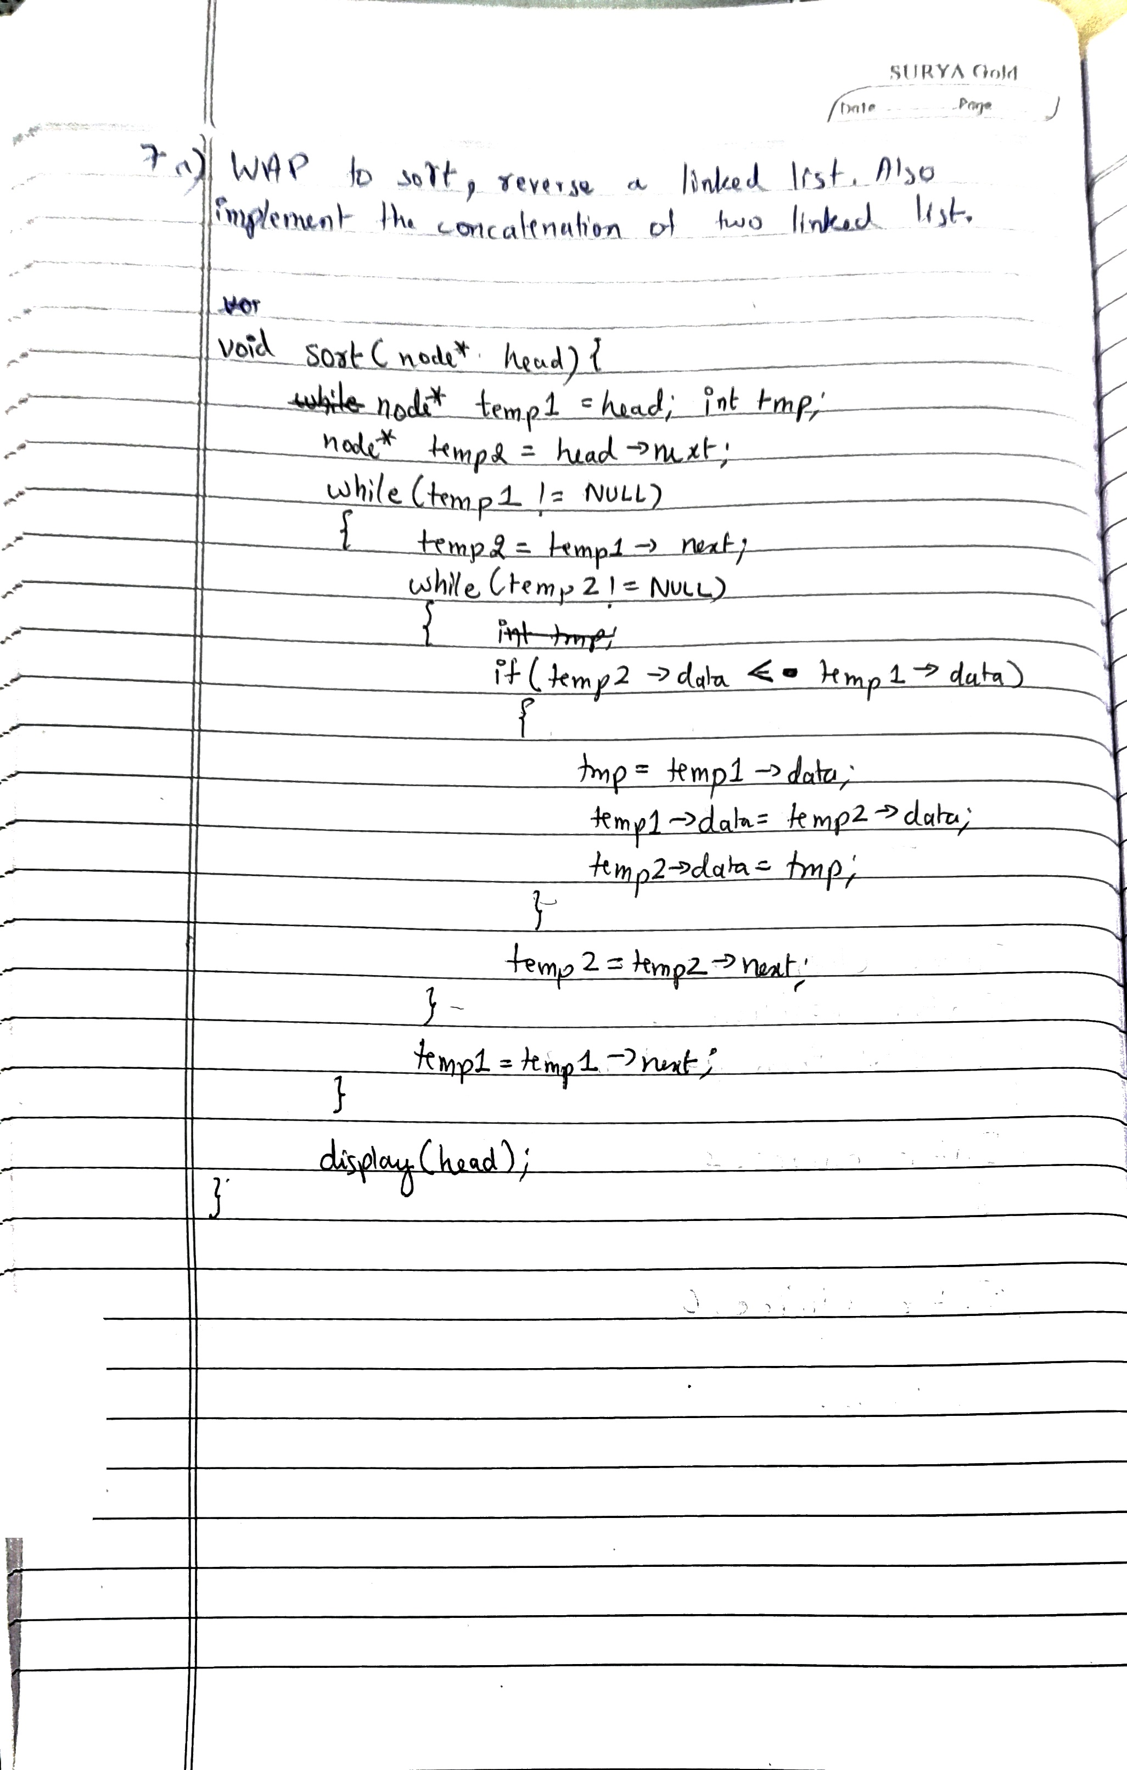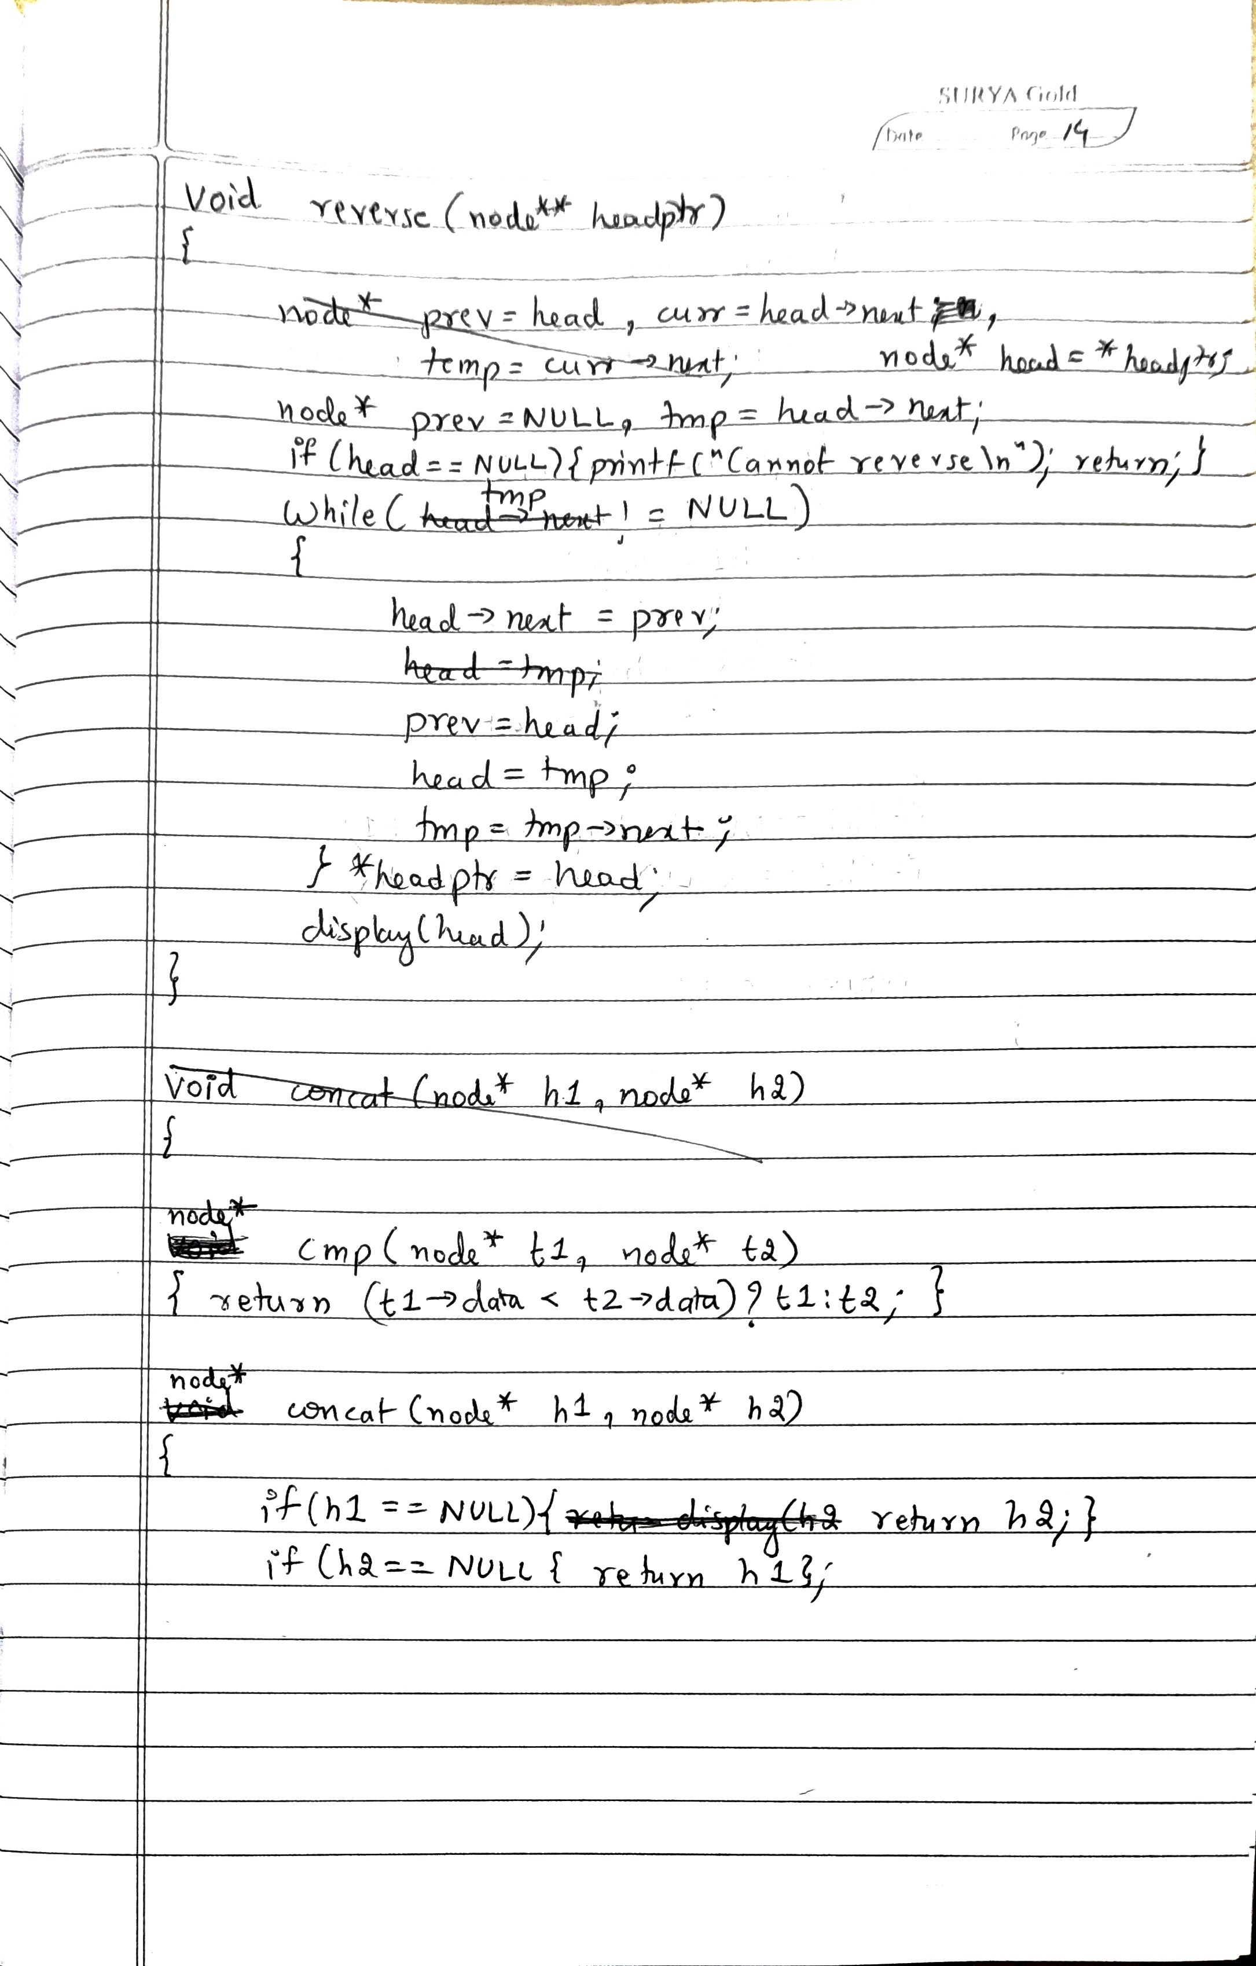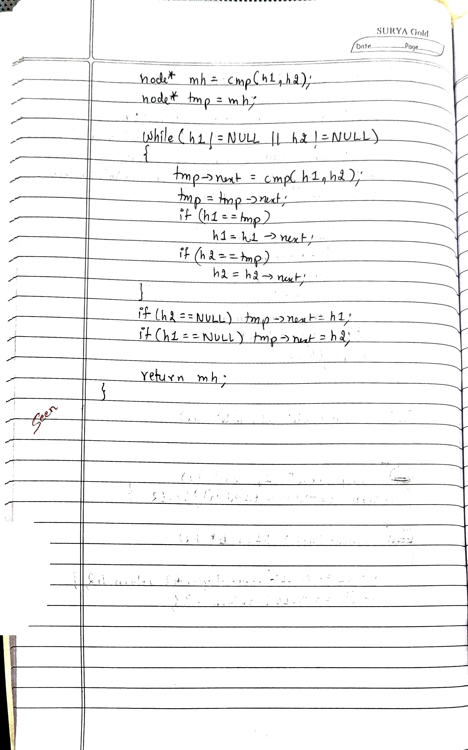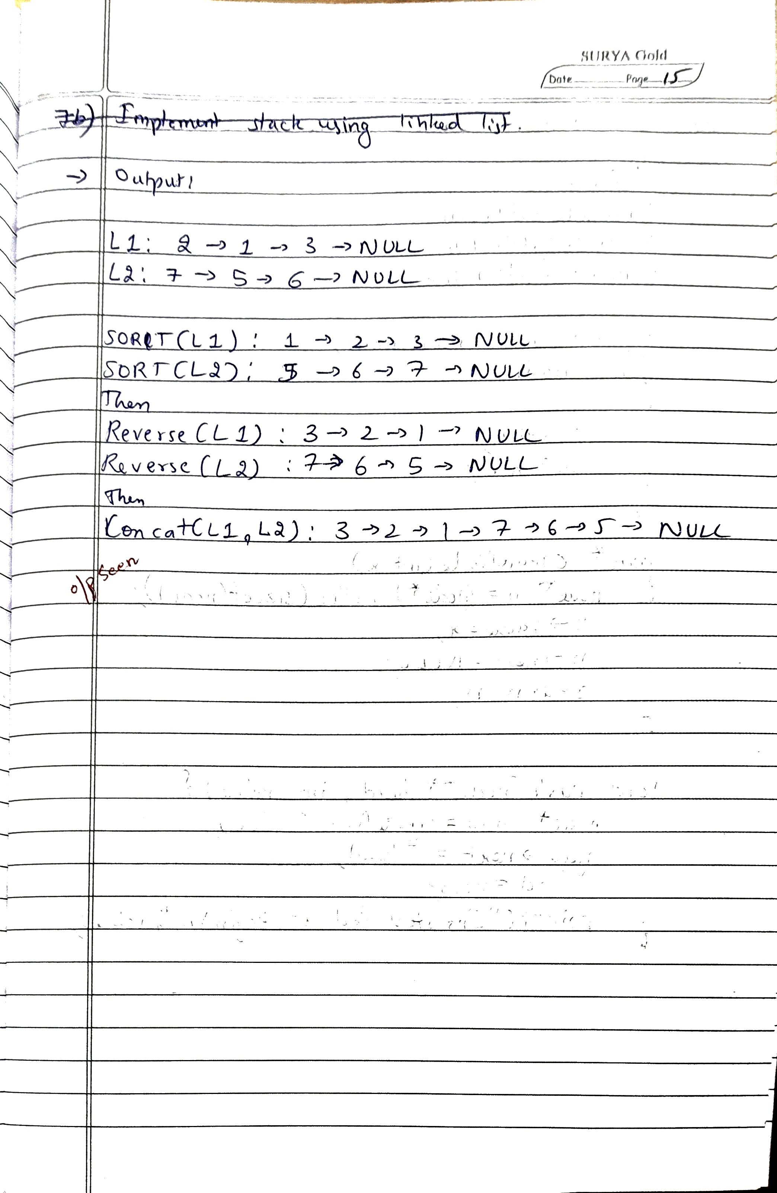

**Code:**

#include <stdio.h>

#include <stdbool.h>

#include <stdlib.h>

typedef struct node node;

struct node {

int value;

node* next;

};

node* createNode(int x) {

node* n = (node*)malloc(sizeof(node));

n->value = x;

n->next = NULL;

return n;

}

void inst_beg(node** head, int value) {

node *new = createNode(value);

new->next = *head;

*head = new;

printf("Inserted %d at begin\n", value);

}

void inst_end(node* head, int value) {

node* new = createNode(value);

node* temp = head;

while (temp->next != NULL) {

temp = temp->next;

}

temp->next = new;

printf("Inserted %d at end\n", value);

}

void display(node* head) {

node *temp = head;

if (temp == NULL) {

printf("No element\n");

return;

}

while (temp != NULL) {

printf("%d -> ", temp->value);

temp = temp->next;

}

printf("NULL\n");

}

void sort(node* head)

{

if (head == NULL) return;

node* temp1 = head;

while (temp1 != NULL)

{

node* temp2 = temp1->next;

while (temp2 != NULL)

{

if (temp2->value < temp1->value)

{

int tmp = temp1->value;

temp1->value = temp2->value;

temp2->value = tmp;

}

temp2 = temp2->next;

}

temp1 = temp1->next;

}

display(head);

}

void reverse(node** headptr)

{

node* head = *headptr;

node* prev = NULL;

node* tmp = head ? head->next : NULL;

while (tmp != NULL)

{

head->next = prev;

prev = head;

head = tmp;

tmp = tmp->next;

}

head->next = prev; // Don't forget to point the new tail to NULL

*headptr = head;

display(head);

}

node* concat(node* h1, node* h2) {

if (h1 == NULL) return h2;

if (h2 == NULL) return h1;

node* mh = NULL;

node* tmp = NULL;

// Initializing the head of the merged list by comparing the first nodes

if (h1->value < h2->value) {

mh = h1;

h1 = h1->next;

} else {

mh = h2;

h2 = h2->next;

}

tmp = mh; // set tmp to the head of the merged list

// Merging the two lists

while (h1 != NULL && h2 != NULL) {

if (h1->value < h2->value) {

tmp->next = h1;

h1 = h1->next;

} else {

tmp->next = h2;

h2 = h2->next;

}

tmp = tmp->next; // Move tmp to the last node

}

// If one of the lists is not empty, append the rest of the remaining list

if (h1 != NULL) {

tmp->next = h1;

} else {

tmp->next = h2;

}

// Display the merged list

display(mh);

return mh;

}

int main() {

node* h1 = NULL;

node* h2 = NULL;

printf("1. Inst-beg\n2. Inst-end\n3. Sort\n4. Reverse\n5. Concat\n6. Display\n0. Exit\n");

int choice;

char c;

do {

printf("\nEnter choice: ");

scanf("%d", &choice);

switch (choice) {

case 1: {

int x,y;

printf("Enter node value and list: ");

scanf("%d%d", &x, &y);

(y==1)?inst_beg(&h1, x):inst_beg(&h2,x);

break;

}

case 2: {

int x,y;

printf("Enter node value and list: ");

scanf("%d%d", &x, &y);

(y==1)?inst_end(h1, x):inst_end(h2,x);

break;

}

case 3:{

int y;

printf("Enter list no: ");

scanf("%d",&y);

sort((y==1)?h1:h2);

break;

}

case 4:{

int y;

printf("Enter list no: ");

scanf("%d",&y);

reverse((y==1)?&h1:&h2);

break;

}

case 5:

node* newList = concat(h1,h2);

break;

case 6: {

int y;

printf("Enter list no: ");

scanf("%d", &y);

display((y==1)?h1:h2);

break;

}

case 0:

break;

default:

printf("Invalid choice\n");

}

if ((c = getchar()) == '\n' || c == EOF) {}

} while (choice != 0);

printf("\nExiting...\n");

return 0;

}

**OUTPUT**

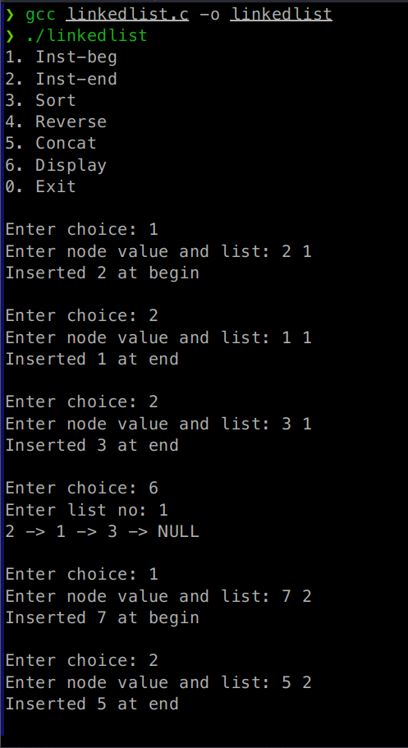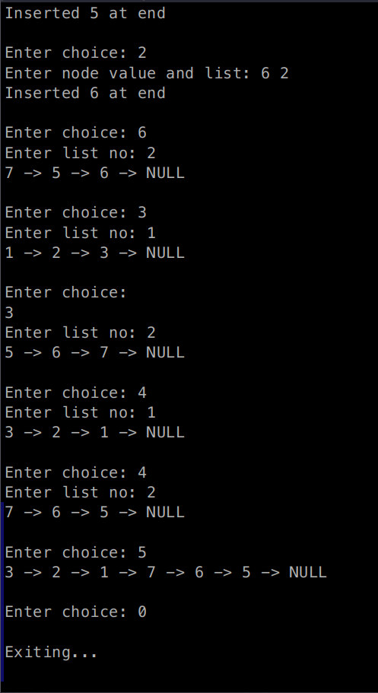

6b) WAP to Implement Single Link List to simulate Stack & Queue Operations.

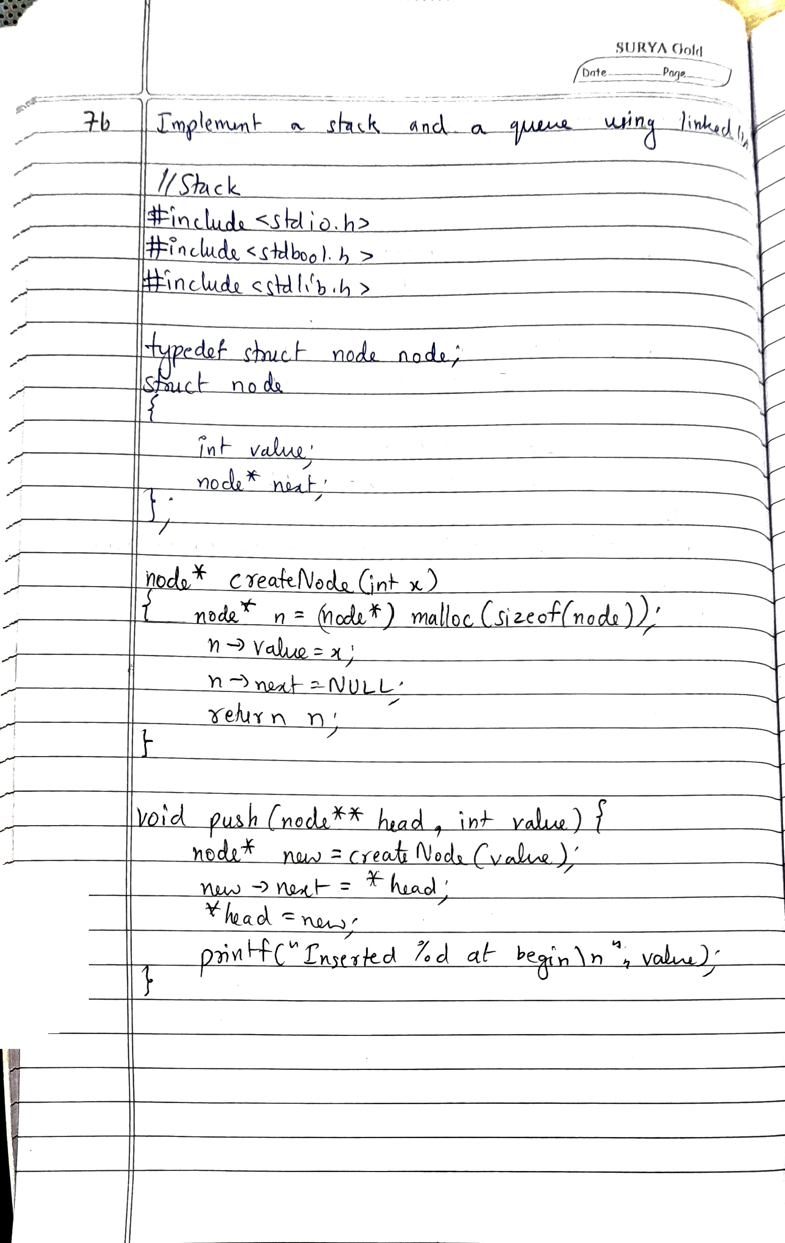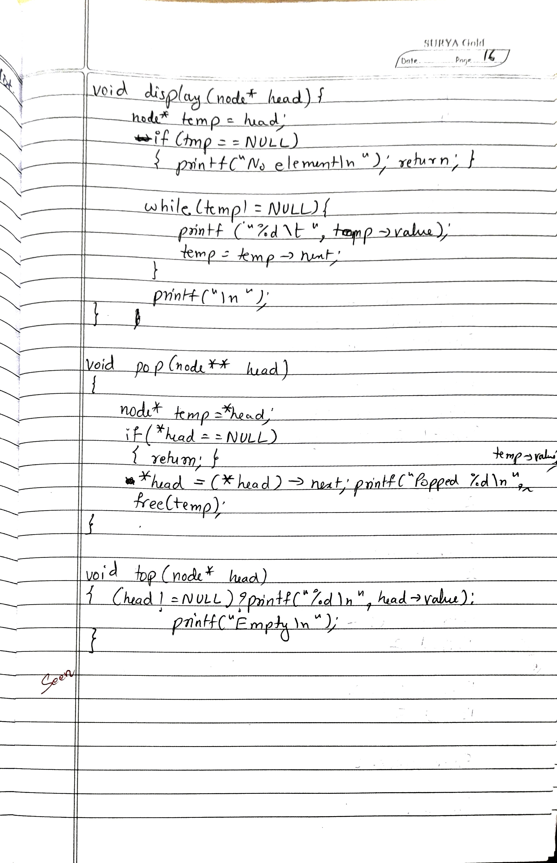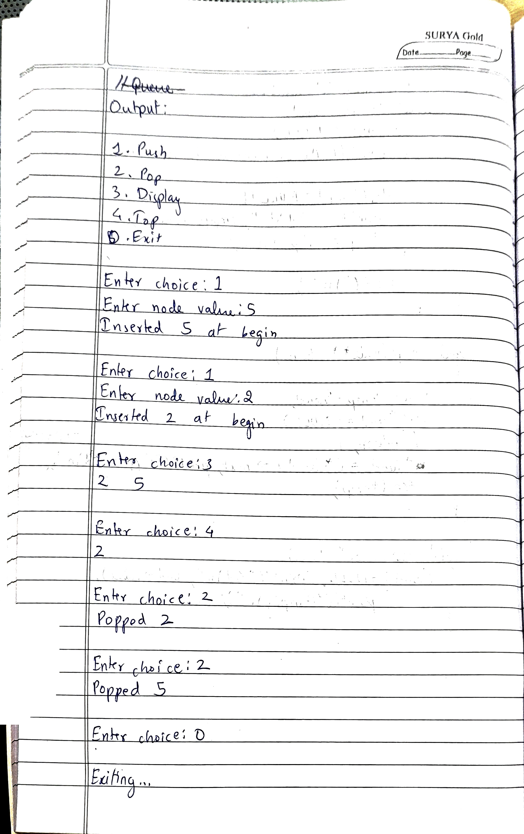

**Code for Stack:**

#include <stdio.h>

#include <stdbool.h>

#include <stdlib.h>

typedef struct node node;

struct node {

int value;

node* next;

};

node* createNode(int x) {

node *n = (node*)malloc(sizeof(node));

n->value = x;

n->next = NULL;

return n;

}

void push(node** head, int value) {

node *new = createNode(value);

new->next = *head;

*head = new;

printf("Inserted %d at begin\n", value);

}

void display(node* head) {

node* temp = head;

if (temp == NULL) {

printf("No element\n");

return;

}

while (temp != NULL) {

printf("%d\t", temp->value);

temp = temp->next;

}

printf("\n");

}

void pop(node** head) {

if (*head == NULL) {

return;

}

node* temp = *head;

*head = (*head)->next;

printf("Popped %d\n",temp->value);

free(temp);

}

void top(node* head)

{

(head!=NULL)?printf("%d\n",head->value):printf("Empty\n");

}

int main() {

node* head = NULL;

printf("1. Push\n2. Pop\n3. Display\n4. Top\n0. Exit\n");

int choice;

char c;

do {

printf("\nEnter choice: ");

scanf("%d", &choice);

switch (choice) {

case 1: {

int x;

printf("Enter node value: ");

scanf("%d", &x);

push(&head, x);

break;

}

case 3:

display(head);

break;

case 2:

pop(&head);

break;

case 4: top(head);

break;

case 0:

break;

default:

printf("Invalid choice\n");

}

if ((c = getchar()) == '\n' || c == EOF) {}

} while (choice != 0);

printf("\nExiting...\n");

return 0;

}

**OUTPUT**

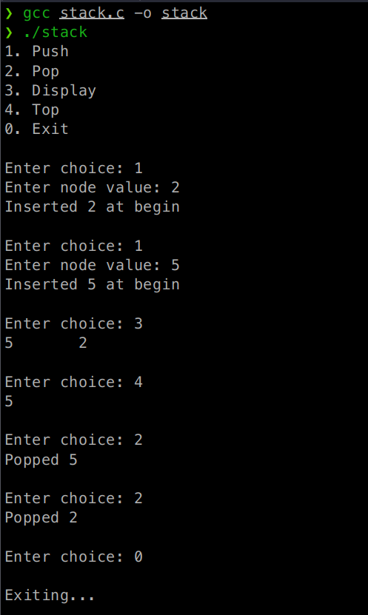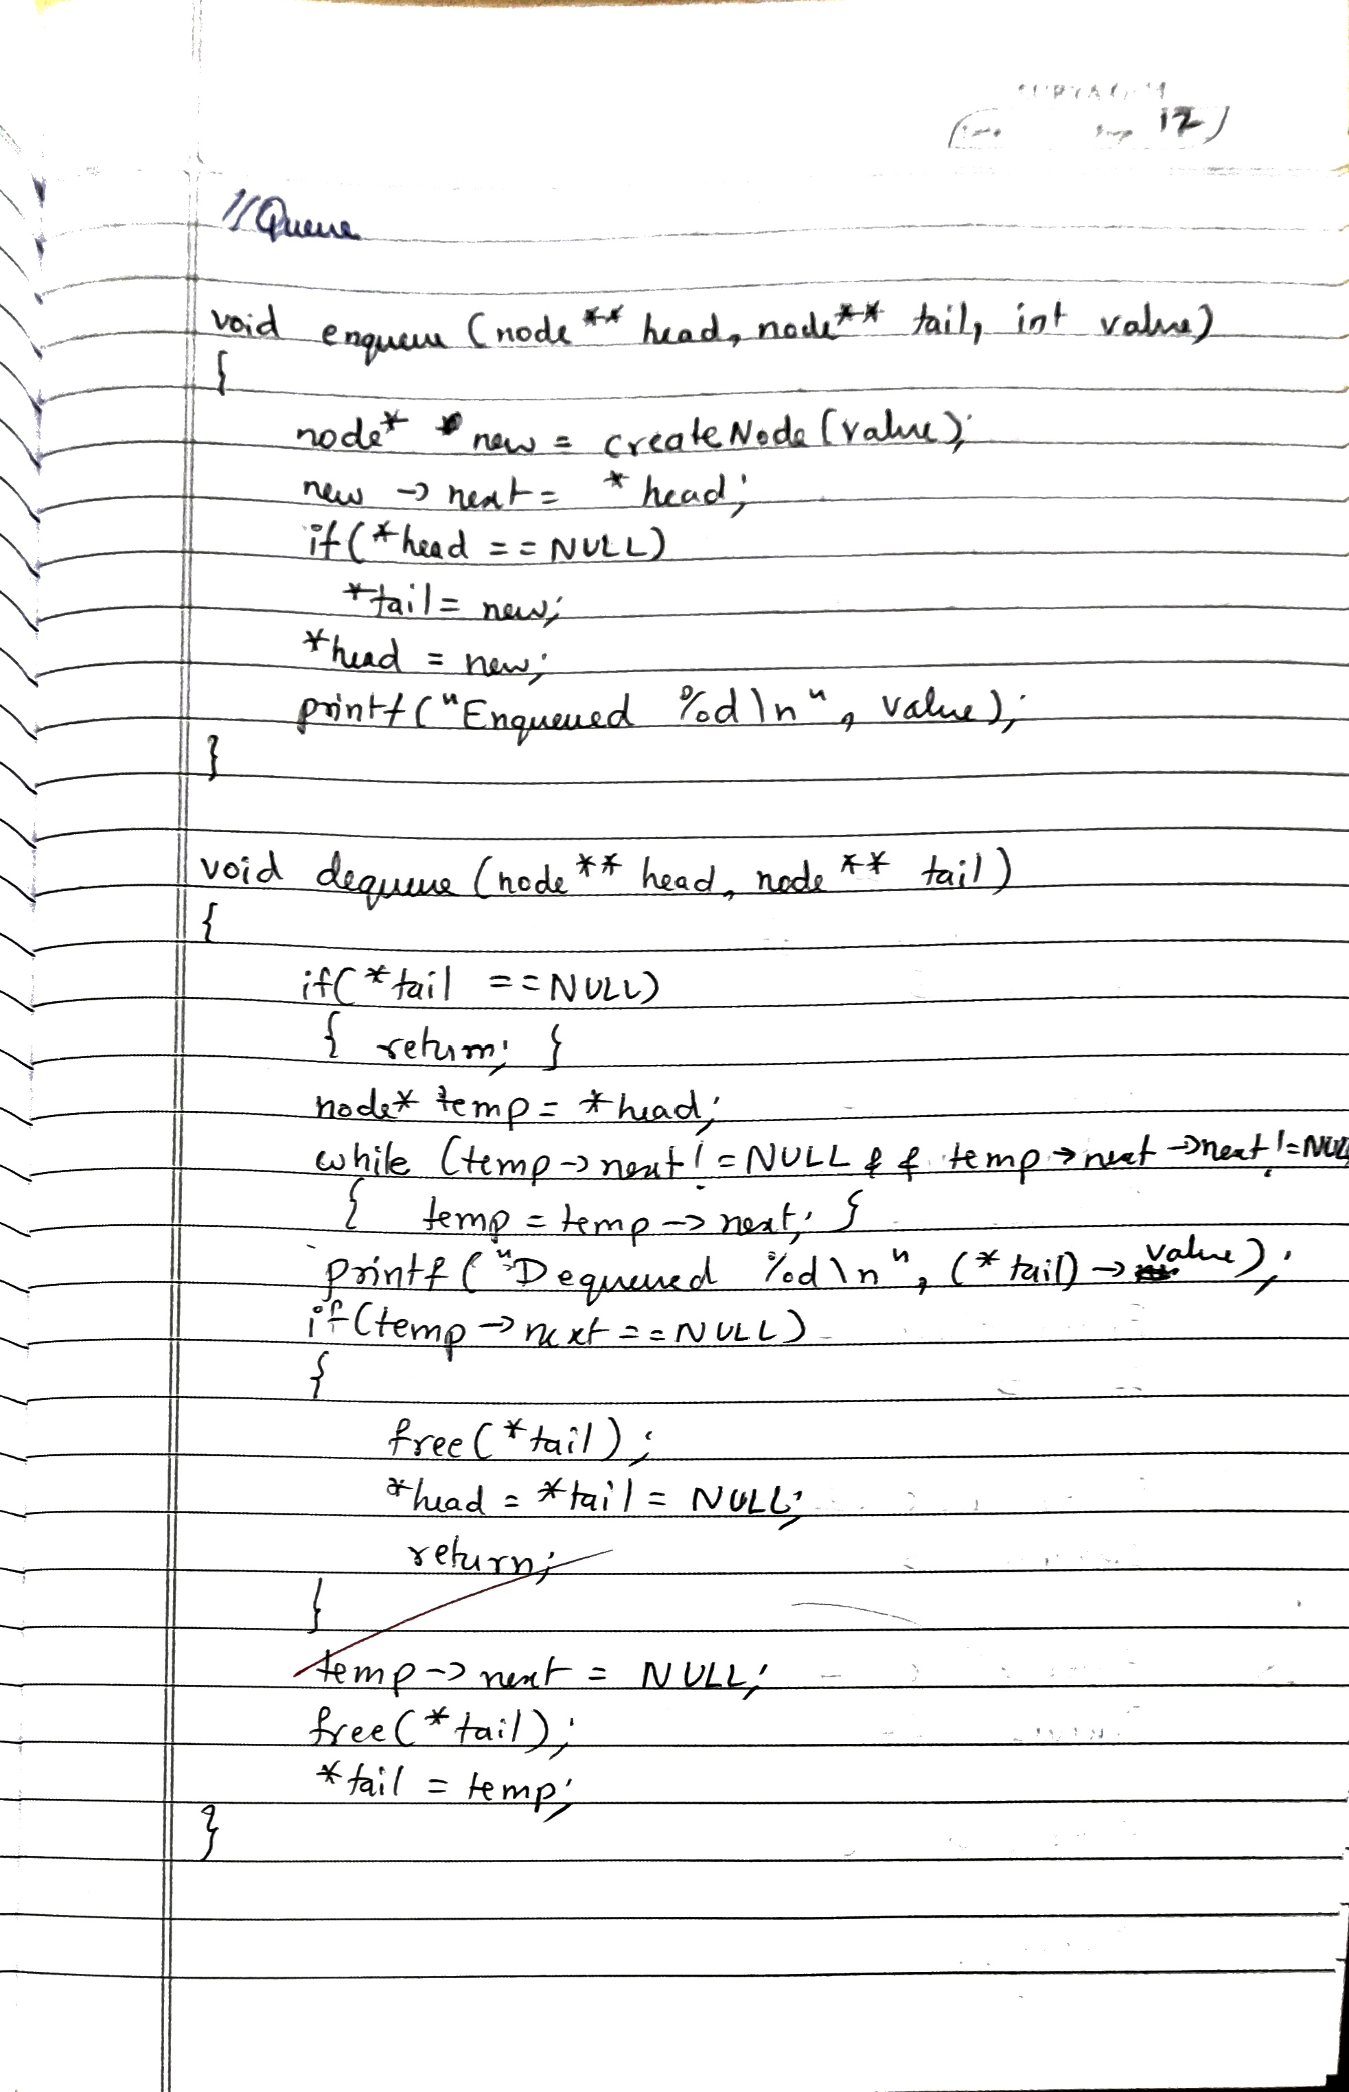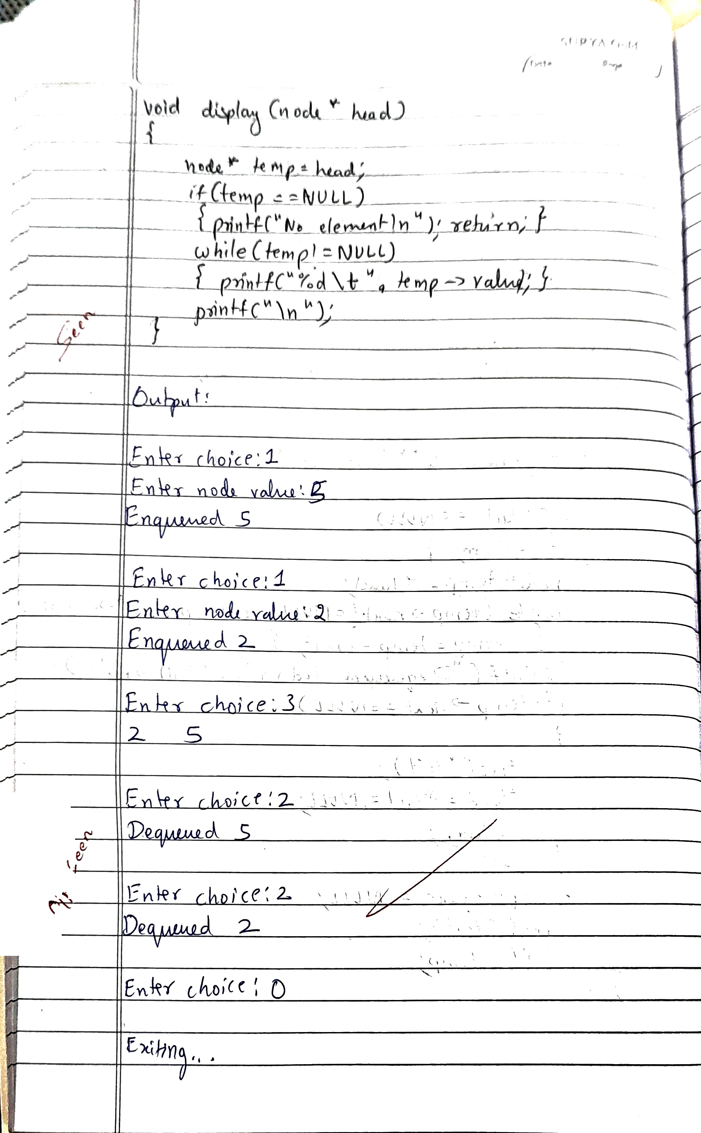

**Code for Queue:**

#include <stdio.h>

#include <stdbool.h>

#include <stdlib.h>

typedef struct node node;

struct node {

int value;

node* next;

};

node* createNode(int x) {

node *n = (node*)malloc(sizeof(node));

n->value = x;

n->next = NULL;

return n;

}

void enqueue(node** head, node** tail, int value) {

node *new = createNode(value);

new->next = *head;

if(*head == NULL)

*tail=new;

*head = new;

printf("Enqueued %d\n", value);

}

void display(node* head) {

node* temp = head;

if (temp == NULL) {

printf("No element\n");

return;

}

while (temp != NULL) {

printf("%d\t", temp->value);

temp = temp->next;

}

printf("\n");

}

void dequeue(node** head, node** tail) {

if (*tail == NULL) {

return;

}

node* temp = *head;

while (temp->next != NULL && temp->next->next != NULL) {

temp = temp->next;

}

printf("Dequeued %d\n",(*tail)->value);

if(temp->next==NULL)

{

free(*tail);

*head = *tail = NULL;

return;

}

temp->next = NULL;

free(*tail);

*tail = temp;

}

int main() {

node* head = NULL;

node* tail = NULL;

printf("1. Enqueue\n2. Dequeue\n3. Display\n0. Exit\n");

int choice;

char c;

do {

printf("\nEnter choice: ");

scanf("%d", &choice);

switch (choice) {

case 1: {

int x;

printf("Enter node value: ");

scanf("%d", &x);

enqueue(&head, &tail, x);

break;

}

case 2: {

dequeue(&head, &tail);

break;

}

case 3:

display(head);

break;

case 0:

break;

default:

printf("Invalid choice\n");

}

if ((c = getchar()) == '\n' || c == EOF) {}

} while (choice != 0);

printf("\nExiting...\n");

return 0;

}

**OUTPUT**

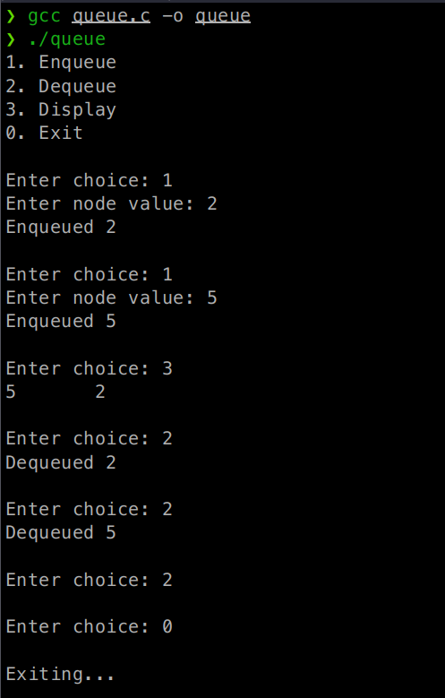

**Program 7:**

WAP to Implement doubly link list with primitive operations

a) Create a doubly linked list.

b) Insert a new node to the left of the node.

c) Display the contents of the list

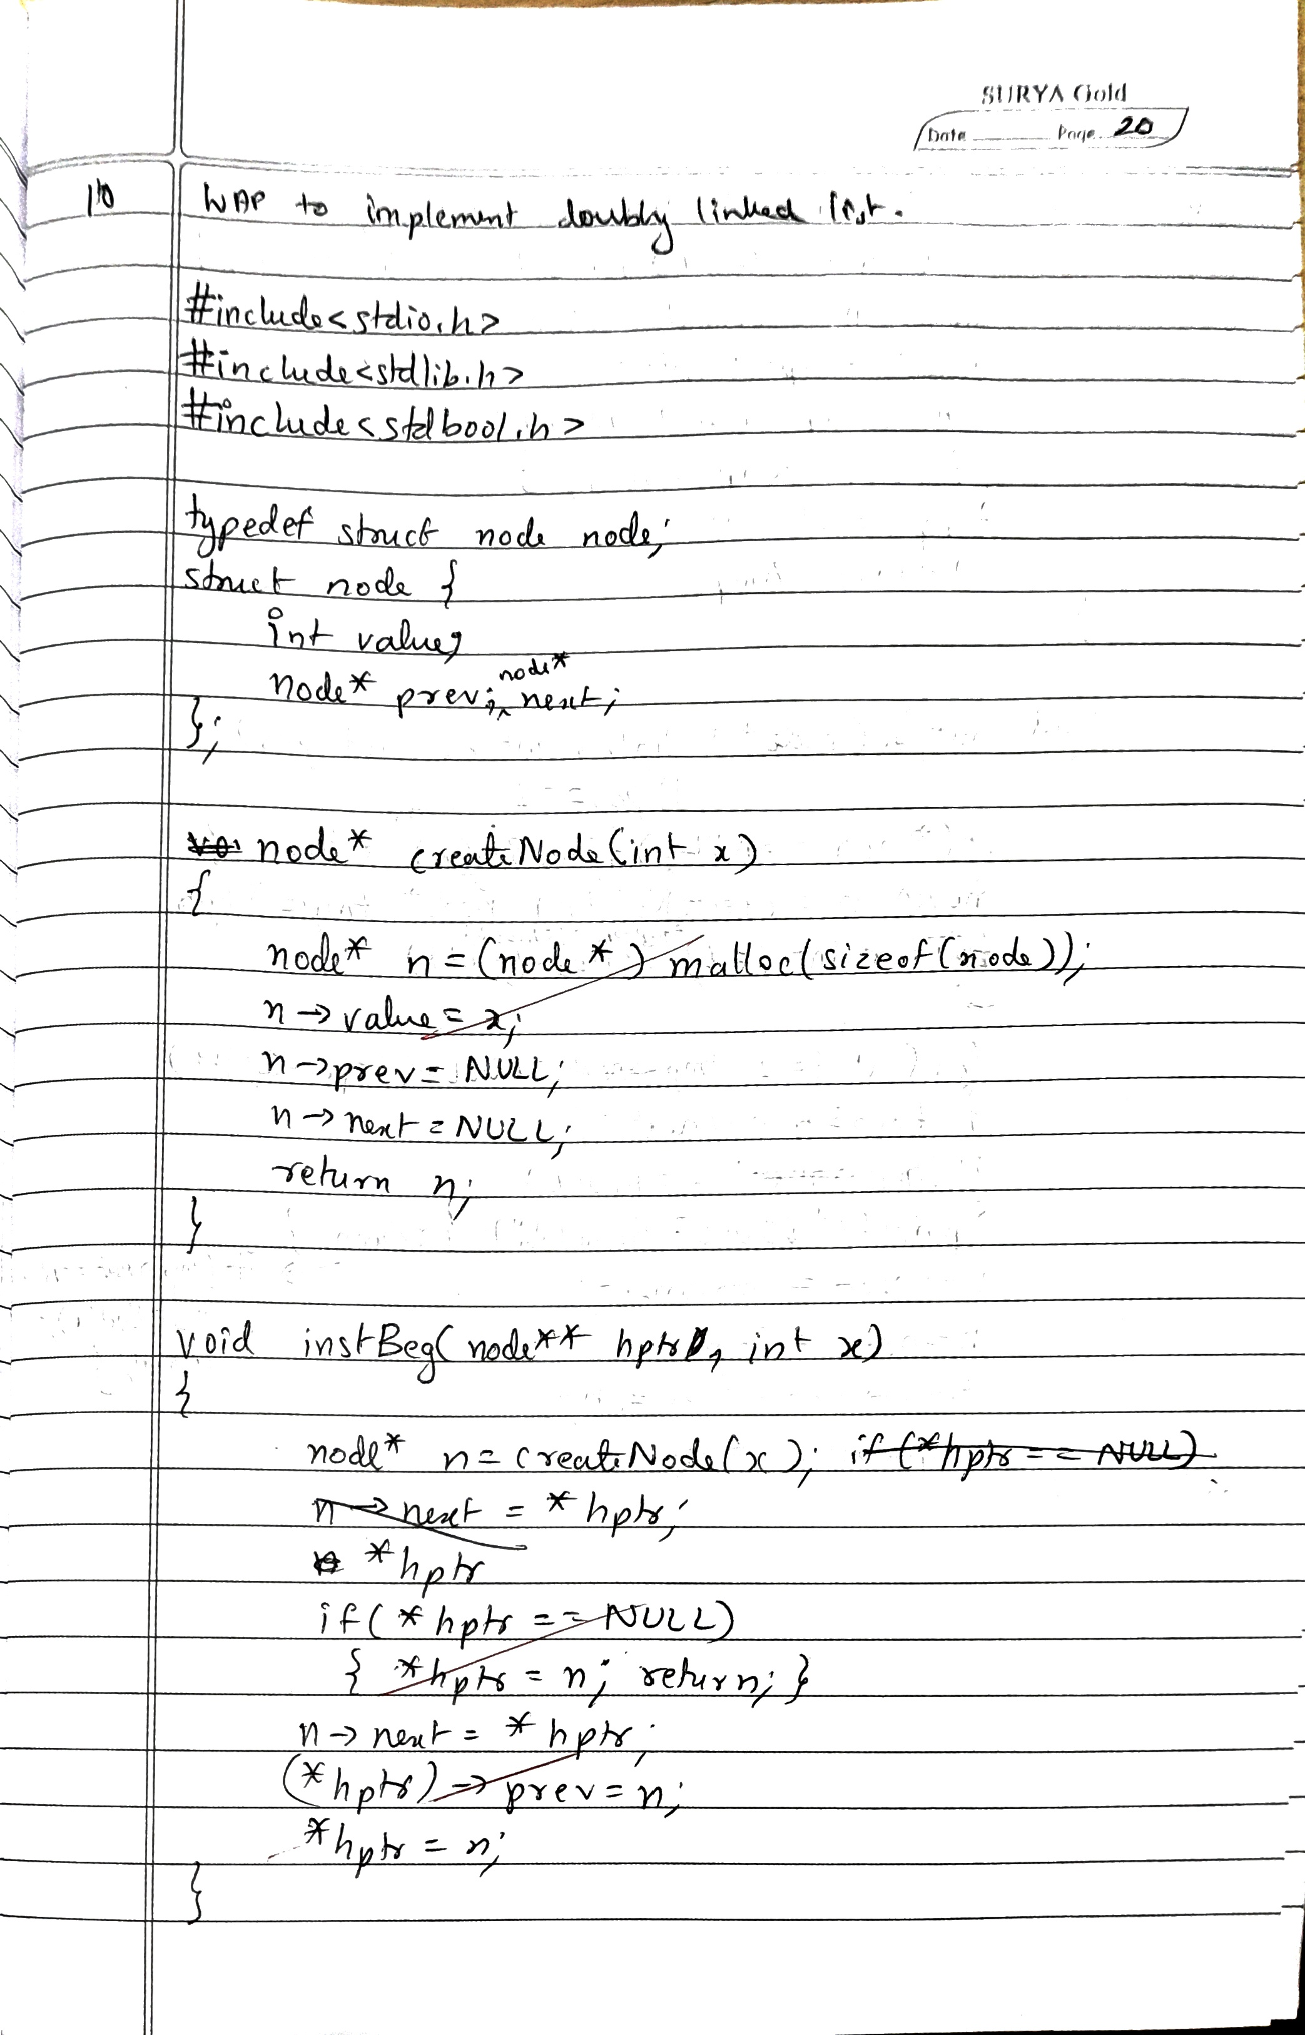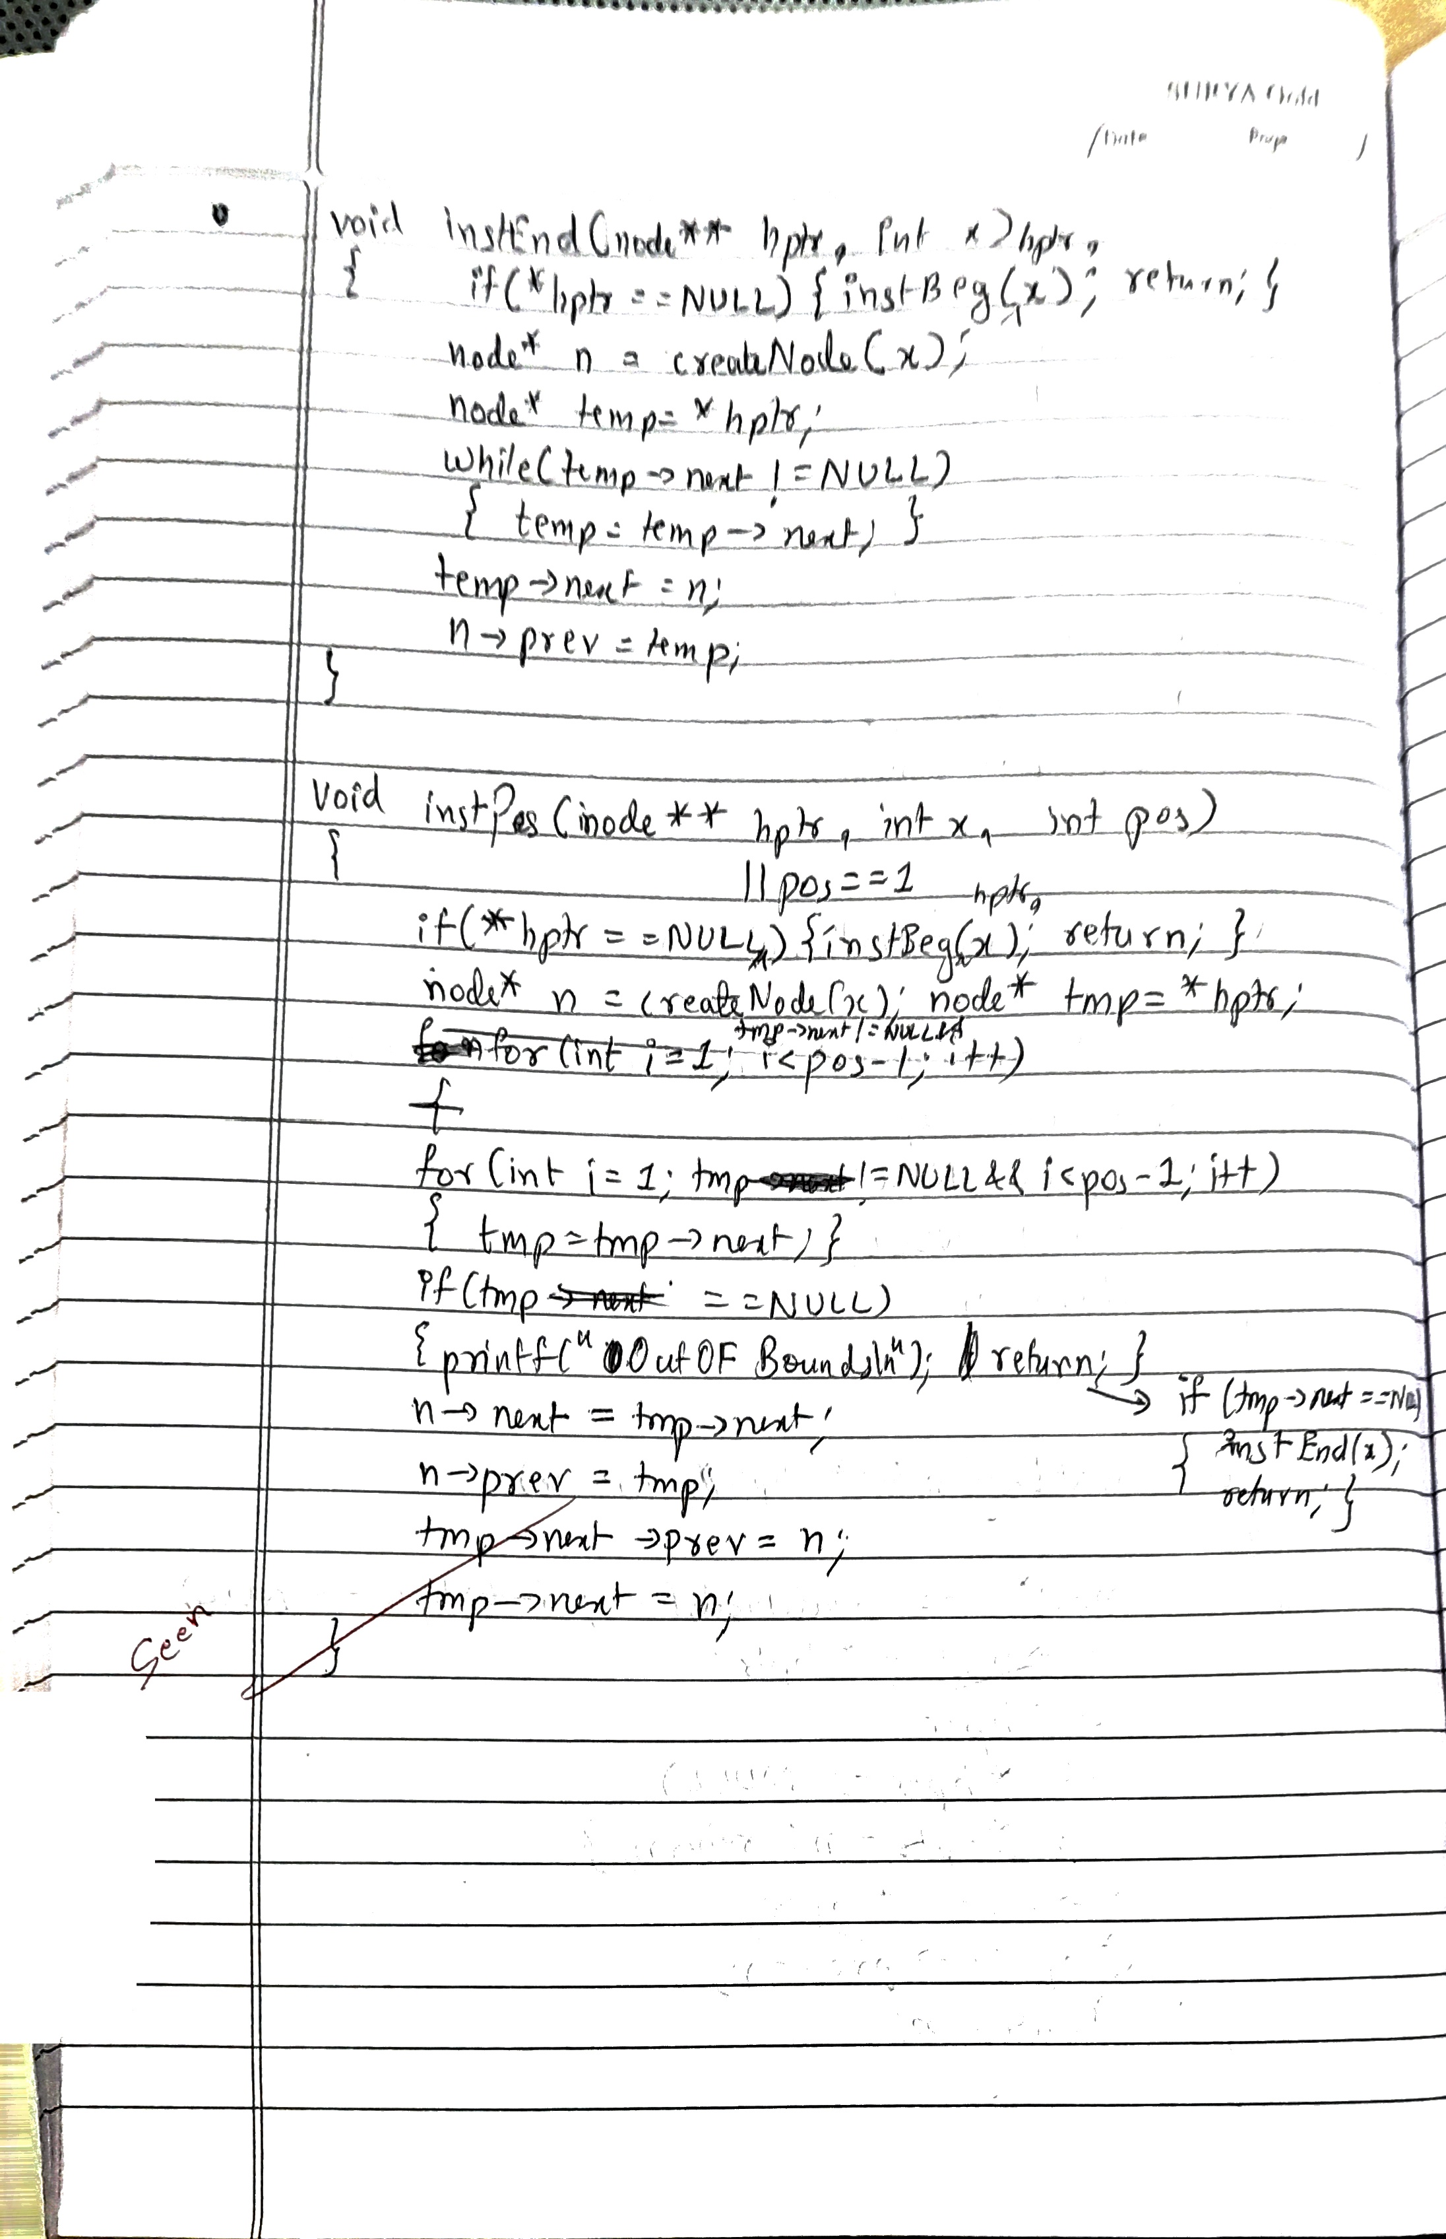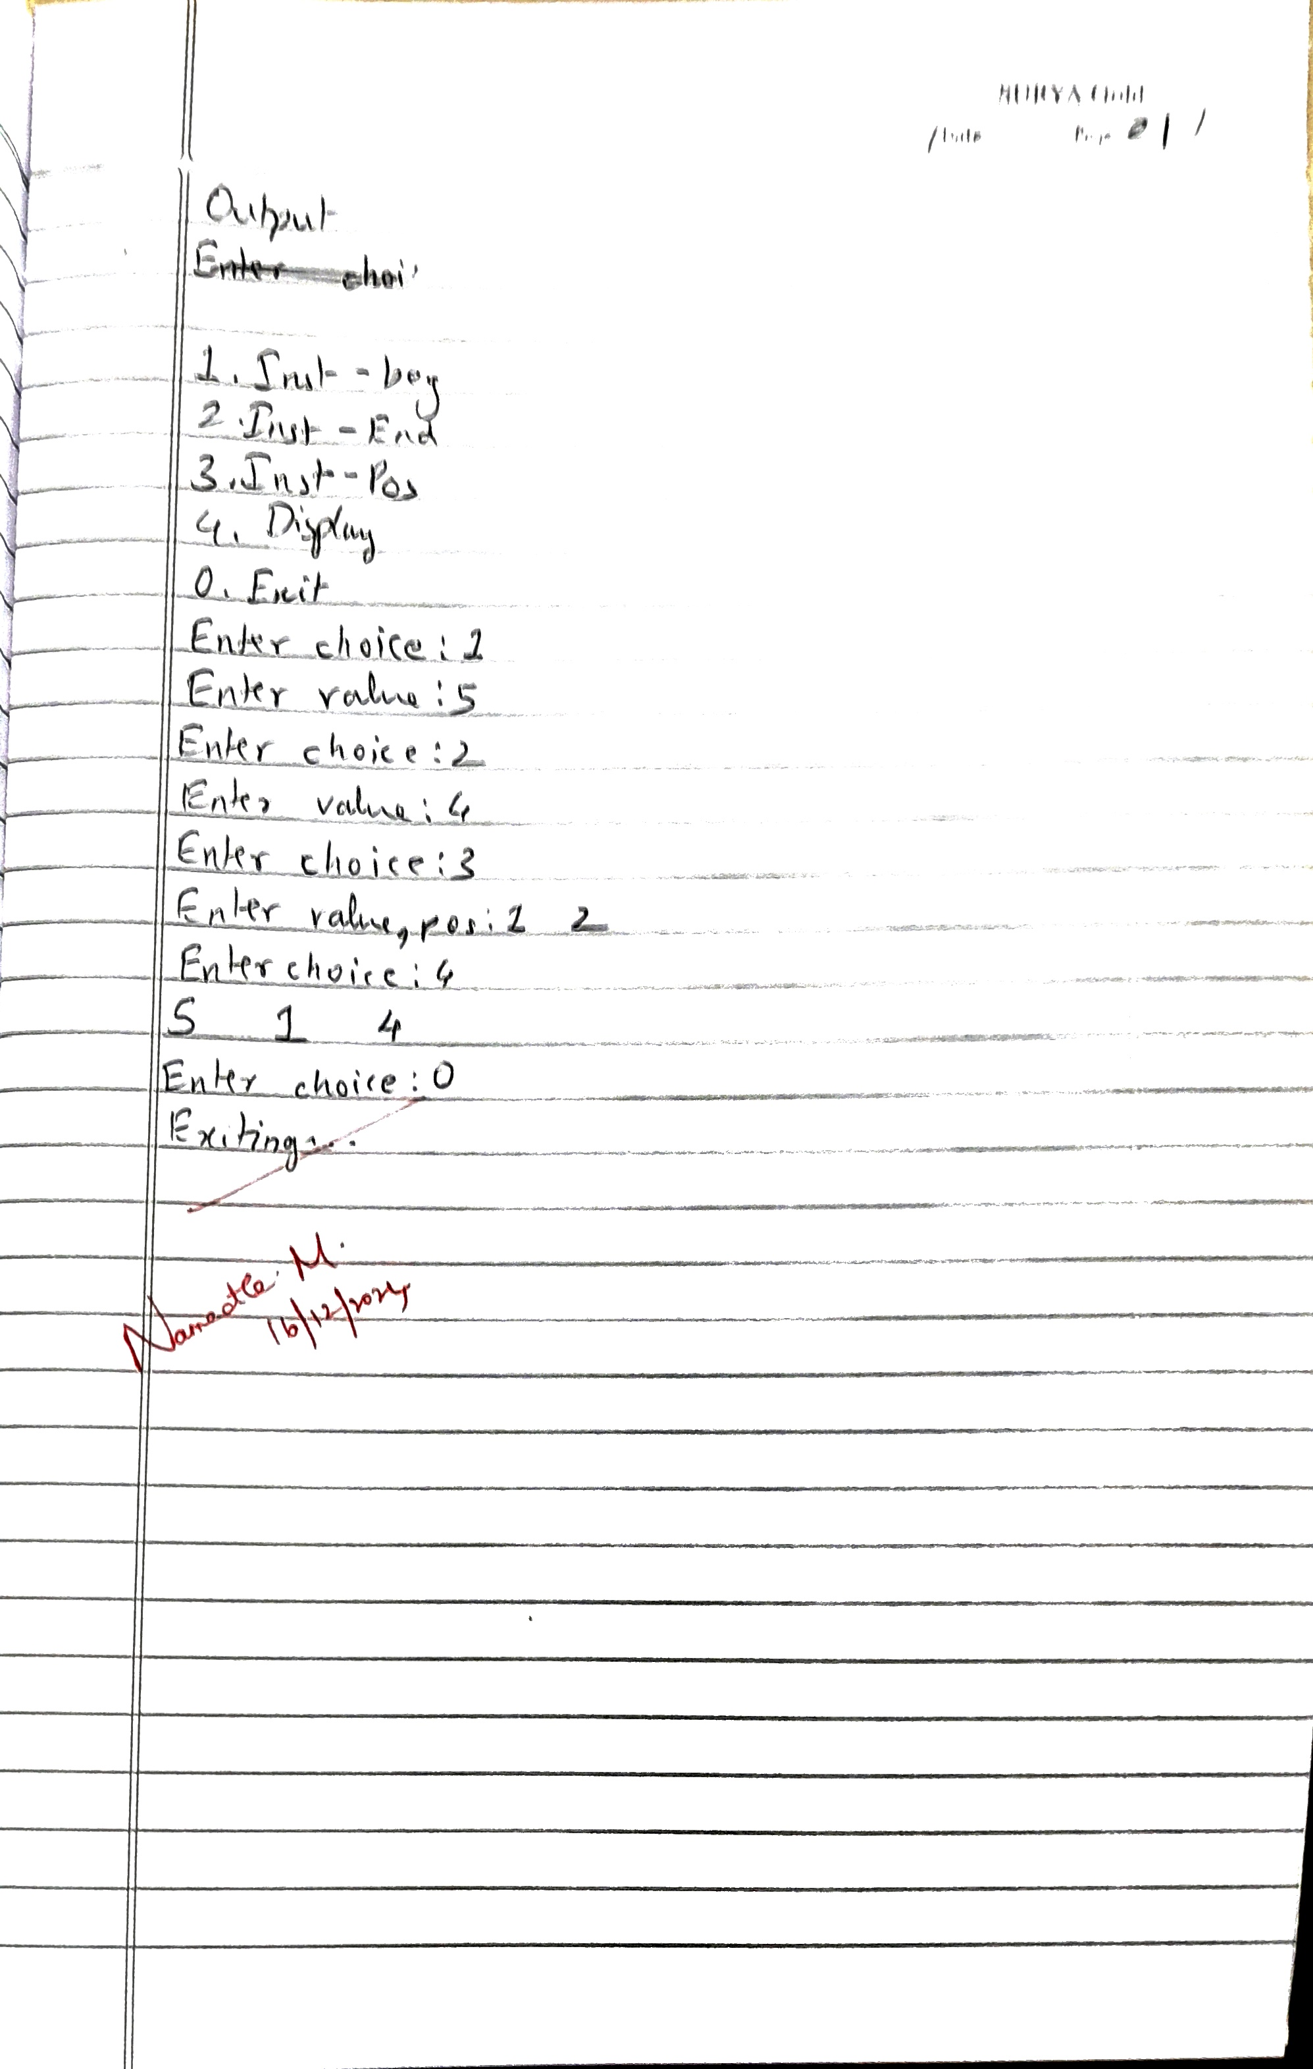

**Code:**

#include<stdio.h>

#include<stdlib.h>

#include<stdbool.h>

typedef struct node node;

struct node{

int value;

node* prev;node* next;

};

node* createNode(int x)

{

node* n = (node*)malloc(sizeof(node));

n->value=x;

n->prev=NULL;

n->next=NULL;

}

void instBeg(node** hptr, int x)

{

node* n = createNode(x);

if(*hptr == NULL)

{

*hptr=n; return;

}

n->next=*hptr;

(*hptr)->prev=n;

*hptr=n;

}

void instEnd(node** hptr, int x)

{

if(*hptr==NULL){instBeg(hptr, x);return;}

node* n = createNode(x);

node* temp = *hptr;

while(temp->next!=NULL)

{temp=temp->next;}

temp->next=n;

n->prev=temp;

}

void instPos(node** hptr, int x, int pos)

{

if(*hptr==NULL||pos==1){instBeg(hptr, x);return;}

node* n = createNode(x);

node* tmp=*hptr;

for(int i=1;tmp!=NULL&&i<pos-1;i++)

{tmp=tmp->next;}

if(tmp==NULL){printf("OutOfBounds\n"); return;}

if(tmp->next==NULL){instEnd(hptr, x);return;}

n->next=tmp->next;

n->prev=tmp;

tmp->next->prev=n;

tmp->next=n;

}

void display(node* head)

{

node* temp=head;

if(head==NULL){printf("Empty List\n");return;}

while(temp!=NULL)

{

printf("%d\t",temp->value);

temp=temp->next;

}

printf("\n");

}

void main()

{

node* head = NULL;

int choice;

printf("1.Inst-beg\n2.Inst-End\n3.Inst-Pos\n4.Display\n0.Exit\n");

do{

printf("Enter choice:");

scanf("%d",&choice);

int x;

switch(choice)

{

case 1: printf("Enter value:");

scanf("%d",&x);

instBeg(&head, x);

break;

case 2: printf("Enter value:");

scanf("%d",&x);

instEnd(&head, x);

break;

case 3: int pos;

printf("Enter value, pos:");

scanf("%d%d",&x,&pos);

instPos(&head, x, pos);

break;

case 4: display(head);

break;

case 0: break;

default:printf("Invalid input\n");

}

}while(choice!=0);

printf("Exiting...");

}

**OUTPUT**

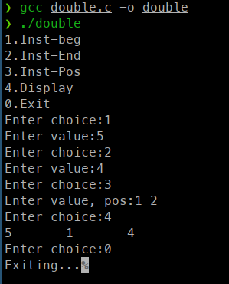

**Program 8 :**

Write a program  
a) To construct a binary Search tree.  
b) To traverse the tree using all the methods i.e., in-order, preorder and post order, display all traversal order

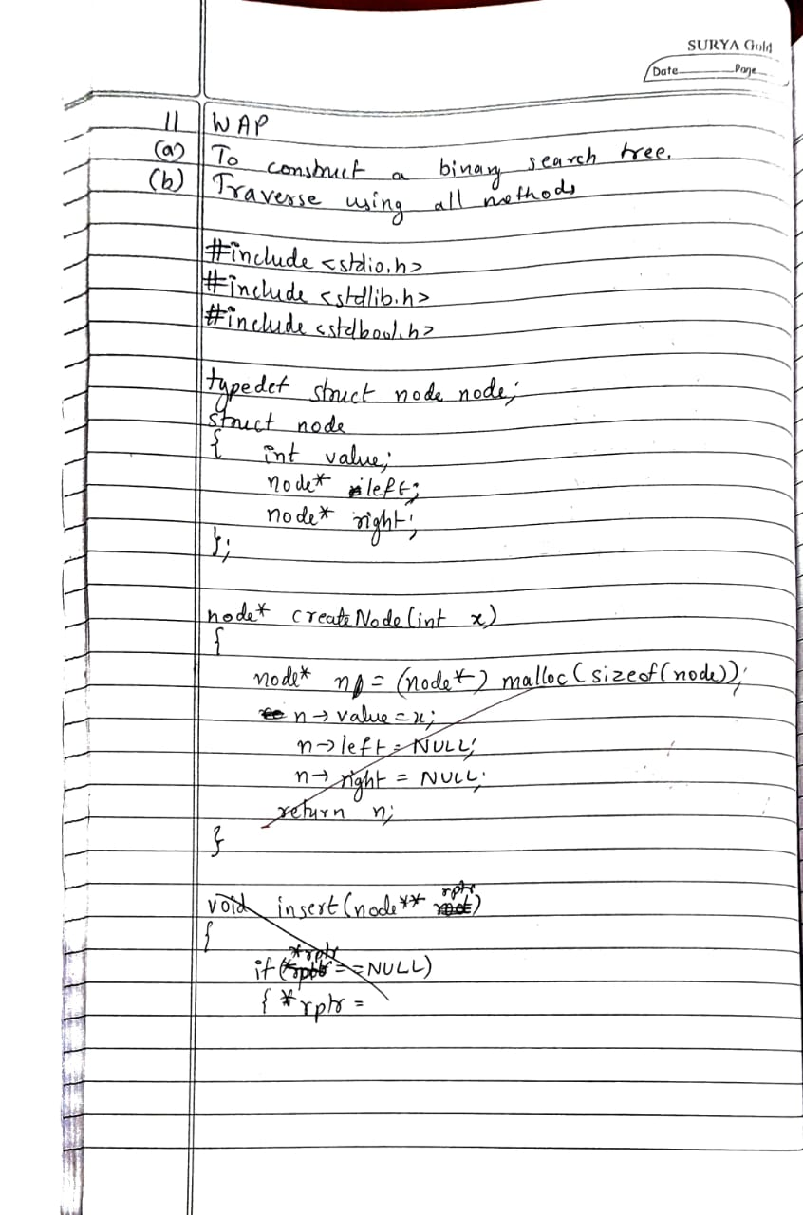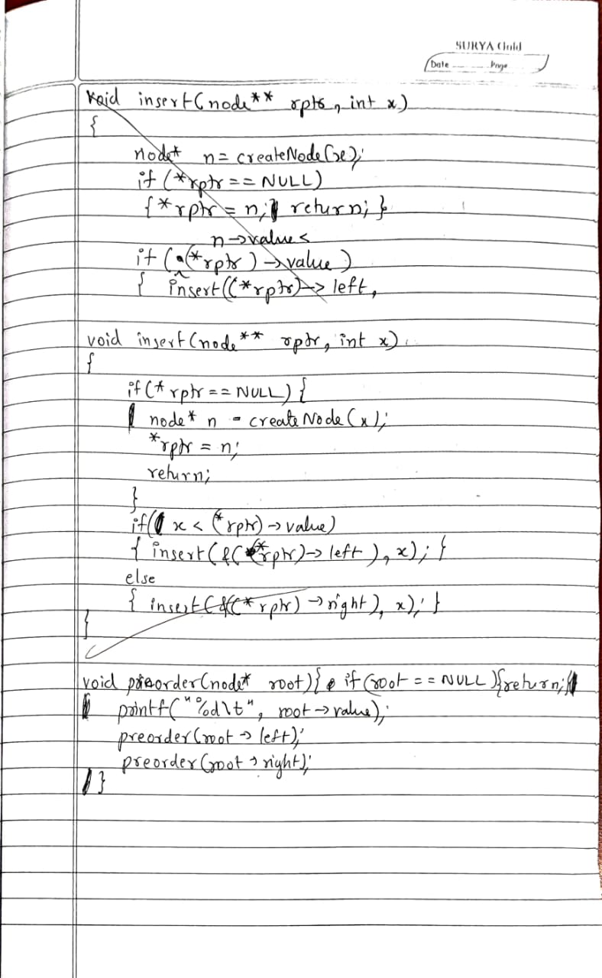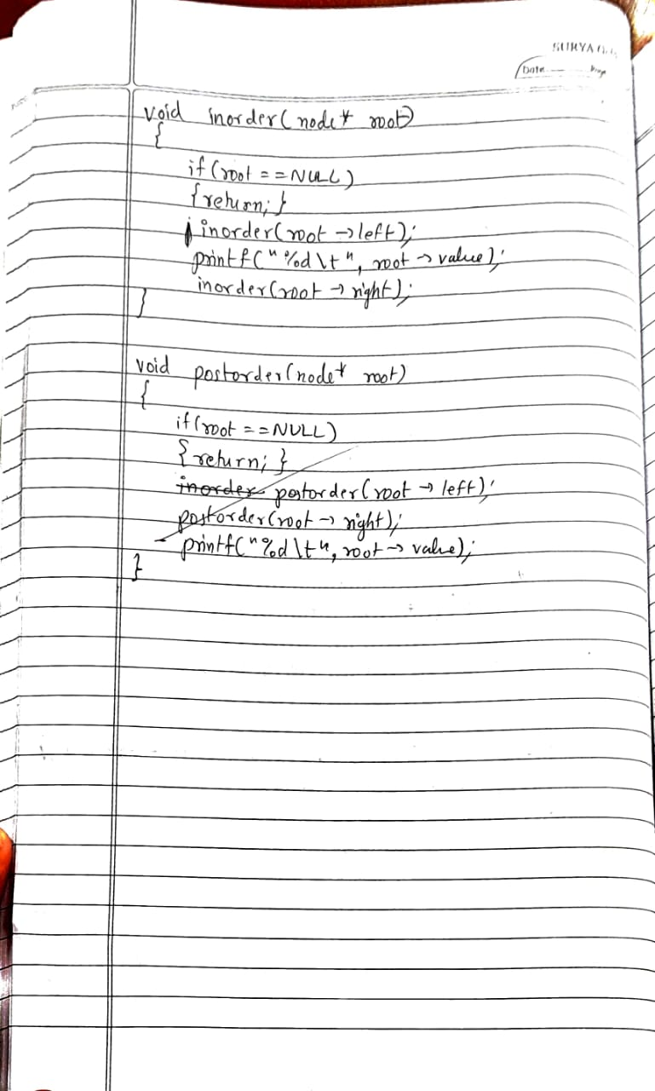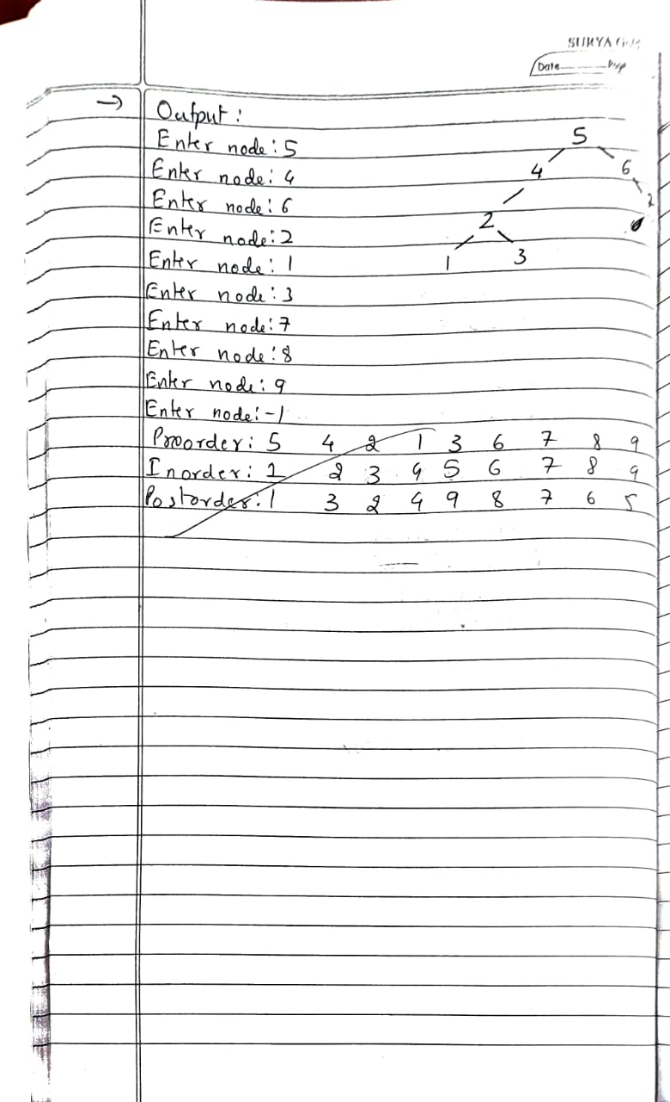

**Code:**

#include <stdio.h>

#include <stdlib.h>

#include <stdbool.h>

typedef struct node node;

struct node

{

int value;

node* left;

node* right;

};

node* createNode(int x)

{

node* n = (node*)malloc(sizeof(node));

n->value=x;

n->left=NULL;

n->right=NULL;

return n;

}

void insert(node** rptr, int x)

{

if(*rptr==NULL)

{

node* n = createNode(x);

*rptr=n;

return;

}

if(x<(*rptr)->value)

{insert(&((*rptr)->left), x);}

else

{insert(&((*rptr)->right), x);}

}

void preorder(node* root)

{

if(root==NULL){return;}

printf("%d\t", root->value);

preorder(root->left);

preorder(root->right);

}

void inorder(node* root)

{

if(root==NULL){return;}

inorder(root->left);

printf("%d\t", root->value);

inorder(root->right);

}

void postorder(node* root)

{

if(root==NULL){return;}

postorder(root->left);

postorder(root->right);

printf("%d\t", root->value);

}

void main()

{

node* root = NULL;

int x=0;

while(x!=-1)

{

printf("Enter node:");

scanf("%d",&x);

if(x!=-1){insert(&root, x);}

}

printf("Preorder:");

preorder(root);

printf("\n");

printf("Inorder:");

inorder(root);

printf("\n");

printf("Postorder:");

postorder(root);

printf("\n");

}

**OUTPUT**

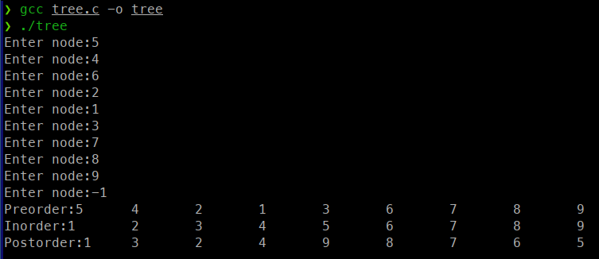

**Program 9:**

a) Write a program to traverse a graph using BFS method.  
b) Write a program to traverse a graph using DFS method.

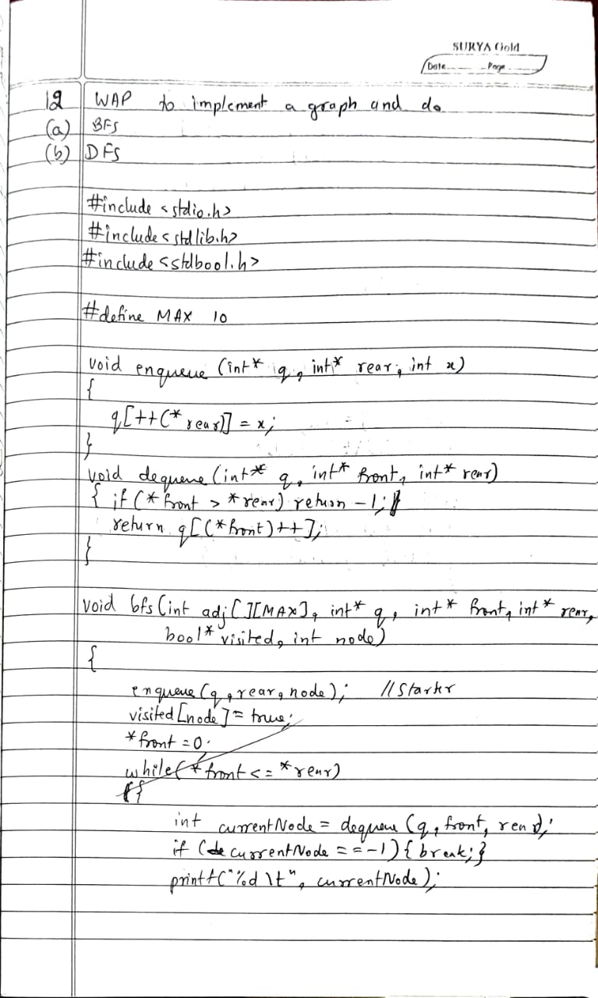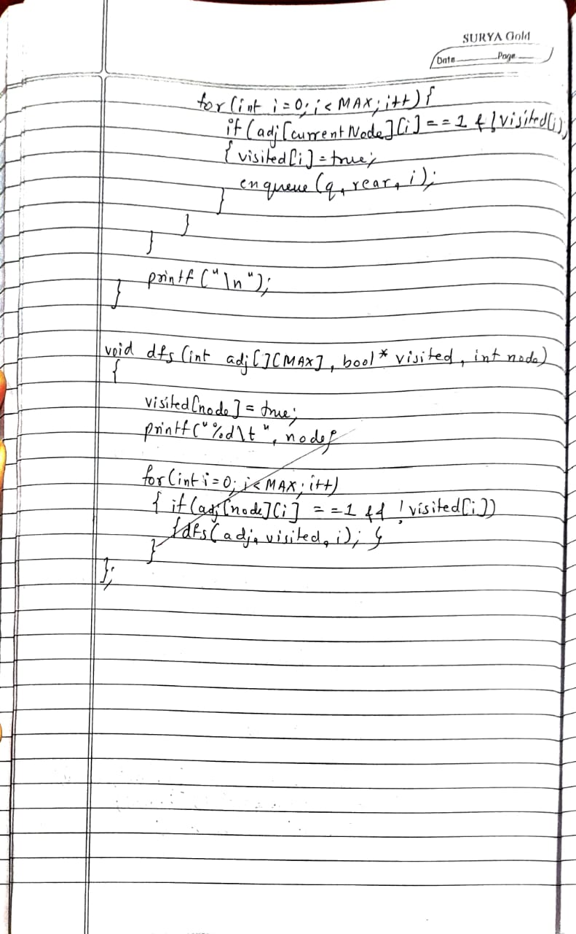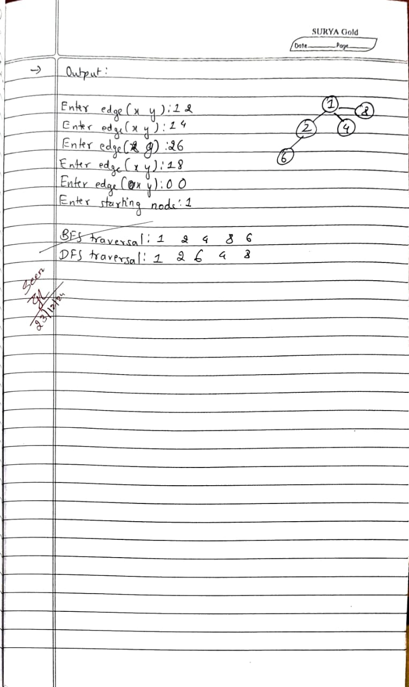

**Code:**

#include <stdio.h>

#include <stdbool.h>

#define MAX 10

// Function to enqueue an element into the queue

void enqueue(int* q, int* rear, int x) {

q[++(*rear)] = x;

}

// Function to dequeue an element from the queue

int dequeue(int* q, int* front, int* rear) {

if (*front > *rear) return -1; // Queue is empty

return q[(*front)++];

}

// Function to perform BFS

void bfs(int adj[][MAX], int* q, int* front, int* rear, bool* visited, int node) {

enqueue(q, rear, node);

visited[node] = true;

*front = 0; // Set front to 0 after the first enqueue

while (*front <= *rear) {

int currentNode = dequeue(q, front, rear);

if (currentNode == -1) {

break;

}

printf("%d\t", currentNode); // Display the visited node

// Check all adjacent nodes

for (int i = 0; i < MAX; i++) {

if (adj[currentNode][i] == 1 && !visited[i]) {

visited[i] = true;

enqueue(q, rear, i); // Enqueue the unvisited node

}

}

}

printf("\n");

}

// Function to perform DFS

void dfs(int adj[][MAX], bool* visited, int node) {

visited[node] = true;

printf("%d\t", node); // Display the visited node

// Visit all adjacent unvisited nodes recursively

for (int i = 0; i < MAX; i++) {

if (adj[node][i] == 1 && !visited[i]) {

dfs(adj, visited, i);

}

}

}

int main() {

int adj[MAX][MAX] = {0}; // Adjacency matrix

bool visited[MAX] = {false}; // Visited array

int q[MAX]; // Queue for BFS

int front = -1, rear = -1; // Queue pointers

int x, y;

// Input the graph as an undirected graph

do {

printf("Enter edge (x y): ");

scanf("%d%d", &x, &y);

if (x == y) {

break;

}

adj[x][y] = 1;

adj[y][x] = 1; // Since it's an undirected graph

} while (x != y);

printf("Enter starting node: ");

scanf("%d", &x);

// Perform BFS

printf("BFS traversal: ");

bfs(adj, q, &front, &rear, visited, x);

// Reset visited array for DFS

for (int i = 0; i < MAX; i++) {

visited[i] = false;

}

// Perform DFS

printf("DFS traversal: ");

dfs(adj, visited, x);

printf("\n");

return 0;

}

**OUTPUT**

